**Spring Boot Overview**

**Spring Boot Solution**

• Make it easier to get started with Spring development

• Minimize the amount of manual configuration

• Perform auto-configuration based on props files and JAR class path

• Help to resolve dependency conflicts (Maven or Gradle)

• Provide an embedded HTTP server so you can get started quickly

• Tomcat, Jetty, Undertow, …

**Spring Boot and Spring**

• Spring Boot uses Spring behind the scenes

• Spring Boot simply makes it easier to use Spring

**Spring Initializr**

https://start.spring.io/

• Quickly create a starter Spring Boot project

• Select your dependencies

• Creates a Maven/Gradle project

• Import the project into your IDE

• Eclipse, IntelliJ, NetBeans etc …



**Spring Boot Embedded Server**

• Provide an embedded HTTP server so you can get started quickly

• Tomcat, Jetty, Undertow, …

• No need to install a server separately

**Running Spring Boot Apps**

• Spring Boot apps can be run standalone (includes embedded server)

• Run the Spring Boot app from the IDE or command-line. E.g,. java -jar mycoolapp.jar

* Spring boot has its own server, so no need to run it on server explicitly, we can run its main function class, run as java

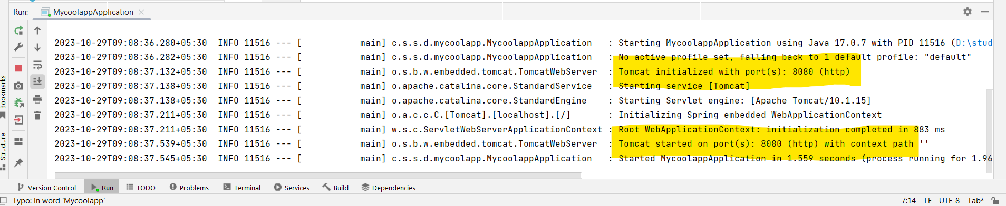

**Deploying Spring Boot Apps**

• Spring Boot apps can also be deployed in the traditional way

• Deploy Web Application Archive (WAR) file to an external server:

• Tomcat, JBoss, WebSphere etc …

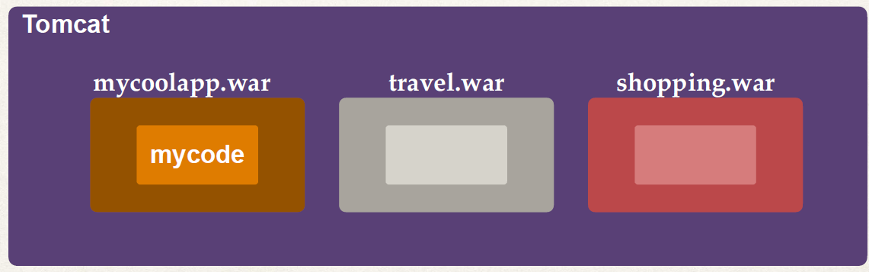

**Spring Boot FAQ #1**

Q: Does Spring Boot replace Spring MVC, Spring REST etc …?

Ans: No. Instead, Spring Boot actually uses those technologies

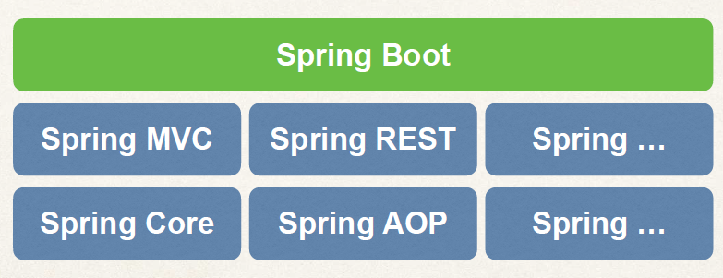

Spring MVC Spring REST Spring …

Spring Core Spring AOP Spring …

**Spring Boot FAQ #2**

Q: Does Spring Boot run code faster than regular Spring code?

Ans: No. Behind the scenes, Spring Boot uses same code of Spring Framework. Remember, Spring Boot is about making it easier to get started. Minimizing configuration etc …

Spring Boot FAQ #3

Q: Do I need a special IDE for Spring Boot?

Ans: No. You can use any IDE for Spring Boot apps … even use plain text editor. The Spring team provides free Spring Tool Suite (STS) [IDE plugins]. Some IDEs provide fancy Spring tooling support. Not a requirement. Feel free to use the IDE that works best for you

**Spring Boot Initializr**

**Quick Word on Maven**

• When building your Java project, you may need additional JAR files

• For example: Spring, Hibernate, Commons Logging, JSON etc…

• One approach is to download the JAR files from each project web site

• Manually add the JAR files to your build path / classpath

**Maven Solution**

• Tell Maven the projects you are working with (dependencies)

• Spring, Hibernate etc ….

• Maven will go out and download the JAR files for those projects for you

• And Maven will make those JAR files available during compile/run

• Think of Maven as your friendly helper / personal shopper :-)

**Development Process: (Step-By-Step)**

1. Configure our project at Spring Initializr website - http://start.spring.io

2. Download the zip file

3. Unzip the file

4. Import the project into our IDE

**Dependencies :-**

**Spring Web WEB**

Build web, including RESTful, applications using Spring MVC. Uses Apache Tomcat as the default embedded container.

Need to add Controller and view pages in the code.

Create rest controller. That will run in the spring boot application.

**Rest Controller**

Create a rest controller. It run in our spring application.

1. Create a new package to your spring application E.g., com.sharada.springbbot.demo.mycoolapp.**rest**
2. Create a new class in the rest package E.g., **FunRestController**
3. Put Rest-Controller annotation **@RestController** and import its package –

import **org.springframework.web.bind.annotation.RestController**;

1. Set up GetMapping for “/” with annotation **@GetMapping("/")** and define the method for it.

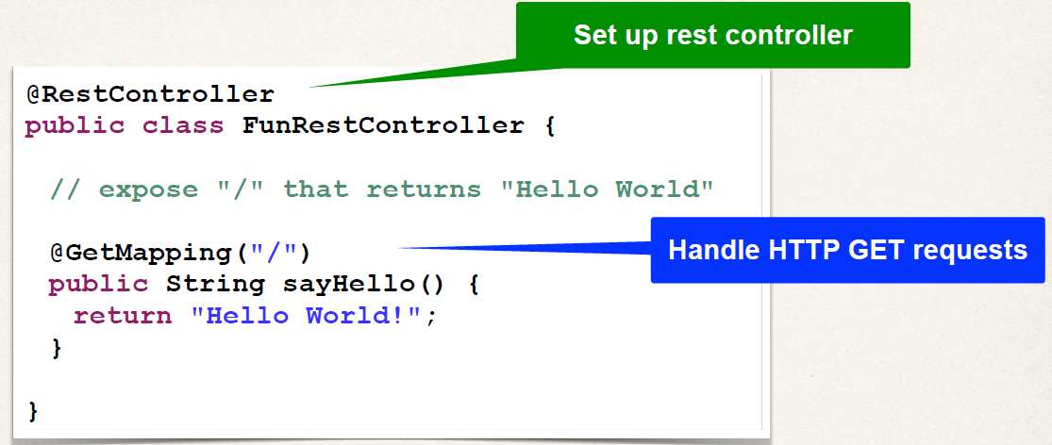

1. Run the main class file and we can get the result on browser port localhost:8080

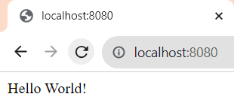

**Spring Website - Official:** [**www.spring.io**](http://www.spring.io)

**Goals of Spring**

• Lightweight development with Java POJOs (Plain-Old-Java-Objects).

* POJOs make it much simpler as compared to heavy weight EJBs early versions of J2EE.

• Dependency injection to promote loose coupling.

* Instead of hard wearing objects together, simply specify the wiring in configurations file or annotations.

• Declarative programming with Aspect-Oriented-Programming (AOP)

• Minimize boilerplate Java code

* Here we can use helper classes to make it easier and to minimize boilerplate code.

**Core Container**

The core container is the main item in Spring. It manages how the beans need to create, based on properties file and configuration files. Spring container hold the beans in memory.

* Factory for creating beans and manage bean dependencies.
* SpEL: Spring Expression language – a language we can use within the config
* Core Container – creating beans and making them available.

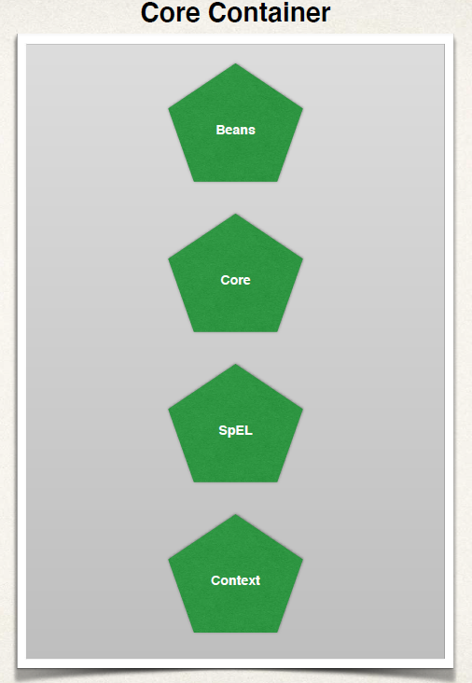

**Infrastructure**

**AOP**: **Aspect Oriented Programming**. It allows the application wide services like logging, security, transactions, instrumentation, etc,. Then you can apply these services to your objects in a declarative fashion. So, no need to modify your code to support for this. You can simply add a config file or an annotation, and that service will be applied to your application.

**Instrumentation Model:** Spring has a lot of fancy technology behind the scenes, here we can use of ***class loader implementations*** to work with different App servers. For example, it can be used to create a Java agent so we can remotely monitor and instrument our application using JMX (Java Management Extension).

Java agents to remotely monitor our app with JMX. As a developer we don’t build an agent ourself, we would simply use the agents provided by the Spring team or the App server vendor.

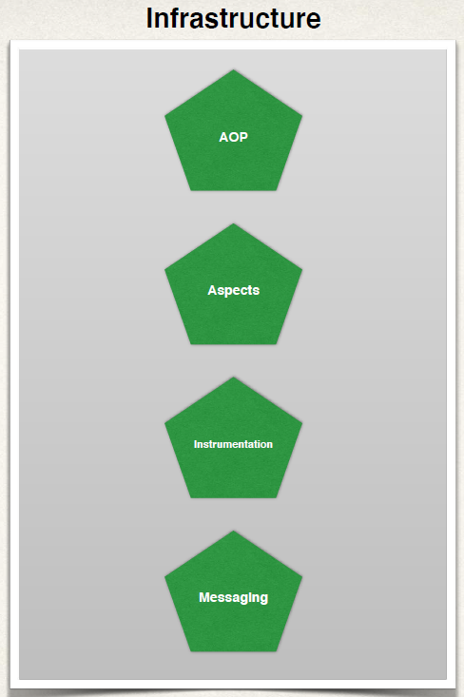

**Data Access Section:**

Communicating with Database either a Relational database or NoSQL database and also making use of like a message queue.

Spring provides some helper class, which makes it much easier to access a database using **JDBC**. By using this Spring JDBC we can reduce our source code by over 50%.

**ORM – Object to Relational Mapping** , a popular section in the module here. It allows us to hook into Hibernate or JPA. Integration with Hibernate and JPA. It provides a lot of support between Spring and Hibernate.

**JMS – Java Message Service**, allows us to send message to a message queue in an asynchronous fashion, that is a core part of Java EE. Here Spring provides a helper class to allow you to make use of the java Message Service. For sending async messages to a Message Broker. Here also we can reduce our source code by over 50% by using Spring’s JMS integration.

Also, Spring has support for **Transaction manger** or supporting transactions. We can do it in very light weight fashion. So, we can make use of transactions on methods, on database calls, and pretty much anything we want, it’s very flexible. It makes heavy use of AOP behind the scenes.

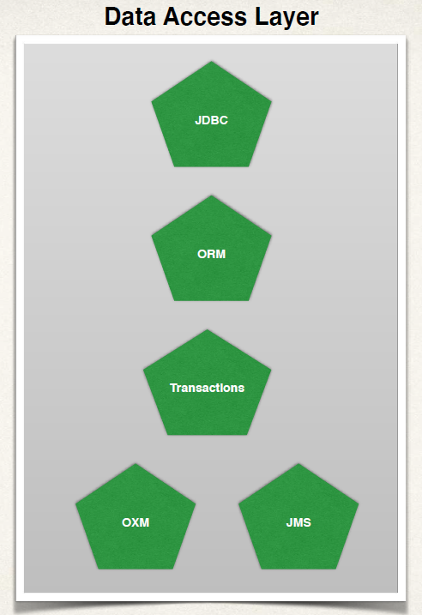

**Web Layer:**

All Web related classes. It’s home for Spring MVC framework. We can build web applications using Spring Core, and also by making use of Spring Controllers and Spring View. We have full spring MVC layout in here.

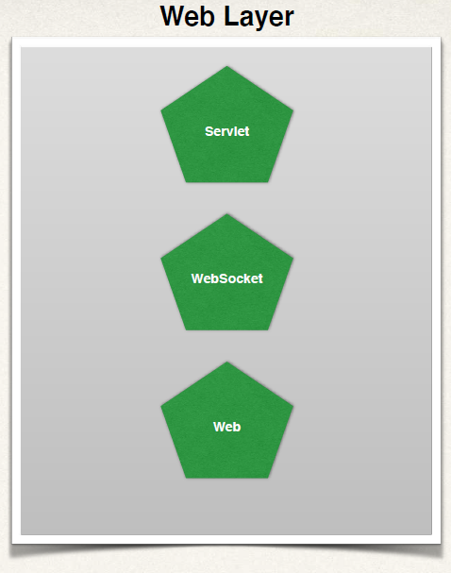

We also have other modules here, where we can actually interface with other web technologies like JSF or Struts. But, if we are using Spring already then it makes sense to just go ahead and use Spring MVC, no need to pull in any other APIs, but we can do it if we want.

They also have support for Remoting here, we can use of web remoting where we can have external clients make calls into the Spring container, it’s of doing like Remote procedure Calls (RPC) or doing the distributive computing, that’s also available in this web module.

**Test Layer**

Spring has support for Test driven development (TDD), So the framework includes mock objects for mocking out servlets, JNDI access and so on. And we can do all of this outside the container.

We can also use of Integration test by creating an application context and wiring up our desired objects. So, there is a lot of good support for testing.

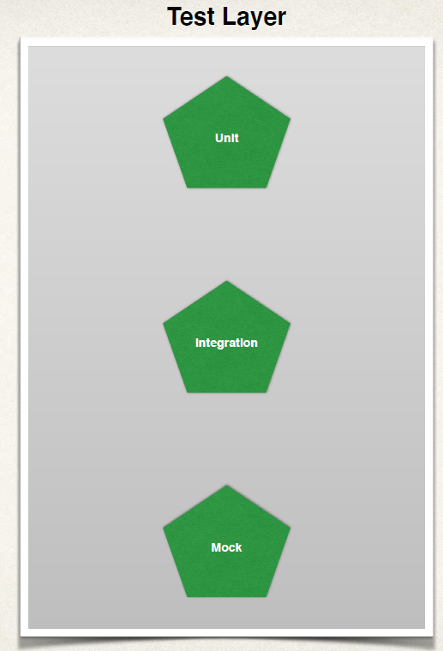

**What Are Spring “Projects”**

• Additional Spring **modules** built-on top of the core Spring Framework

• Only use the module what you need …

• Spring Cloud, Spring Data – Spring cloud for cloud-based development and Spring Data for database integration.

• Spring Batch, Spring Security – Spring Batch for creating Batch processes and Spring Security for securing applications.

• Spring Web Services, Spring LDAP – Spring Web Services for web RESTful and SOAP webservices and Spring LDAP for accessing LDAP servers.

• others .

**Maven**

**Spring Boot and Maven**

• When you generate projects using Spring Initializr: start.spring.io

• It can generate a Maven project for you.

**Basics of Maven**

• Viewing dependencies in the Maven pom.xml file

• Spring Boot Starters for Maven

**What is Maven?**

• Maven is a Project Management tool

• Most popular use of Maven is for build management and dependencies

**What Problems Does Maven Solve?**

• When building your Java project, you may need additional JAR files

• For example: Spring, Hibernate, Commons Logging, JSON etc…

• One approach is to download the JAR files from each project web site

• Manually add the JAR files to your build path / classpath

**Maven Solution**

• Tell Maven the projects you are working with (dependencies)

• Spring, Hibernate etc ….

• Maven will go out and download the JAR files for those projects for you

• And Maven will make those JAR files available during compile/run

• Think of Maven as your friendly helper / personal shopper :-)

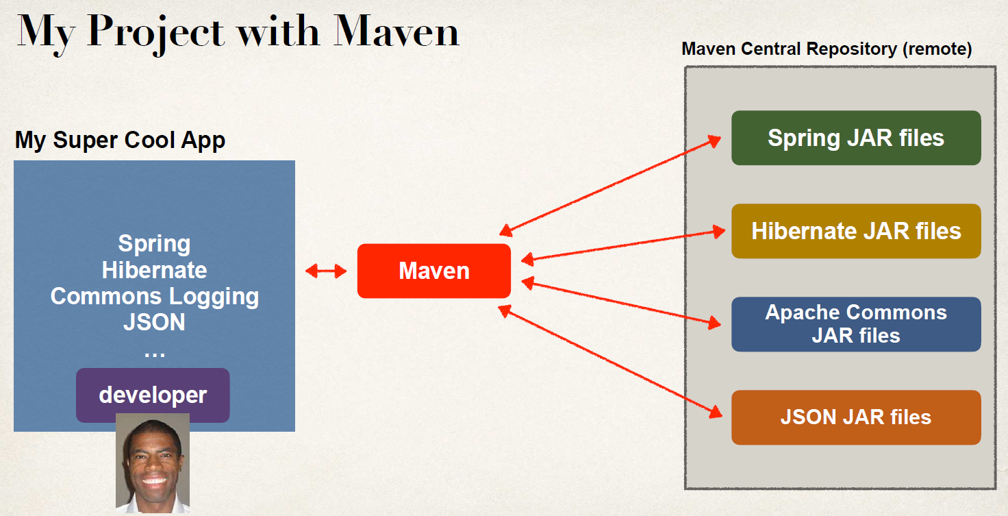

**Maven - How It Works**

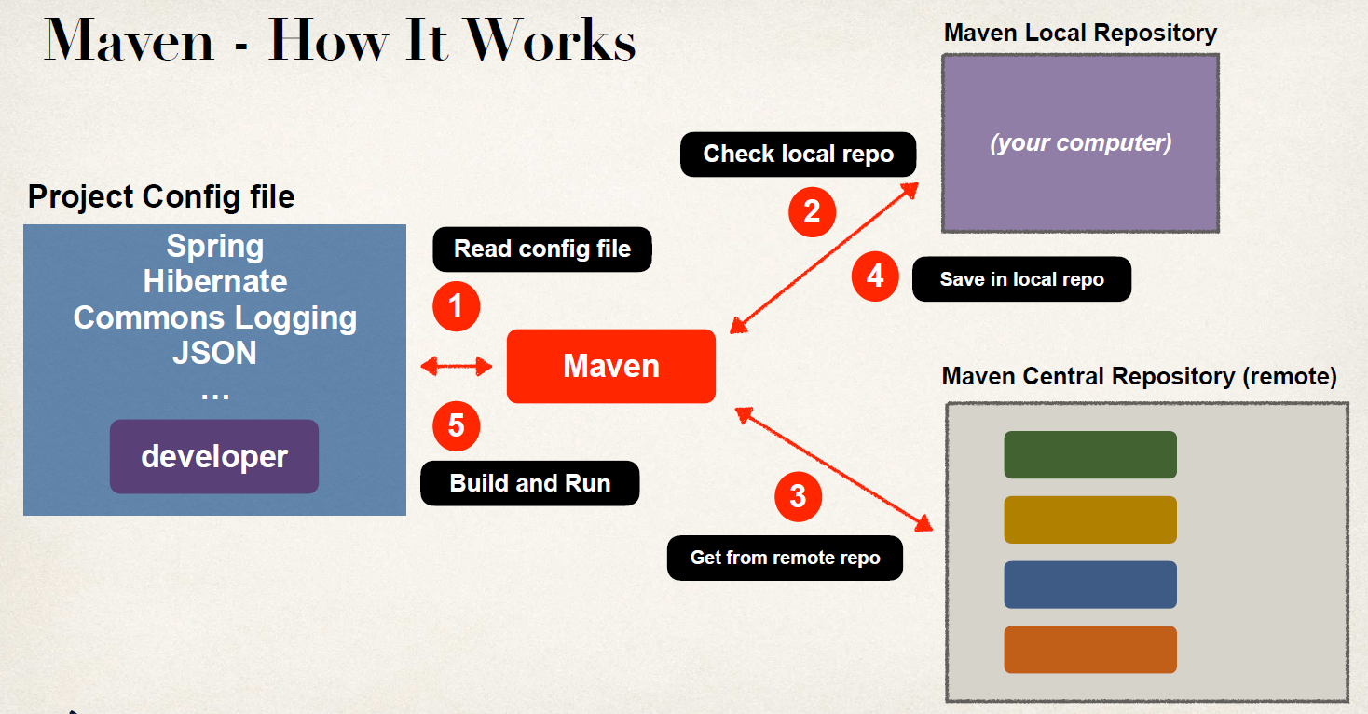

Using Maven, you have a project configuration file that maven will read. So that’s basically your shopping list. Maven will read your config file then maven will check in local repository that resides on your computer. It’s like your local cache. If you don’t have that file in your local repo, then Maven will go out to the internet at maven central repository which is remote and it pulls down the files from the Maven Central Repo on the internet. Then save versions of those files in your local repository, so you can build up your local cache, then Maven will use that to build and run your application.

**Handling JAR Dependencies**

• When Maven retrieves a project dependency

• It will also download supporting dependencies

• For example: Spring depends on commons-logging …

• Maven will handle this for us automagically.

**Building and Running**

• When you build and run your app. You don’t have to manually configure your class path. Simply setup the maven config file and Maven will do all the work.

• Maven will handle class / build path for you.

• Based on config file, Maven will add JAR files accordingly.

**Maven Project Structure**

**Standard Directory Structure**

Normally when you join a new project. Each development team dreams up their own directory structure. Not ideal for new comers and not standardized. Maven solves this problem by providing a standard directory structure.

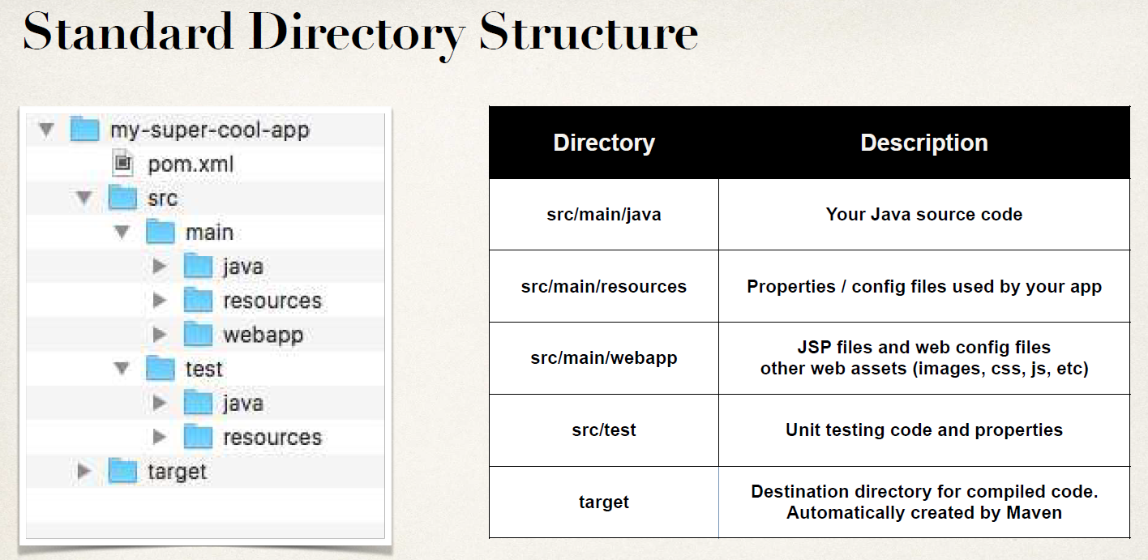

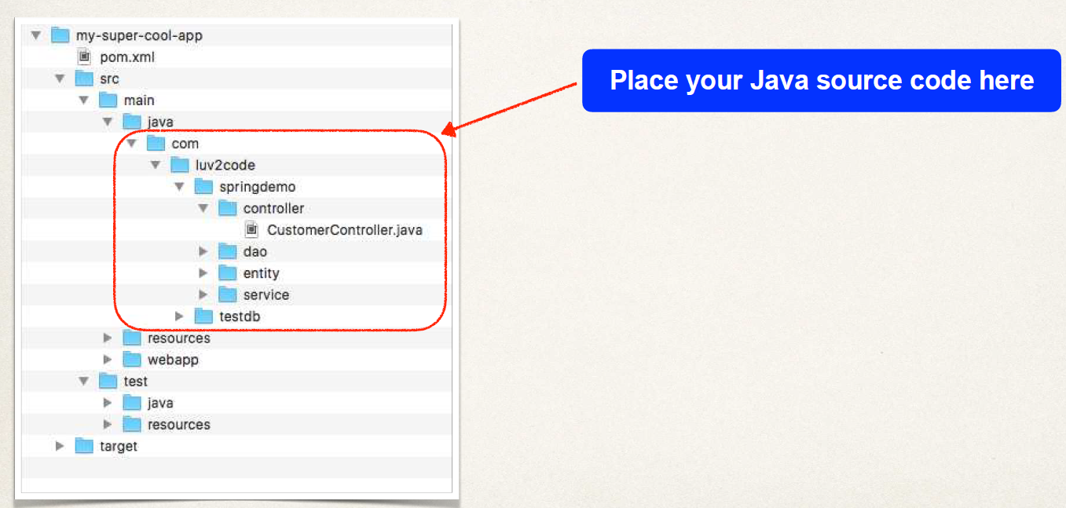

For web App.

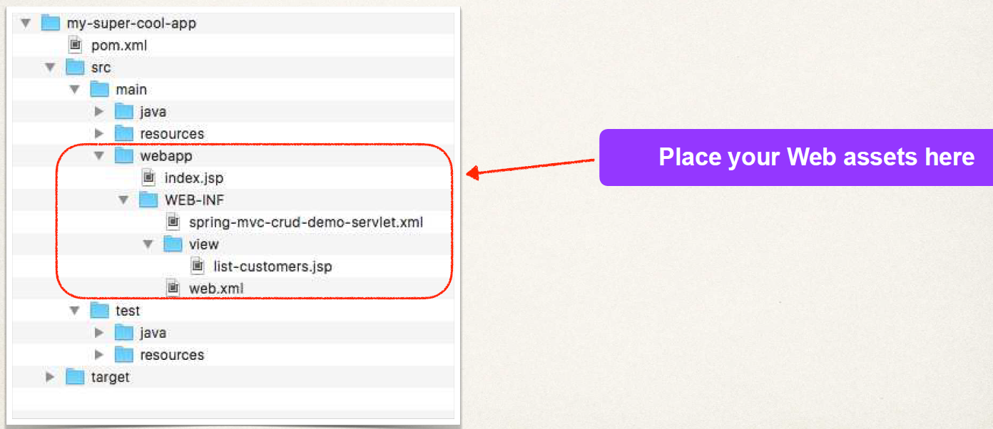

**Benefits of Standard Directory Structure**

• For new developers joining a project. They can easily find code, properties files, unit tests, web files etc.

• Most major IDEs have built-in support for Maven

• Eclipse, IntelliJ, NetBeans etc

• IDEs can easily read/import Maven projects

• Maven projects are portable

• Developers can easily share projects between IDEs

• No need to fight about which IDE is the best LOL!

**Advantages of Maven**

**Dependency Management**

• Maven will find JAR files for you

• No more missing JARs

**Building and Running your Project**

• No more build path / classpath issues

**Standard directory structure**

• Once you learn Maven, you can join a new project and be productive

• You can build and run a project with minimal local configuration

**Maven Key Concepts**

• POM File - pom.xml

• Project Coordinates

**POM File - pom.xml**

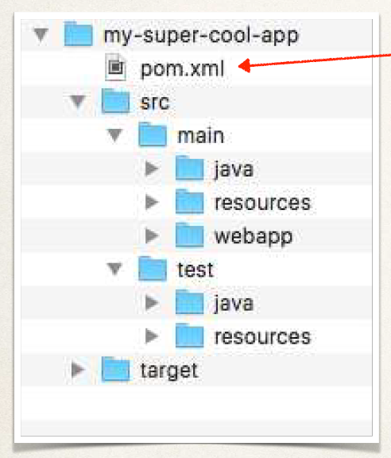

**Project Object Model file: POM** file

• Configuration file for your project. Basically your “shopping list” for Maven :-). Located in the root of your Maven project

**POM File Structure**

**Project meta data**

**Dependencies**

**Plug ins:**

**Project meta data:**

Project name, version etc

Output file type: JAR, WAR, …

**Dependencies:**

List of projects we depend on Spring, Hibernate, etc…

**Plug ins:**

Additional custom tasks to run:

Here we can use it to generate JUnit test reports etc…

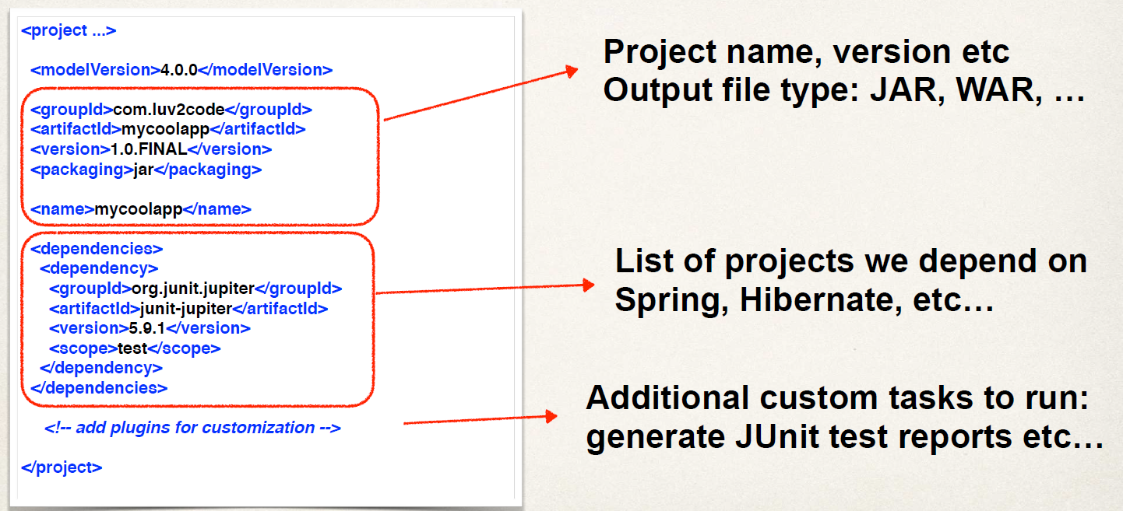

**Project Coordinates:** Project Coordinates uniquely identify a project

• Similar to GPS coordinates for your house: latitude / longitude

• Precise information for finding your house (city, street, house #)

Like precise information of coordinates to find your house, similarly in maven here it is to identify the project.

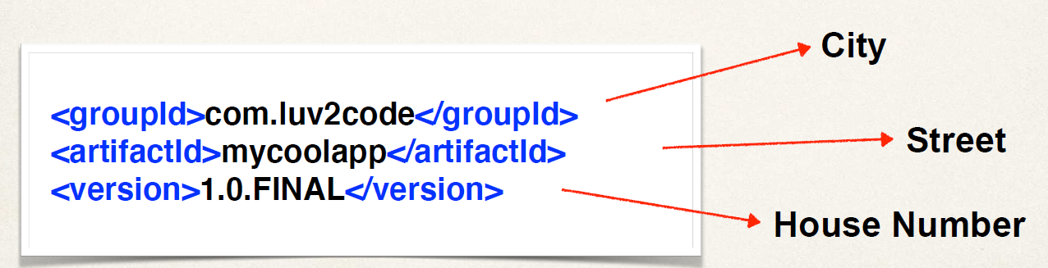

**Project Coordinates – Elements:**

Name : Description

Group ID : Name of company, group, or organization. Convention is to use reverse domain name: com.luv2code

Artifact ID : Name for this project: mycoolapp

Version : A specific release version like: 1.0, 1.6, 2.0 … If project is under active development, then: 1.0 - SNAPSHOT

* SNAPSHOT - means it is still under active development.

**Adding Dependencies:** For Example: Adding dependency for Spring framework and Hibernate in dependency section.

<project ...>

...

<dependencies>

<dependency>

<groupId>org.springframework</groupId>

<artifactId>spring-context</artifactId>

<version>6.0.0</version>

</dependency>

<dependency>

<groupId>org.hibernate.orm</groupId>

<artifactId>hibernate-core</artifactId>

<version>6.1.4.Final</version>

</dependency>

...

</dependencies>

</project>

**Dependency Coordinates:**

To add given dependency project, we need

• **Group ID**, **Artifact ID**

• **Version** is optional …

• Best practice is to include the version (repeatable builds) in DevOps work.

May see this referred to as: **GAV -** Group ID, Artifact ID and Version

**Q. How to Find these Dependency Coordinates:**

• Option 1: Visit the project page (spring.io, hibernate.org etc)

• Option 2: Visit http://search.maven.org (easiest approach)

**Spring Boot Project Structure**

* We know how to use spring initializr to create Maven project. <http://start.spring.io>
* Let’s explore the project structure.

**Maven Standard Directory Structure:**

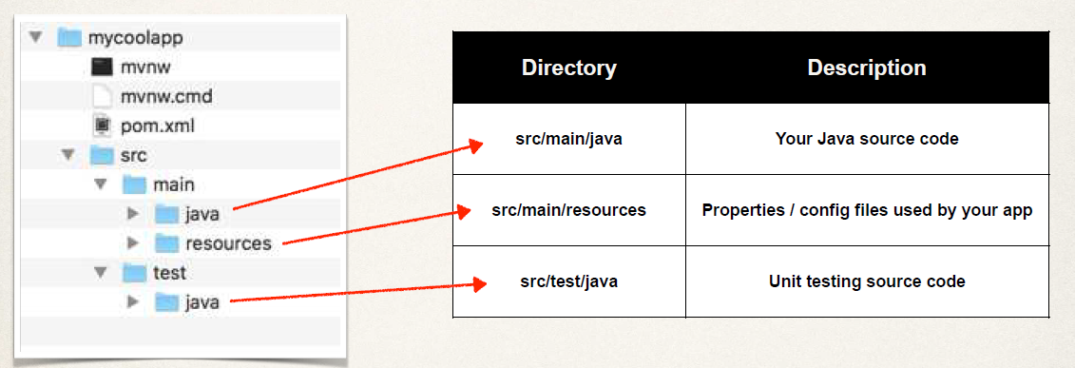

**Maven Wrapper files:**

Maven Wrapper files **(mvnw)** allows you to run a Maven project.

• No need to have Maven installed or present on your path

• If correct version of Maven is NOT found on your computer. Then it will automatically download correct version from the internet and runs Maven.

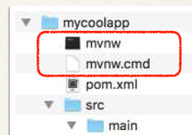

Two files are provided:

• **mvnw.cmd** for MS Windows -> **mvnw clean compile test**

• **mvnw.sh** for Linux/Mac -> **$ ./mvnw clean compile test**

If you already have Maven installed previously. Then you can ignore/delete the **mvnw** files. Just use Maven as you normally would.

So, we don’t use **mvnw** anymore, we only use **mvn** here.

**$ mvn clean compile test**

**Maven POM file:**

**pom.xml** includes info that you entered at Spring Initializr website. Information like: groupID, artifactId, etc. This information automatically generated in pom file.

**<groupId>com.luv2code.springboot.demo</groupId>**

**<****artifactId>mycoolapp</artifactId>**

**<version>0.0.1-SNAPSHOT</version>**

**<packaging>jar</packaging>**

Also, we have collection of **maven dependencies** in the pom file, too. They are called **Spring Boot starters**. A collection of maven dependencies (Compatible versions for these dependencies). Save's the developer from having to list all of the individual dependencies. Also, makes sure you have compatible versions.

For example, here **spring-boot-starter-web** is collection of individual dependencies like, *spring-web; spring-webmvc; spring hibernate-validator; tomcat*, etc.

**<dependencies>**

**<dependency>**

**<groupId>org.springframework.boot</groupId>**

**<artifactId>spring-boot-starter-web</artifactId>**

**</dependency>**

**<dependency>**

**<groupId>org.springframework.boot</groupId>**

**<artifactId>spring-boot-starter-test</artifactId>**

**<scope>test</scope>**

**</dependency>**

**…**

**</dependencies>**

**Spring Boot Maven plugin:**

Spring Boot Maven plugin can be found in bottom of pom.xml file. These plugins are used to package executable jar files, those we can run from the command line or to create a war archive file. We can also use this plugin to easily run the app.

**<build>**

**<plugins>**

**<plugin>**

**<groupId>org.springframework.boot</groupId>**

**<artifactId>spring-boot-maven-plugin</artifactId>**

**</plugin>**

**</plugins>**

**</build>**

Command to run the application using these plugins.

**$ ./mvnw package**

**$ ./mvnw spring-boot:run**

If you already have Maven installed on the system, then no need to use mnvw. Instead use below,

**$ ./mvn package**

**$ ./mvn spring-boot:run**

**Java Source Code:**

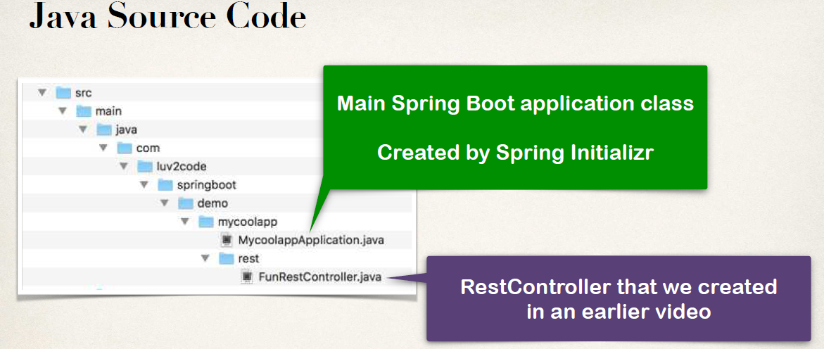

**Application Properties:**

By default, Spring Boot will load properties from specific file: **application.properties.** Spring looks for it in source/ main/ resources directory. It created when we create the spring application using spring initializer.

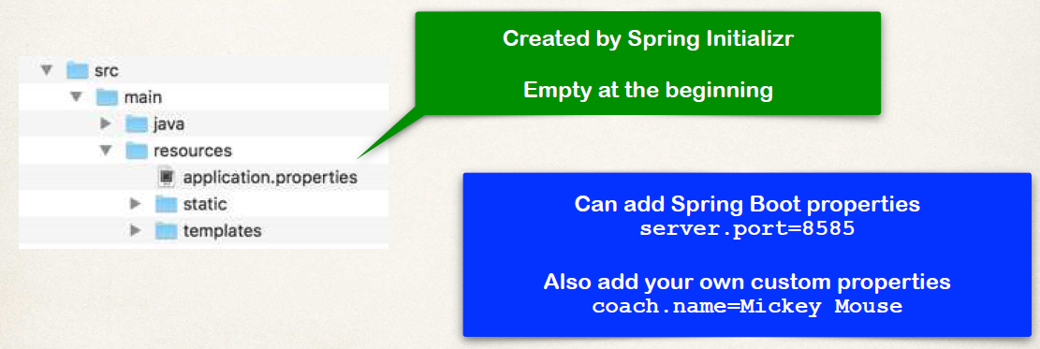

We can give specific instructions or my own custom properties here to maven server and application in this file. Like mentioned below,

**# configure server port**

**server.port=8484**

**# configure my props**

**coach.name=Mickey Mouse**

**team.name=The Mouse Crew**

Then, how we can read the data from the **application.properties** .We can read this or use it in rest controller by making use of injection. By shown below,

**@RestController**

**public class FunRestController {**

**@Value("${coach.name}")**

**private String coachName;**

**@Value("${team.name}")**

**private String teamName;**

**…**

**}**

**Static Content:**

By default, Spring Boot will load static resources from "/static" directory.

Example of static resources like - HTML files, cascading style sheets, JavaScript, images, PDFs, etc.

We can simply place these static files in static directory and spring boot will load it automatically for given application.

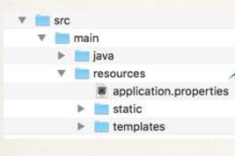



**WARNING**:

* Do not use the src/main/webapp directory if your application is packaged as a JAR.
* Although this is a standard Maven directory, it works only with WAR packaging.
* It is silently ignored by most build tools if you generate a JAR.

**Template:**

Spring Boot includes auto-configuration for following template engines.

* **FreeMarker**
* Thymeleaf (It is a popular template engine)
* Mustache

By default Spring boot will load templates from “/templates” directory.



**Unit Tests:**

It’s just basic test of the code. We can add our own custom unit test files. It’s a part of the spring boot infrastructure.



**Spring Boot Starters**

The problem in getting the minimum dependencies for building a Spring boot application or Hibernate application can be easily handled by Spring boot starter.

* Simple list of Maven dependencies; Collected as a group of dependencies … one-stop shop; So, we don't have to search for each dependency.

Spring Boot Starters provides: -

• A curated list of Maven dependencies

• A collection of dependencies grouped together

• Tested and verified by the Spring Development team

• Makes it much easier for the developer to get started with Spring

• Reduces the amount of Maven configuration

We can add this maven dependencies to our maven pom file. This is an entry of spring boot starter. Through it we can fetch all required related dependencies.

For example, Spring Boot provides: spring-boot-starter-web CONTAINS spring-web, spring-webmvc, hibernate-validator, json, tomcat …etc. It save's the developer from having to list all of the individual dependencies. Also, makes sure you have compatible versions.

* Spring Boot Starters: A collection of Maven dependencies (Compatible versions)

In Spring Initializr, simply select Web dependency. You automatically get spring-boot-starter-web in pom.xml.





If we are building a Spring app that needs: Web, Security,... Simply select the dependencies in the Spring Initializr. It will add the appropriate Spring Boot starters to your pom.xml

** **

There are 30+ Spring Boot Starters from the Spring Development team. For example,

**Name Description**

*spring-boot-starter-web* -Building web apps, includes validation, REST. Uses Tomcat as default embedded server.

*spring-boot-starter-security* -Adding Spring Security support

*spring-boot-starter-data-jpa* -Spring database support with JPA and Hibernate

etc…

We can find full list of Spring Boot Starters through bellow link.

[www.luv2code.com/spring-boot-starters](http://www.luv2code.com/spring-boot-starters)

Most IDEs have a Dependency Management / View feature. It’s much easier to navigate.

For Eclipse:

• Open the pom.xml

• Select the tab Dependency Hierarchy

• Expand the desired starter



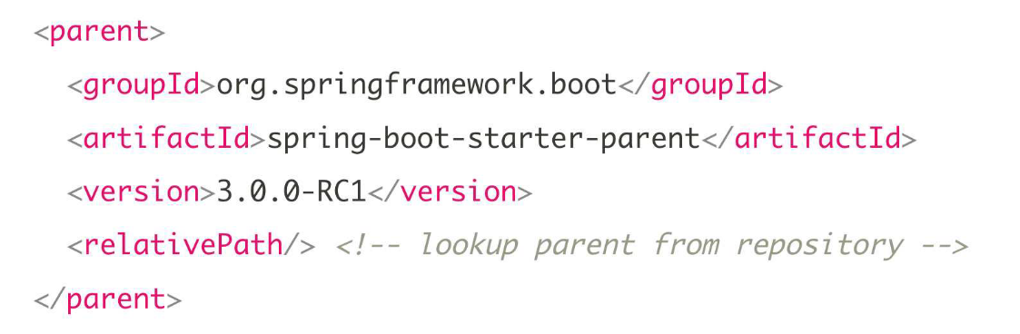

For IntelliJ users

• Select View > Tool Windows > Maven Projects > Dependencies



**Spring Boot Starter Parent**

Spring Boot provides a "Starter Parent". This is *a special starter that provides Maven defaults*. This is included in the pom.xml file automatically. Maven defaults defined in the Starter Parent

• Default compiler level

• UTF-8 source encoding

• Others …



Suppose if we want to use a different java version then we can do that changing in the property by specifying the required property. To override a default, set as a property below



* For the spring-boot-starter-* dependencies, no need to mention list individual versions. Just specify the starter version, individual dependencies will inherit version from Starter Parent. It is great for compatibility and maintenance!





* Also, the starter parent provides the default configuration of Spring boot plugins. In <build>…</build> section of your pom.xml file, we simply reference the spring boot maven plugin and it is there ready to go. No need for additional configurations to configure the Spring boot plugins. And we can simply run them from command line. **> mvn spring-boot:run**

**Benefits of the Spring Boot Starter Parent:-**

• Default Maven configuration: Java version, UTF-encoding etc

• Dependency management

• Use version on parent only

• **spring-boot-starter-\*** dependencies inherit version from parent

• Default configuration of Spring Boot plugin

**Spring Boot Dev Tools**

The Problem: When running Spring Boot applications. If you make changes to your source code. Then you have to manually restart your application.

**spring-boot-devtools** to the rescue! It automatically restarts your application when code is updated. We simply add the dependency to your POM file. No need to write additional code :-)

• For IntelliJ, need to set additional configurations.

To user spring-boot-dev tools , we simply need to add this dependency to your POM file.

We give ***groupId, artifactId ‘*spring-boot-devtools*’*** and then it can automatically restarts you application when code is updated.

**<dependency>**

**<groupId>org.springframework.boot</groupId>**

**<artifactId>spring-boot-devtools</artifactId>**

**</dependency>**

**N.B:** IntelliJ Community Edition does not support DevTools by default. We need to do some additional configuration to use it.

• Select: Preferences > Build, Execution, Deployment > Compiler

• Check box: Build project automatically



One more additional setting

• Select: Preferences > Advanced Settings

• Check box: Allow auto-make to ...



On windows: -

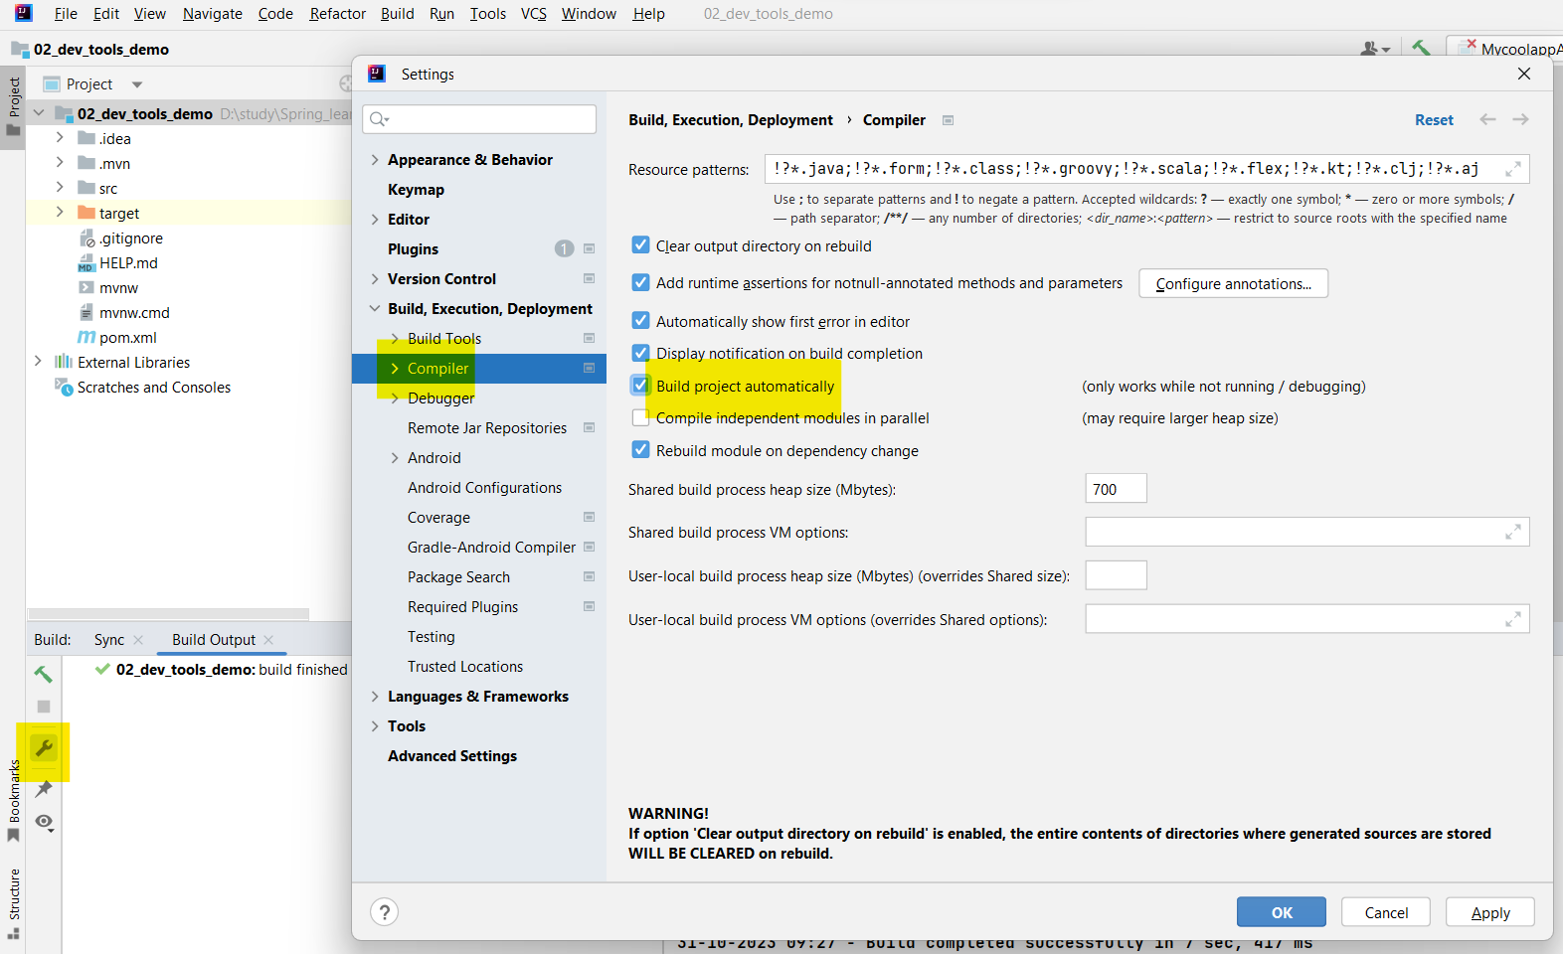

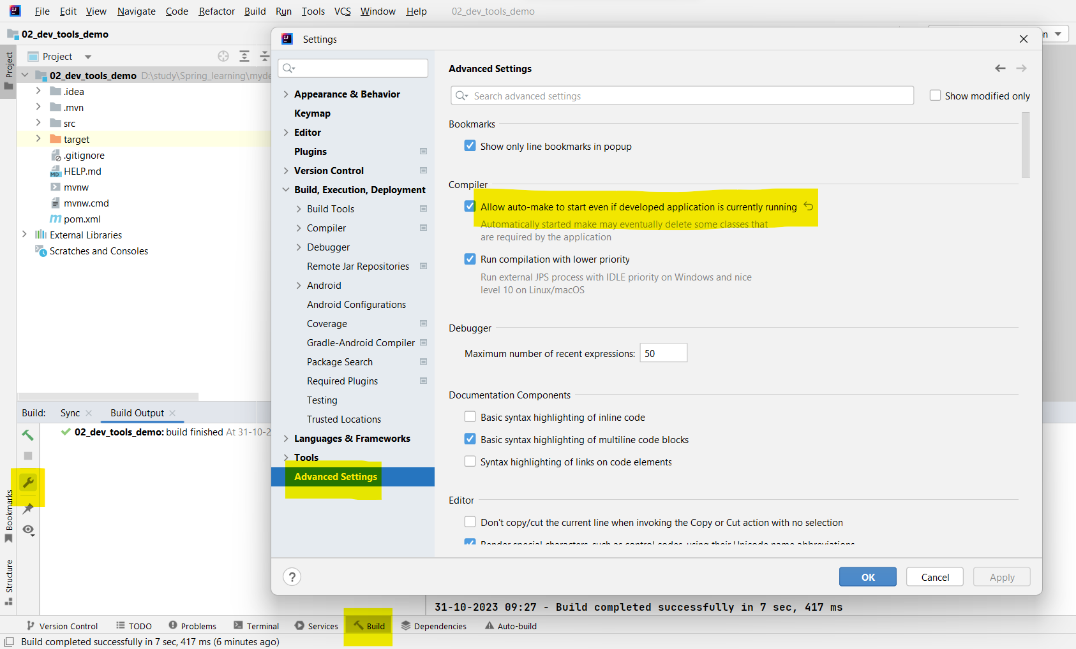

**Development Process (Step-By-Step)**

1. Apply IntelliJ configurations

2. Edit *pom.xml* and add *spring-boot-devtools*

3. Add new REST endpoint to our app

4. Verify the app is automatically reloaded

**Spring Boot Actuator**

The Problem: How can I monitor and manage my application? ; How can I check the application health? ; How can I access application metrics?

**Spring Boot Actuator**: It exposes end point to monitor and manage your application.

• We easily get DevOps functionality out-of-box

• Simply add the dependency to your POM file. Then, REST endpoints are *automatically* added to your application – No need to write additional code!. You get new REST endpoints for Free!.

**<dependency>**

**<groupId>org.springframework.boot</groupId>**

**<artifactId>spring-boot-starter-actuator</artifactId>**

**</dependency>**

• Spring Boot Actuator - automatically exposes endpoints for metrics out-of-the-box.

• Endpoints are prefixed with: /actuator

**/actuator/health** - Health information about your application

We can get these endpoints for free. No additional code is required in our rest controller

**Health Endpoint**

• **/health** checks the status of your application.

• Normally used by monitoring apps to see if your app is up or down.

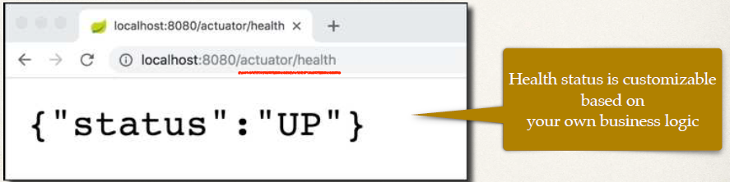

**Info Endpoint**

• By default, only **/health** is exposed

• The **/info** endpoint can provide information about your application. We can customize it.

• To expose endpoint **/info**, to we need to do some update in our *application.properties* file.

File: src/main/resources/application.properties

**management.endpoints.web.exposure.include=health,info**

**management.info.env.enabled=true**

• **/actuator/info** gives information about your application but, by default it is empty {}. We have to customize this /info endpoint.

• To customize, we need to update the *application.properties* with our given application information.

• We can add some properties for info like mentioned below. Properties name starting with “info” will be used by /info endpoint.

File: src/main/resources/application.properties

**info.app.name=My Super Cool App**

**info.app.description=A crazy and fun app, yoohoo!**

**info.app.version=1.0.0**

• Anything following with **info.**xxxxxx – we can get the JSON object for that through **/info** endpoint given by us in properties file. We can customize it and add as much details as we need for our application.

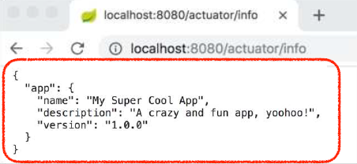

• There are other 10+ Spring Boot Actuator endpoints.

| **ID** | **Description** |
| --- | --- |
| **/auditevents** | Exposes audit events information for the current application. Requires an AuditEventRepository bean. |
| **/beans** | Displays a complete list of all the Spring beans in your application. OR List of all beans registered in the Spring application context |
| **/caches** | Exposes available caches. |
| **/conditions** | Shows the conditions that were evaluated on configuration and auto-configuration classes and the reasons why they did or did not match. |
| **/configprops** | Displays a collated list of all @ConfigurationProperties. |
| **/env** | Exposes properties from Spring’s ConfigurableEnvironment. |
| **/flyway** | Shows any Flyway database migrations that have been applied. Requires one or more Flyway beans. |
| **/health** | Shows application health information. |
| **/httpexchanges** | Displays HTTP exchange information (by default, the last 100 HTTP request-response exchanges). Requires an HttpExchangeRepository bean. |
| **/info** | Displays arbitrary application info. |
| **/integrationgraph** | Shows the Spring Integration graph. Requires a dependency on spring-integration-core. |
| **/loggers** | Shows and modifies the configuration of loggers in the application. |
| **/liquibase** | Shows any Liquibase database migrations that have been applied. Requires one or more Liquibase beans. |
| **/metrics** | Shows “metrics” information for the current application. |
| **/mappings** | Displays a collated list of all @RequestMapping paths. |
| **/quartz** | Shows information about Quartz Scheduler jobs. |
| **/scheduledtasks** | Displays the scheduled tasks in your application. |
| **/sessions** | Allows retrieval and deletion of user sessions from a Spring Session-backed session store. Requires a servlet-based web application that uses Spring Session. |
| **/shutdown** | Lets the application be gracefully shutdown. Only works when using jar packaging. Disabled by default. |
| **/startup** | Shows the [startup steps data](https://docs.spring.io/spring-boot/docs/current/reference/htmlsingle/#features.spring-application.startup-tracking) collected by the ApplicationStartup. Requires the SpringApplication to be configured with a BufferingApplicationStartup. |
| **/threaddump** | Performs a thread dump. |

• By default, all endpoints except for shutdown are enabled. To configure the enablement of an endpoint, use bellow

management.endpoint.shutdown.enabled=**true**

• If your application is a web application (Spring MVC, Spring WebFlux, or Jersey), you can use the following additional endpoints:

| **ID** | **Description** |
| --- | --- |
| **/heapdump** | Returns a heap dump file. On a HotSpot JVM, an HPROF-format file is returned. On an OpenJ9 JVM, a PHD-format file is returned. |
| **/logfile** | Returns the contents of the logfile (if the logging.file.name or the logging.file.path property has been set). Supports the use of the HTTP Range header to retrieve part of the log file’s content. |
| **/prometheus** | Exposes metrics in a format that can be scraped by a Prometheus server. Requires a dependency on micrometer-registry-prometheus. |

**Exposing Endpoints:**

• By default, only /health is exposed.

• To expose individual endpoints we can mention those comma ‘,’

File: src/main/resources/application.properties

**management.endpoints.web.exposure.include=health,info**

• To expose all actuator endpoints over HTTP, update application.properties file with below,

File: src/main/resources/application.properties

**# Use wildcard "*" to expose all endpoints**

**# Can also expose individual endpoints with a comma-delimited list # management.endpoints.web.exposure.include=\***

• Get a List of Beans, Access by <http://localhost:8080/actuator/beans> . But what about the security, we can show all the beans to everyone with out proper authorization or credentials.

**Spring Security**:

The Problem: About Security - We may NOT want to expose all of this information to anyone on the web. We can avoid this by adding **Spring Security** to project and endpoints are secured 😊.

**<dependency>**

**<groupId>org.springframework.boot</groupId>**

**<artifactId>spring-boot-starter-security</artifactId>**

**</dependency>**

• /health is still available. We can disable it if you want.

• Suppose by use of Spring Security, when we use of actuator endpoint **/actuator/beans** to access beans, it will prompt for login.

Default user name: **user**

For Password: - Check console logs for password

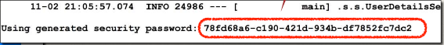

• We can overwrite this default user credentials by adding properties in *application.properties* file. So, spring will use this given credential when obtaining data through actuator endpoints.

File: src/main/resources/application.properties

**spring.security.user.name=scott**

**spring.security.user.password=tiger**

• We can **Customizing Spring Security** for Spring Boot Actuator for use a database role, encrypted password etc,.

• We can exclude actuator endpoints,

File: src/main/resources/application.properties

**# Exclude individual endpoints with a comma-delimited list # management.endpoints.web.exposure.exclude=health**

• For more details on Actuator follow below URL,

<https://docs.spring.io/spring-boot/docs/current/reference/htmlsingle/#actuator>

• **Development Process**

1. Edit pom.xml and add spring-boot-starter-security

2. Verify security on actuator endpoints for: /beans etc

3. Disable endpoints for /health and /info

**Running from the Command-Line**

- During development we spend most of our time in the IDE. However, we may want to run our Spring Boot app outside of the IDE. One approach is running from the command-line.

- When running from the command-line, no need to have IDE open/running.

- Since we using Spring Boot, the server is embedded in our JAR file, no need to have separate server installed/running.

- Spring Boot apps are self-contained. No need of IDE or separate server. Nothing else to install.

Two options for running the app

• Option 1: Use > **java -jar mycoolapp.jar**

• **Option 2:** Use Spring Boot Maven plugin

> **mvnw spring-boot:run**

• **Option 1:** If we have already installed Maven then we can run app through **mvnw package.**

* Go to the spring application directory and run cmd.
* Enter command > **mvnw package**
* On BUILD SUCCESS, the JAR file will be created. JAR file is inside TARGET sub directory > **cd target/**
* Run app using command > **java -jar mycoolapp-0.0.1-SNAPSHOT.jar**
* Stop spring application by **CTRL+C** from cmd.

• **Option 2: Use Spring Boot Maven plugin**

- Go to the spring application directory and run cmd.

- Run command> **mvnw spring-boot:run**

• **mvnw** allows you to run a Maven project

• No need to have Maven installed or present on your path

• If correct version of Maven is NOT found on your computer

• **Automatically downloads** correct version and runs Maven

• Two files are provided

• **mvnw.cmd** for MS Windows

• **mvnw.sh** for Linux/Mac

**Spring Boot - Custom Application Properties**

The problem: You need for your app to be configurable … no hard-coding of values. We need to read app configuration from a properties file

• By default, Spring Boot reads information from a standard properties file

• Located at: **src/main/resources/application.properties**

• We can define ANY custom properties in this file

• Our Spring Boot app can access properties using **@Value** annotation.

**Development Process** (Step-By-Step)

1. Define custom properties in application.properties

2. Inject properties into Spring Boot application using @Value

**Step 1: Define custom application properties**

We can give any custom property names.

File: src/main/resources/application.properties

**# Define custom properties**

**coach.name=Mickey Mouse**

**team.name=The Mouse Club**

**Step 2: Inject Properties into Spring Boot app**

@RestController

public class FunRestController {

// inject properties for: coach.name and team.name

@Value("${coach.name}")

private String coachName;

@Value("${team.name}")

private String teamName;

…

}

**Spring Boot Properties**

• Spring Boot can be configured in the **application.properties** file

• Server port, context path, actuator, security etc …

• Spring Boot has 1,000+ properties … wowzers

• Use bellow URL to get List of Common Properties,

<https://docs.spring.io/spring-boot/docs/current/reference/html/application-properties.html#appendix.application-properties>

• The properties are logically grouped into the following categories,

1. Core

1. Web
2. Security
3. Data
4. Actuator
5. Integration
6. DevTools
7. Testing

**Core Properties**

For example: We can setup different logging levels (TRACE, DEBUG, INFO, WARN, ERROR, FATAL, OFF) and setup different severity mappings for those given packages or projects.

**File: src/main/resources/application.properties**

**# Log levels severity mapping**

**logging.level.org.springframework=DEBUG**

**logging.level.org.hibernate=TRACE**

**logging.level.com.luv2code=INFO**

**N.B:** Set logging levels based on package names.

• We can setup different logfile for storing log output from console.

**# Log file name**

**logging.file.name=my-crazy-stuff.log**

**logging.file.path=c:/myapps/demo**

• Use URL below to check the documentation on Spring boot logging configuration,

<https://docs.spring.io/spring-boot/docs/current/reference/html/features.html#features.logging>

**Web Properties**

For example: we can change default Port, change Context path of application.

So, we can access for spring boot application on web browser by <http://localhost:7070/my-silly-app/fortune>

We can also change default HTTP Session time out.

File: src/main/resources/application.properties

**# HTTP server port**

**server.port=7070**

**# Context path of the application**

**server.servlet.context-path=/my-silly-app**

**N.B:** All requests should be prefixed with **/ my-silly-app**

**# Default HTTP session time out**

**server.servlet.session.timeout=15m**

**Actuator Properties**

File: src/main/resources/application.properties

**Endpoints to include by name or wildcard management.endpoints.web.exposure.include=\***

**# Endpoints to exclude by name or wildcard management.endpoints.web.exposure.exclude=beans,mapping**

**# Base path for actuator endpoints**

**management.endpoints.web.base-path=/actuator**

**Security Properties**

File: src/main/resources/application.properties

**# Default user name**

**spring.security.user.name=admin**

**# Password for default user**

**spring.security.user.password=topsecret**

**Data Properties**

File: src/main/resources/application.properties

**# JDBC URL of the database**

**spring.datasource.url=jdbc:mysql://localhost:3306/ecommerce**

**# Login username of the database**

**spring.datasource.username=scott**

**# Login password of the database**

**spring.datasource.password=tiger**

• **Development Process** (Step-By-Step)

1. Configure the server port

2. Configure the application context path

**Spring Core**

**Inversion of Control (IOC):**

• The approach of outsourcing the construction and management of objects.

Coding Scenario

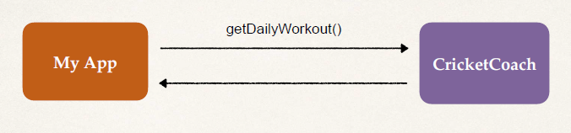

• App should be configurable

• Easily change the coach for another sport

• Baseball, Hockey, Tennis, Gymnastics etc …

Ideal Solution: - We have our application; we can ask our object factory “Hei... give me a coach object”. So this object factory based on its configuration can create a coach and give its reference to us.

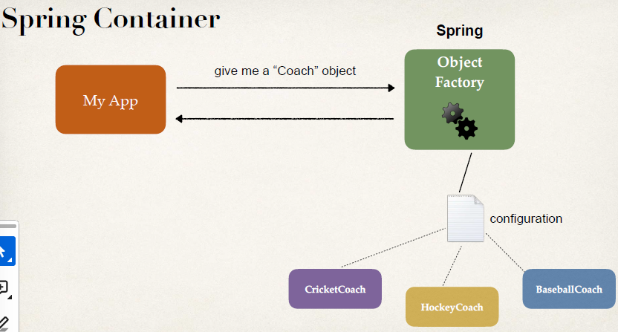

**Spring container** is the object factory here. In Background spring will determine which coach object you need based on the configuration, and give us reference to that object.

**Primary functions Spring container: -**

• Create and manage objects (**Inversion of Control**)

• Inject object dependencies (**Dependency Injection**)

**Configuring Spring Container: -**

• XML configuration file (legacy) – old wa

• Java Annotations (modern)

• Java Source Code (modern)

**Spring Dependency Injection: -**

The dependency inversion principle: The client delegates to another object the responsibility of providing its

dependencies.

For example: A car factory, you want to purchase a car, so I communicate with the car factory to give me a car. The car factory goes out and grab the given car and make it available to you. In background the factory has to assemble the car its various parts like engine, door, windshield all different components.

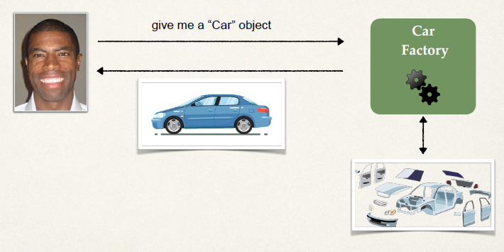

• Whole idea of dependency injection is to give me a given object, if it has any components or helper component then assemble all these ahead of time then give it to me, so I can use it out of the box.

• Dependency injection - Injecting the dependencies or helper components for a given object.

Spring container is the object factory. Here in our example, it is helping us to give us a coach object, this coach object may have additional dependencies or additional helpers. Suppose the Head coach and it has system of coaches like physical trainers, medical staffs. Spring container will put all together and give it to us.

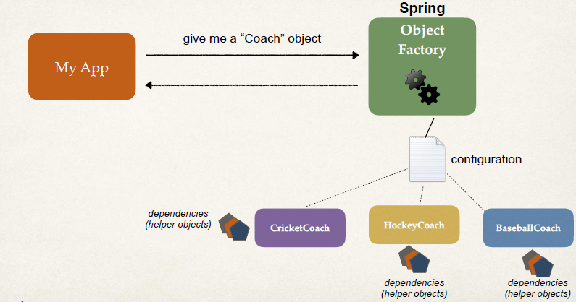

Demo Example

• **Coach** will provide daily workouts

• The DemoController wants to use a Coach

• New helper: **Coach**

• This is a **dependency**

• Need to *inject* this *dependency*

**Injection Types**

• There are multiple types of injection with Spring

• We will cover the two recommended types of injection

• Constructor Injection

• Setter Injection

**Constructor Injection**

**Q. Which one to use?**

**Ans.**

• Constructor Injection

• Use this when you have required dependencies

• Generally recommended by the spring.io development team as first choice

• Setter Injection

• Use this when you have optional dependencies

• If dependency is not provided, your app can provide reasonable default logic

**Q. What is Spring AutoWiring?**

**Ans.**

For dependency injection, Spring can use **autowiring**

• Spring will look for a class that matches

• ***matches by type***: class or interface

• Spring will inject it automatically … hence it is autowired

**Autowiring Example**

• Injecting a Coach implementation

• Spring will scan for **@Components** or any class that annotated with annotation @Components.

• And search among them check if any one implements the Coach interface???

• If found so, let’s inject them. For example: CricketCoach - It has implemented with the couch interface, then inject cricket coach as dependency. This an example of dependency injection through autowiring.

Example Application:

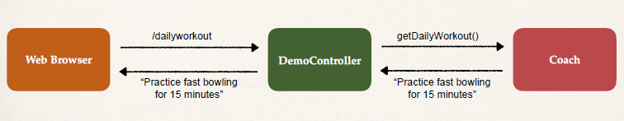

**Development Process - Constructor Injection** (Step-By-Step)

1. Define the dependency interface and class

2. Create Demo REST Controller

3. Create a constructor in your class for injections then, dependency injection with **@Autowired** annotation

4. Add **@GetMapping** for /dailyworkout endpoint

**Step 1: Define the dependency interface and class**

• First define the interface.

File: Coach.java

**package com.luv2code.springcoredemo;**

**public interface Coach {**

**String getDailyWorkout();**

**}**

• Implement the interface – CricketCoach implement Coach interface.

File: CricketCoach.java

**package com.luv2code.springcoredemo;**

**import org.springframework.stereotype.Component;**

**@Component**

**public class CricketCoach implements Coach {**

**@Override**

**public String getDailyWorkout() {**

**return "Practice fast bowling for 15 minutes";**

**}**

**}**

**N.B:** @Component annotation marks the class as a Spring Bean as a candidate for dependency injection.

**@Component annotation: -**

• @Component marks the class as a Spring Bean.

• A Spring Bean is just a regular Java class that is managed by Spring.

• @Component also makes the bean available for dependency injection.

**Step 2: Create Demo REST Controller**

• Create a basic REST controller.

File: DemoController.java

**package com.luv2code.springcoredemo;**

**import org.springframework.web.bind.annotation.RestController;**

**@RestController**

**public class DemoController {**

**}**

**Step 3: Create a constructor in your class for injections**

• Create constructor method ‘DemoController’ in controller class.

• and Use @Autowired annotation on it. @Autowired annotation tells Spring to inject a dependency.

• Spring object factory will handle injecting this dependency based on the configuration.

File: DemoController.java

**package com.luv2code.springcoredemo;**

**import org.springframework.beans.factory.annotation.Autowired;**

**import org.springframework.web.bind.annotation.RestController;**

**@RestController**

**public class** **DemoController {**

**private Coach myCoach;**

**@Autowired**

**public DemoController(Coach theCoach) {**

**myCoach = theCoach;**

**}**

**}**

**N.B:** If you only have one constructor then @Autowired on constructor is optional.

We only have one Coach implementation CricketCoach. We can also do multiple Coach implementations.

**Step 4: Add @GetMapping for /dailyworkout**

• Add **@GetMapping** annotation with method getDailyWorkout() to expose endpoint "/dailyworkout” with a return String value.

File: DemoController.java

**package com.luv2code.springcoredemo;**

**import org.springframework.beans.factory.annotation.Autowired;**

**import org.springframework.web.bind.annotation.RestController;**

**@RestController**

**public class DemoController {**

**private Coach myCoach;**

**@Autowired**

**public DemoController(Coach theCoach) {**

**myCoach = theCoach;**

**}**

**@GetMapping****("/dailyworkout")**

**public String getDailyWorkout() {**

**return myCoach.****getDailyWorkout();**

**}**

**}**

• Then run the main class and check the result on web browser <http://localhost:8080/dailyworkout>

• **Constructor Injection Behind the Scenes:** Spring Processes your application in behind with bellow calls,

***Coach theCoach = new CricketCoach();***

***DemoController demoController = new DemoController(theCoach);*** *//Constructor injection*

**Component Scanning**

Scanning for Component Classes

• Spring will scan your Java classes for special annotations

• **@Component**, etc …

• Automatically register the beans in the Spring container

**import org.springframework.boot.autoconfigure.SpringBootApplication;**

Spring application main class created with spring initializer has imported above package. It **enables Auto configuration, Component scanning** and **Additional configuration** with spring boot. These composed of annotations **@EnableAutoConfiguration, @ComponentScan and @Configuration**.

• @SpringBootApplication is composed of the following annotations: -

**@EnableAutoConfiguration** -> Enables Spring Boot's auto-configuration support.

**@ComponentScan** -> Enables component scanning of current package. Also recursively scans sub-packages.

**@Configuration** -> Able to register extra beans with **@Bean** or import other configuration classes.

**• Java Source Code:**

Our Spring application main java class created with spring initializer.

File: SpringcoredemoApplication.java

package com.luv2code.springcoredemo;

**// it helps us to Bootstrap our Spring Boot application  
  
import org.springframework.boot.SpringApplication;**

**import org.springframework.boot.autoconfigure.SpringBootApplication;  
  
@SpringBootApplication  
public class** **SpringcoredemoApplication {**

**// name of our class SpringcoredemoApplication**

**public static void main(String[] args) {  
 SpringApplication.*run*(SpringcoredemoApplication.class, args);  
 }  
}**

**N.B:** Behind the scenes …It creates application context and registers all beans. Also starts the embedded server

Tomcat etc…

• By default, Spring Boot starts component scanning

• From same package as your main Spring Boot application

• Also scans sub-packages recursively

• This implicitly defines a base search package

• Allows you to leverage default component scanning

• No need to explicitly reference the base package name

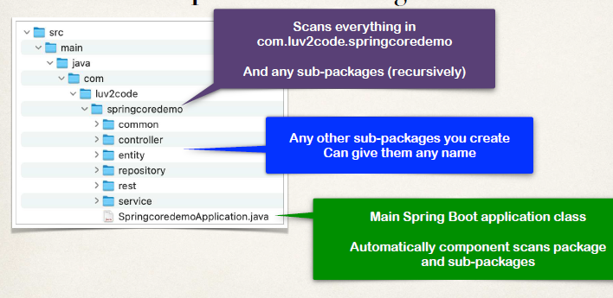

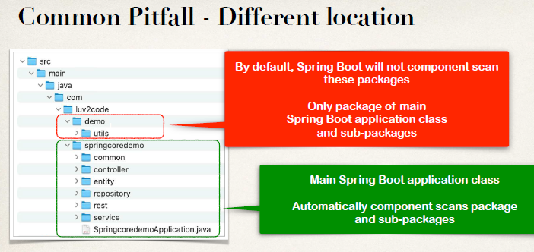

• By default, it will not scan components outside of main class package. We need to explicitly mention these base packages for component scan.

**package com.luv2code.springcoredemo;**

**…**

**@SpringBootApplication(**

**scanBasePackages={"com.luv2code.springcoredemo",**

**"com.luv2code.util",**

**"org.acme.cart",**

**"edu.cmu.srs"})** // Explicitly list base packages to scan

**public class SpringcoredemoApplication {**

**…**

**}**

**Setter Injection**

• Inject dependencies by calling setter method(s) on your class.

Autowiring Example

• Injecting a Coach implementation

• Spring will scan for @Components

• Any one implements the Coach interface???

• If so, let’s inject them. For example: CricketCoach

**Development Process - Setter Injection** (Step-By-Step)

1. Create setter method(s) in your class for injections

2. Configure the dependency injection with **@Autowired** Annotation

**Step1: Create setter method(s) in your class for injections**

• Define setter method in Rest controller.

**Step 2: Configure the dependency injection with Autowired Annotation**

• Add **@Autowired** annotation on this setter method for dependency injection.

File: DemoController.java

**@RestController**

**public class DemoController {**

**private Coach myCoach;**

**@Autowired**

**public void setCoach(Coach theCoach) {**

**myCoach = theCoach;**

**}**

**…**

**}**

• The Spring Framework will perform operations behind the scenes for us: -

***Coach theCoach = new CricketCoach();***

***DemoController demoController = new DemoController();***

***demoController.setCoach(theCoach);***

**N.B:** Inject dependencies by calling ANY method on your class by Simply giving: @Autowired

**@RestController**

**public class DemoController {**

**private Coach myCoach;**

**@Autowired**

**public void doSomeStuff(Coach theCoach) {** // Can use any method name

**myCoach = theCoach;**

**}**

**…**

**}**

**Q. Injection Types - Which one to use?**

**Sol.**

• Constructor Injection

• Use this when you have required dependencies

• Generally recommended by the spring.io development team as first choice

• Setter Injection

• Use this when you have optional dependencies

• If dependency is not provided, your app can provide reasonable default logic

**Field Injection with Annotations and Autowiring**

• Field Injection is not recommended by the spring.io development team. it makes the code harder to unit test. it makes the code harder to unit test.

• spring.io development team recommended

**Constructor Injection** for required dependencies

**Setter Injection** for optional dependencies

• Inject dependencies by setting field values on your class directly (even private fields). Accomplished by using **Java Reflection**.

**Annotation Autowiring and Qualifiers**

**Autowiring**

• Injecting a Coach implementation

• Spring will scan @Components

• Any one implements Coach interface???

• If so, let’s inject them … **oops which one?**

**package com.luv2code.springcoredemo;**

**import org.springframework.beans.factory.annotation.Autowired;**

**…**

**@RestController**

**public class DemoController {**

**@Autowired**

**private Coach myCoach;**

// If through Field injection no setter or constructor injection is needed.

**@GetMapping("/dailyworkout")**

**public String getDailyWorkout() {**

**return myCoach.getDailyWorkout();**

**}**

**}**

• **Multiple Coach Implementations:**

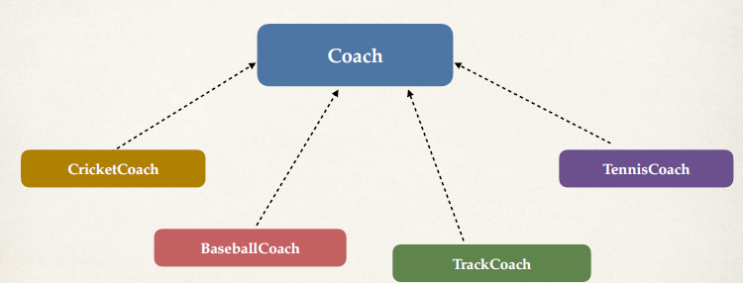

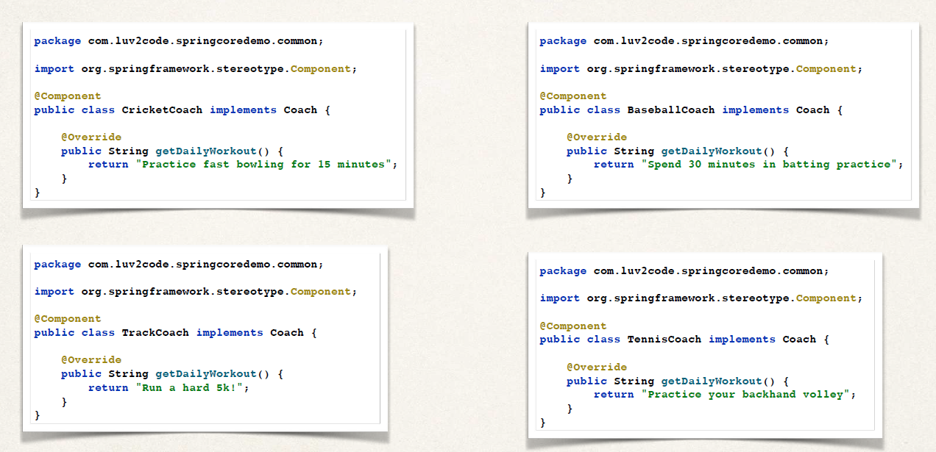

• Complier Error:

Parameter 0 of constructor in com.luv2code.springcoredemo.rest.DemoController required a single bean, but 4 were found:

- baseballCoach

- cricketCoach

- tennisCoach

- trackCoach

• **Solution: Be specific! -** **@Qualifier**: -

Specify the bean id: *cricketCoach*. Same name as class, first character lower-case. Other bean ids we could use: baseballCoach, trackCoach, tennisCoach

**Constructor Injection - @Qualifier**

**package com.luv2code.springcoredemo.rest;**

**import com.luv2code.springcoredemo.common.Coach;**

**import org.springframework.beans.factory.annotation.Autowired;**

**import org.springframework.beans.factory.annotation.Qualifier;**

**…**

**@RestController**

**public class DemoController {**

**private Coach myCoach;**

**@Autowired**

**public DemoController(@Qualifier("cricketCoach") Coach theCoach) {**

**myCoach = theCoach;**

**}**

// Specify the bean id: ***cricketCoach***. Same name as class, first character lower-case.

**@GetMapping("/dailyworkout")**

**public String getDailyWorkout() {**

**return myCoach.getDailyWorkout();**

**}**

**}**

**Setter Injection - @Qualifier**

**package com.luv2code.springcoredemo.rest;**

**import com.luv2code.springcoredemo.common.Coach;**

**import org.springframework.beans.factory.annotation.Autowired; import org.springframework.beans.factory.annotation.Qualifier;**

**…**

**@RestController**

**public class DemoController {**

**private Coach myCoach;**

**@Autowired**

**public void setCoach(@Qualifier("cricketCoach") Coach theCoach) {**

**myCoach = theCoach;**

**}**

// Give bean id: ***cricketCoach***. Same name as class, first character lower-case.

**@GetMapping("/dailyworkout")**

**public String getDailyWorkout() {**

**return myCoach.getDailyWorkout();**

**}**

**}**

• **Alternate solution: -**

• Instead of specifying a coach by name using **@Qualifier**, we can use the **@Primary** so it will take it as primary or by default for dependency injection.

• I simply need a coach … I don’t care which coach. If there are multiple coaches. Then you coaches figure it out … and tell me who’s the primary coach.

**package com.luv2code.springcoredemo.common;**

**import org.springframework.context.annotation.Primary;**

**import org.springframework.stereotype.Component;**

**@Component**

**@Primary**

**public class TrackCoach implements Coach {**

**@Override**

**public String getDailyWorkout() {**

**return "Run a hard 5k!";**

**}**

**}**

• Resolved with **@Primary**: -

**package com.luv2code.springcoredemo.rest;**

**import com.luv2code.springcoredemo.common.Coach;**

**import org.springframework.beans.factory.annotation.Autowired;**

**…**

**@RestController**

**public class DemoController {**

**private Coach myCoach;**

// No need for @Qualifier. There is a **@Primary** coach. This example will use TrackCoach

**@Autowired**

**public DemoController(Coach theCoach) {**

**myCoach = theCoach;**

**}**

**@GetMapping("/dailyworkout")**

**public String getDailyWorkout() {**

**return myCoach.getDailyWorkout();**

**}**

**}**

**@Primary - Only one**

• When using @Primary, can have only one for multiple implementations

• If you mark multiple classes with @Primary … umm, we have a problem

Unsatisfied dependency expressed through constructor parameter 0:

No qualifying bean of type 'com.luv2code.springcoredemo.common.Coach' available:

**more than one 'primary' bean found among candidates:**

[baseballCoach, cricketCoach, tennisCoach, trackCoach]

**…**

Mixing **@Primary** and **@Qualifier**

• If you mix @Primary and @Qualifier

• @Qualifier has higher priority

**Which one: @Primary or @Qualifier?**

• @Primary leaves it up to the implementation classes

• Could have the issue of multiple @Primary classes leading to an error

• @Qualifier allows to you be very specific on which bean you want

• In general, I recommend using @Qualifier

• More specific

• Higher priority

**Lazy Initialization**

**Initialization:**

• By default, when your application starts, all beans are initialized - @Component, etc …

• Spring will create an instance of each and make them available.

**Lazy Initialization:**

Instead of creating all beans up front, we can specify lazy initialization

• A bean will only be initialized in the following cases:

• It is needed for dependency injection

• Or it is explicitly requested

• Add the  annotation to a given class

**// Bean is only initialized**

**if needed for dependency injection**

**import org.springframework.context.annotation.Lazy;**

**import org.springframework.stereotype.Component;**

**@Component**

**@Lazy**

**public class TrackCoach implements Coach {**

**public TrackCoach() {**

**System.*out*.println("In constructor: " + getClass().getSimpleName());**

**}**

**…**

**}**

**//Inject cricketCoach**

**@RestController**

**public class DemoController {**

**private Coach myCoach;**

**@Autowired**

**public DemoController(@Qualifier("cricketCoach") Coach theCoach) {**

**myCoach = theCoach;**

**}**

**…**

**}**

**//Output - Since we are NOT injecting TrackCoach … it is not initialized**

…

In constructor: BaseballCoach

In constructor: CricketCoach

In constructor: TennisCoach

…

**Lazy Initialization - Global configuration:**

To configure other beans for lazy initialization

• We would need to add **@Lazy** to each class

• Turns into tedious work for a large number of classes

• I wish we could set a global configuration property …

• We can do it by specifying the spring lazy initialization property as true. So, all beans are lazy, no beans are created until they are needed.

File: application.properties

**spring.main.lazy-initialization=true**

**…**

// All beans are lazy … no beans are created until needed. Including our DemoController.

// Once we access REST endpoint /dailywork > Spring will determine dependencies for DemoController …

// For dependency resolution Spring creates instance of CricketCoach first …Then creates instance of DemoController and injects the CricketCoach

**Bean Scopes**

• Scope refers to the lifecycle of a bean

• How long does the bean live?

• How many instances are created?

• How is the bean shared?

• Default scope is **singleton**.

Refresher: **What Is a Singleton?**

• Spring Container creates only one instance of the bean, by default

• It is cached in memory

• All dependency injections for the bean

• will reference the SAME bean

For Example: -

@RestController

public class DemoController {

private Coach myCoach;

private Coach anotherCoach;

@Autowired

public DemoController(

@Qualifier("cricketCoach") Coach theCoach,

@Qualifier("cricketCoach") Coach theAnotherCoach ) { **// Both point to the same instance**

myCoach = theCoach;

anotherCoach = theAnotherCoach;

}

…

}

**Explicitly Specify Bean Scope:**

**import org.springframework.beans.factory.config.ConfigurableBeanFactory;**

**import org.springframework.context.annotation.Scope;**

**import org.springframework.stereotype.Component;**

**@Component**

**@Scope(ConfigurableBeanFactory.*SCOPE_SINGLETON*)**

**public class CricketCoach implements Coach {**

**…**

**}**

**Additional Spring Bean Scopes:**

|  |  |
| --- | --- |
| **Scope** | **Description** |
| **singleton** | Create a single shared instance of the bean. Default scope. |
| **prototype** | Creates a new bean instance for each container request. Also for each injection point. |
| **request** | Scoped to an HTTP web request. Only used for web apps |
| **session** | Scoped to an HTTP web session. Only used for web apps. |
| **global-session** | Scoped to a global HTTP web session. Only used for web apps. |

**Prototype Scope Example:**

• *Prototype scope: new object instance for each injection.*

**import org.springframework.beans.factory.config.ConfigurableBeanFactory;**

**import org.springframework.context.annotation.Scope;**

**import org.springframework.stereotype.Component;**

**@Component**

**@Scope(ConfigurableBeanFactory.*SCOPE_PROTOTYPE*)**

**public class CricketCoach implements Coach {**

**…**

**}**

**Checking on the scope:**

Check to see if this is the same bean. True or False depending on the bean scope. Singleton: True || Prototype: False.

**@RestController**

**public class DemoController {**

**private Coach myCoach;**

**private Coach anotherCoach;**

**@Autowired**

**public DemoController(**

**@Qualifier("cricketCoach") Coach theCoach,**

**@Qualifier("cricketCoach") Coach theAnotherCoach) {**

**myCoach = theCoach;**

**anotherCoach = theAnotherCoach;**

**}**

**@GetMapping("/check")**

**public String check() {**

**return "Comparing beans: myCoach == anotherCoach, " + (myCoach == anotherCoach);**

**}**

**…**

**}**

**Bean Lifecycle Methods – Annotations**

**Bean Lifecycle:**

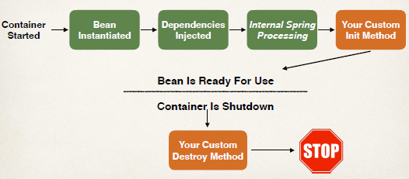

**Bean Lifecycle Methods / Hooks**

• You can add custom code during bean initialization

• Calling custom business logic methods

• Setting up handles to resources (db, sockets, file etc)

• You can add custom code during bean destruction

• Calling custom business logic method

• Clean up handles to resources (db, sockets, files etc)

**Development Process (Step-By-Step)**

1. Define your methods for init and destroy

2. Add annotations: **@PostConstruct** and **@PreDestroy**

**Init: method configuration & Destroy: method configuration:**

**@Component**

**public class CricketCoach implements Coach {**

**public CricketCoach() {**

**System.*out*.println("In constructor: " + getClass().getSimpleName());**

**}**

**@PostConstruct**

**public void doMyStartupStuff() {**

**System.*out*.println("In doMyStartupStuff(): " + getClass().getSimpleName());**

**}**

**@PreDestroy**

**public void doMyCleanupStuff() {**

**System.*out*.println("In doMyCleanupStuff(): " + getClass().getSimpleName());**

**}**

**…**

**}**

• We can see our init method in console during build once the bean got created. Then our destroy method can be seen in the console when we stop or close our spring application.

**Special Note about Prototype Scope - Destroy Lifecycle Method and Lazy Init**

• **Prototype Beans and Destroy Lifecycle: -**

There is a subtle point you need to be aware of with "prototype" scoped beans.

**For "prototype" scoped beans, Spring does not call the destroy method. Gasp!**

**---**

In contrast to the other scopes, **Spring does not manage the complete lifecycle of a prototype bean:** the container instantiates, configures, and otherwise assembles a prototype object, and hands it to the client, with no further record of that prototype instance.

Thus, although **initialization lifecycle callback methods are called on all objects regardless of scope, in the case of prototypes, configured destruction lifecycle callbacks are not called.** The client code must clean up prototype-scoped objects and release expensive resources that the prototype bean(s) are holding.

• **Prototype Beans and Lazy Initialization: -**

**Prototype beans are lazy by default.** There is no need to use the @Lazy annotation for prototype scopes beans.

**Configuring Beans with Java Code**

• **No special annotations:** We are not going to use any special annotation on the class like @Component. Instead, we will configure it as a bean using the Java code.

**Development Process (Step-By-Step)**

1. Create @Configuration class

2. Define @Bean method to configure the bean

3. Inject the bean into our controller

**Step 1: Create a Java class and annotate as @Configuration:**

• Using the **@Configuration** annotation we set configuration class to configure Spring using our customer approach.

• For Better approach we create this configuration class in separate package *config*.

**package com.luv2code.springcoredemo.config;**

**import org.springframework.context.annotation.Configuration;**

**@Configuration**

**public class SportConfig {**

**…**

**}**

**Step 2: Define @Bean method to configure the bean:**

• In our configuration class, we use the **@Bean** annotation to configure the bean.

• And we have the method for example *swimCoach()* with @Bean annotation. **Inside this method we return an instance of SwimCoach. So here we manually construct the object and return it to the given caller.**

• **The bean id defaults to the method name** – here *swimCoach***.**

**package com.luv2code.springcoredemo.config;**

**import com.luv2code.springcoredemo.common.Coach;**

**import com.luv2code.springcoredemo.common.SwimCoach;**

**import org.springframework.context.annotation.Bean;**

**import org.springframework.context.annotation.Configuration;**

**@Configuration**

**public class SportConfig {**

**@Bean**

**public Coach** **swimCoach() {**

**return new SwimCoach();**

**}**

**}**

**Step 3: Inject the bean into our controller:**

• Inject the bean in the controller using the bean id.

**package com.luv2code.springcoredemo.rest;**

**import com.luv2code.springcoredemo.common.Coach;**

**import org.springframework.beans.factory.annotation.Autowired;**

**import org.springframework.beans.factory.annotation.Qualifier;**

**import org.springframework.web.bind.annotation.GetMapping;**

**import org.springframework.web.bind.annotation.RestController;**

**@RestController**

**public class DemoController {**

**private Coach myCoach;**

**@Autowired**

**public DemoController(@Qualifier("swimCoach") Coach theCoach) {**

**System.*out*.println("In constructor: " + getClass().getSimpleName()); myCoach = theCoach;**

**}**

**…**

**}**

**N.B: One advantage of Configuring Beans with Java Code.**

**Use case for @Bean**

• You may wonder …

• Using the “new” keyword … is that it???

• Why not just annotate the class with @Component???

• Make an existing third-party class available to Spring framework

• We may not have access to the source code of third-party class. We may simply have a .jar file, we can pull that in and leverage that as a spring bean.

• However, you would like to use the outside third-party class as a Spring bean

***- Make an existing third-party class available to Spring framework.***

**Real-World Project Example: -**

• Our project used Amazon Web Service (AWS) to store documents

• Amazon Simple Storage Service (Amazon S3)

• Amazon S3 is a cloud-based storage system

• can store PDF documents, images etc

• We wanted to use the AWS S3 client as a Spring bean in our app

• The AWS S3 client code is part of AWS SDK. So, we can’t modify the AWS SDK source code. We can’t just add @Component in their source code to use it as a bean in our code.

• However, we can configure it as a Spring bean using @Bean annotation while suing the third-party jar import.

For Example: -

• *Configure AWS S3 Client using @Bean: -*

* We make an s3 client. S3 client is from AWS S3 SDK.
* By use of @Bean annotation and our method remoteClient(), in it we create a s3 client instance to connect to AWS S3 storage. And we can return it as a spring bean. We can use it in other part of our application.

**package com.luv2code.springcoredemo.config;**

**…**

**import software.amazon.awssdk.auth.credentials.ProfileCredentialsProvider;**

**import software.amazon.awssdk.regions.Region;**

**import software.amazon.awssdk.services.s3.S3Client;**

**@Configuration**

**public class DocumentsConfig {**

**@Bean**

**public S3Client remoteClient() {**

***// Create an S3 client to connect to AWS S3***

**ProfileCredentialsProvider credentialsProvider = ProfileCredentialsProvider.*create*();**

**Region region = Region.*US_EAST_1*;**

**S3Client s3Client = S3Client.*builder*()**

**.region(region)**

**.credentialsProvider(credentialsProvider)**

**.build();**

**return s3Client;**

**}**

**}**

• *Inject the S3Client as a bean: -*

**package com.luv2code.springcoredemo.services;**

**import software.amazon.awssdk.services.s3.S3Client;**

**…**

**@Component**

**public class DocumentsService {**

**private S3Client s3Client;**

**@Autowired**

**public DocumentsService(S3Client theS3Client) {**

**s3Client = theS3Client;**

**}**

**…**

**}**

*• Also, we can use that autowired bean into other services of our application to use third party services like Store our document in AWS cloud S3 through the operation .putObject(…): -*

**package com.luv2code.springcoredemo.services;**

**import software.amazon.awssdk.services.s3.S3Client;**

**…**

**@Component**

**public class DocumentsService {**

**private S3Client s3Client;**

**@Autowired**

**public DocumentsService(S3Client theS3Client) {**

**s3Client = theS3Client;**

**}**

**public void processDocument(Document theDocument) {**

***// get the document input stream and file size …***

***// Store document in AWS S3***

***// Create a put request for the object***

**PutObjectRequest putObjectRequest = PutObjectRequest.builder()**

**.bucket(bucketName)**

**.key(subDirectory + "/" + fileName) .acl(ObjectCannedACL.BUCKET_OWNER_FULL_CONTROL).build();**

***// perform the putObject operation to AWS S3 ... using our autowired bean* s3Client.****putObject(putObjectRequest, RequestBody.fromInputStream(fileInputStream, contentLength));**

**}**

**}**

**Wrap Up**

• We could use the Amazon S3 Client in our Spring application

• The Amazon S3 Client class was not originally annotated with @Component

• However, we configured the S3 Client as a Spring Bean using @Bean

• It is now a Spring Bean and we can inject it into other services of our application

**• *Make an existing third-party class available to Spring framework***

***OR in other words,***

***Take existing third-party class and expose as a Spring bean.***

**N.B:**

• We can set a custom bean Id to our bean in our configuration class.

**@Bean (“anyNameForBeanId”)**

**public S3Client remoteClient() {**

**….**

**Hibernate / JPA Overview**

• What is Hibernate?

• Benefits of Hibernate

• What is JPA?

• Benefits of JPA

• Code Snippets

**What is Hibernate?**

• A framework for persisting / saving Java objects in a database.

• [www.hibernate.org/orm](http://www.hibernate.org/orm)

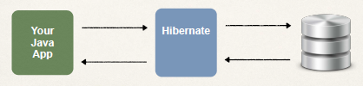

**Benefits of Hibernate**

• Hibernate handles all of the low-level SQL

• Minimizes the amount of JDBC code you have to develop

• Hibernate provides the Object-to-Relational Mapping (ORM)

**Object-To-Relational Mapping (ORM)**

• Hibernate provides the Object-To-Relational Mapping ORM.

• The developer defines mapping between Java class and database table. Developer tells the hibernate how the java class mapped to the data on the data base.

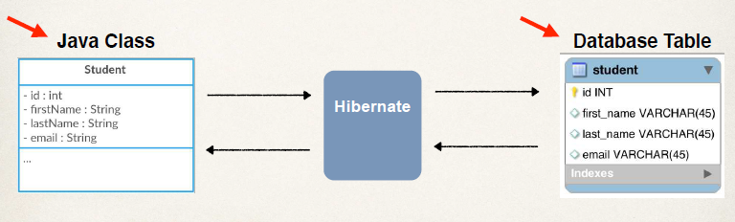

• id: primary key of the Database DB.

• Heere the java class is mapped to this given table and we set one-one mapping between these fields and the columns in the database.

• We can set this mapping in the configuration file using XML or using java annotation.

**What is JPA?**

• Jakarta Persistence API (JPA) … previously known as Java Persistence API.

• **Standard API for Object-to-Relational-Mapping (ORM)**

• Only a specification – JPA Spec

• Defines a set of interfaces

• Requires an implementation to be usable.

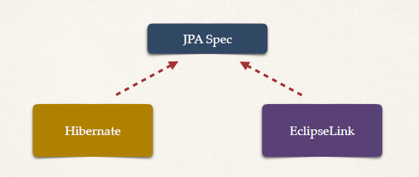

• JPA - Vendor Implementations: [www.luv2code.com/jpa-vendors](http://www.luv2code.com/jpa-vendors)

* As we know to use JPA we need an implementation of JPA Specifications (set of interfaces). **Hibernate** is one of those vendor implementations. **Hibernate is the most popular implementation of JPA Spec**. Also, the default implementation used in spring boot.
* Similarly, **EclipseLink** is another implementation of JPA Spec.

**What are Benefits of JPA?**

• By having a standard API, you are not locked to vendor's implementation.

• We can maintain portable, flexible code by coding to JPA spec (interfaces).

• Can theoretically we can switch vendor implementations

• For example, if Vendor ABC stops supporting their product

• You could switch to Vendor XYZ without vendor lock in

• Reason: we are coding to the actual JPA specification or the standard API.

• **Swapping vendor application** – Consider we have our app ‘My Biz App’. And we are writing our DAO code based on JAP Spec. And version 1 of our project let using **EclipseLink.** And suppose for version 2 of our project we want to move todifferent vendor implementation.OR for another scenario, if there is an issue withused vendor implementation **EclipseLink** then, well we can easily swap easily to different JPA vendor implementation like **Hibernate**. So, it’s there up and running. Also, we need to minimal code changes because, we are writing code to standard specification.

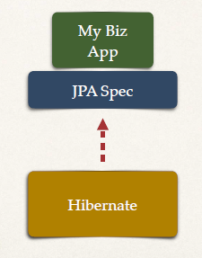

**Code Snippets - Saving a Java Object with JPA**

Example: How to save a java object with JPA.

*// create Java object*

**Student theStudent = new Student("Paul", "Doe", "paul@luv2code.com");**

*// save it to database*

**entityManager.persist(theStudent);**

• Here we are using a **Special JPA helper object** ‘**entityManager**’.

• The data will be stored in the database

• ‘**entityManager.persist’** - SQL insert

• In the back ground JPA will take the java object based on those mapping we defined earlier. JPA will take that information and store it at appropriate table in the appropriate columns.

• Here behind the scenes, Hibernate is the implementation JPA. So, it will do all the work here.

• In the old days of JDBC we would have to manually write the SQL code. Manually set those values, manually execute the SQL statement and so forth. And here in JPA with the help of Hibernate, it do all the work in the back ground.

• So it is easy to save a java object in DB using JPA.

**Code Snippets - Retrieving a Java Object with JPA**

• There are nos. of options to retrieve a java object from DB. Here we do it by use of primary key.

• We are using the primary key of 1 here. In this example we know that our DB is empty and we know the first item have the primary key of 1. So, we can use this id of 1 to retrieve the data.

*// create Java object*

Student theStudent = new Student("Paul", "Doe", "paul@luv2code.com");

*// save it to database*

entityManager.persist(theStudent);

*// now retrieve from database using the primary key*

**int theId = 1;**

**Student myStudent = entityManager.find(Student.class, theId);**

• ‘**entityManager.find**’ - Query the database for given id.

• In background, JPA will go and look for the table student and find the student whose primary key matches this id. It will find that student object and return it to us.

**Code Snippets - Querying for Java Objects**

• For retrieving list of students, we can setup a query and retrieve all the students.

• JPA has a language of queries. Basically, it can give list of all of student objects by retrieving making use of **theQuery.getResultList**. Returns a list of Student objects from the database

• Behind the scene it does the query and give list of objects. We need not have to do any low SQL level of coding or JDBC coding. Here we do very basic query that we call JPA Query language.

**TypedQuery<Student> theQuery = entityManager.createQuery("from Student", Student.class); List<Student> students=** **theQuery.getResultList**

• **Other aspects of Hibernate: -**

• Connection to the DB

• How to use the JPA **entityManager**

**JPA/Hibernate CRUD Apps**

**CRUD : Create - Read - Update - Delete**

• Create objects

• Read objects

• Update objects

• Delete objects

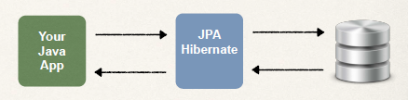

**Hibernate / JPA and JDBC: -**

• **How does Hibernate / JPA relate to JDBC?**

* Hibernate / JPA uses JDBC for all database communications.
* Hibernate / JPA is another layer of abstraction on top of JDBC.
* Application uses the Hibernate – JPA framework. Your app will store and retrieve the objects using JAP API.
* Hibernate JPA API will do a lot of low-level work for you. In the background it all go to standard JDBC API.

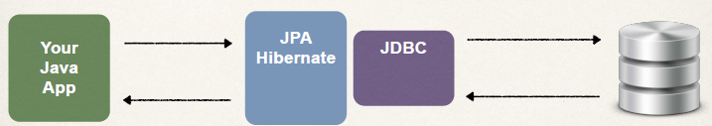

**MySQL Database**

**MySQL Database:**

• In this course, we will use the MySQL Database

• MySQL includes two components

**• MySQL Database Server**

**• MySQL Workbench**

**MySQL Database Server:**

• The MySQL Database Server is the main engine of the database

• Stores data for the database

• Supports CRUD features on the data

**MySQL Workbench:**

• MySQL Workbench is a client GUI for interacting with the database

• To Create database schemas and tables

• To Execute SQL queries to retrieve data

• To Perform insert, updates and deletes on data

• To Handle administrative functions such as creating users

• Others …

**Install the MySQL software**

• Step 1: Install MySQL Database Server

• <https://dev.mysql.com/downloads/mysql/>

• Step 2: Install MySQL Workbench

• <https://dev.mysql.com/downloads/workbench/>

**Setup Database Table:**

Two Database Scripts

1. Folder: 00-starter-sql-scripts

**01-create-user.sql**

**02-student-tracker.sql**

**About: 01-create-user.sql**

1. Create a new MySQL user for our application

**user id:** springstudent

**password:** springstudent

**About: 02-student-tracker.sql**

1. Create a new database table: **student**

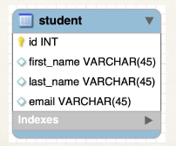

**01. create-user.sql**

-- Drop user first if they exist

DROP USER if exists 'springstudent'@'%' ;

-- Now create user with prop privileges

CREATE USER 'springstudent'@'%' IDENTIFIED BY 'springstudent';

GRANT ALL PRIVILEGES ON * . * TO 'springstudent'@'%';

**Password**

**User Id**

**02-student-tracker.sql**

CREATE DATABASE IF NOT EXISTS `student_tracker`;

USE `student_tracker`;

--

-- Table structure for table `student`

--

DROP TABLE IF EXISTS `student`;

CREATE TABLE `student` (

`id` int NOT NULL AUTO_INCREMENT,

`first_name`varchar(45) DEFAULT NULL,

`last_name` varchar(45) DEFAULT NULL,

`email` varchar(45) DEFAULT NULL,

PRIMARY KEY (`id`)

) ENGINE=InnoDB AUTO_INCREMENT=1 DEFAULT CHARSET=latin1;

**Setting Up Spring Boot Project: -**

**Automatic Data Source Configuration**

• In Spring Boot, **Hibernate** is the default implementation of JPA

• **EntityManager** is main component for creating queries etc …

• EntityManager is from Jakarta Persistence API (JPA)

• Based on configs, Spring Boot will automatically create the beans:

• **DataSource**, **EntityManager**, …

• You can then inject these into your app, for example your DAO

**Setting up Project with Spring Initializr**

• At Spring Initializr website, start.spring.io

• Add dependencies

• MySQL Driver: **mysql-connector-j**

• Spring Data JPA: **spring-boot-starter-data-jpa**

**Spring Boot - Auto configuration**

• Spring Boot will **automatically configure** your data source for you

• Based on entries from Maven pom file

• JDBC Driver: **mysql-connector-j**

• Spring Data (ORM): **spring-boot-starter-data-jpa**

• Also Spring boot automatically read DB connection info from **application.properties**

**Setting up application.properties file: -**

• Add JDBC database connection info.

**File: *application.properties***

spring.datasource.url=jdbc:mysql://localhost:3306/student_tracker

spring.datasource.username=springstudent

spring.datasource.password=springstudent

**N.B:** No need to give JDBC driver class name. Spring Boot will automatically detect it based on URL.

**Creating Spring Boot - Command Line App**

• We will create a Spring Boot - Command Line App

• This will allow us to focus on Hibernate / JPA

• Later in the course, we will apply this to a CRUD REST API

**import org.springframework.boot.CommandLineRunner;**

**import org.springframework.boot.SpringApplication;**

**import org.springframework.boot.autoconfigure.SpringBootApplication;**

**import org.springframework.context.annotation.Bean;**

**@SpringBootApplication**

**public class CruddemoApplication {**

**public static void main(String[] args) {**

**SpringApplication.*run*(CruddemoApplication.class, args);**

**}**

**@Bean**

**public CommandLineRunner commandLineRunner(String[] args) {**

**return runner -> {**

**System.*out*.println("Hello world");**

**};**

**}**

**}**

**N.B:**

• Under the @Bean section, we create this command line runner.

• This CommandLineRunner is from the Spring framework and it’s basically a hook that allows us to execute code after the Spring Beans have been loaded into the application context.

• In code we have return runner and we do have system.out.println line. This little code block is a Lambda expression. Here Lambda expression is a shortcut notation for providing an implementation of the CommandLineRunner interface.

• And this is where we can basically add our own custom code. At the moment here in code we are saying “Hello world”

• We can add some DAO code for interacting with database in this custom code section of CommandLineRunner.

• Setting up the infrastructure, setting up the framework is done.

**Remove Spring Banner and Reduce Logging info: -**

# Turn off the Spring boot banner  
spring.main.banner-mode=off  
  
# Reduce the logging level. set logging level to: warn. Only show warning and errors.  
logging.level.root=warn

• We can turn off the Spring application Banner below one in logger information. By adding the property in ***application.properties*** file.

**spring.main.banner-mode=off**

. ____ _ __ _ _

/\\ / ___'_ __ _ _(_)_ __ __ _ \ \ \ \

( ( )\___ | '_ | '_| | '_ \/ _` | \ \ \ \

\\/ ___)| |_)| | | | | || (_| | ) ) ) )

' |____| .__|_| |_|_| |_\__, | / / / /

=========|_|==============|___/=/_/_/_/

:: Spring Boot :: (v3.2.1)

• We can also reduce the logging level. set logging level to: warn. Only show warning and errors but not all the normal background logging information for Spring. We can keep this on depending on the application requirement. By adding the property in ***application.properties*** file.

**logging.level.root=warn**

**JPA Development Process**

**JPA Dev Process - To Do List**

1. Annotate Java Class

2. Develop Java Code to perform database operations

*Let’s just say “JPA”

• As mentioned, Hibernate is the default JPA implementation in Spring Boot

• Going forward in this course, I will simply use the term: JPA. Instead of saying “JPA Hibernate”

• We know that by default, Hibernate is used behind the scenes

***Terminology***

• **Entity Class -** Java class that is mapped to a database table.

• **Object-to-Relational Mapping (ORM)** – Mapping a java class to a database table. Mapping the java class fields to columns of database table using JPA.

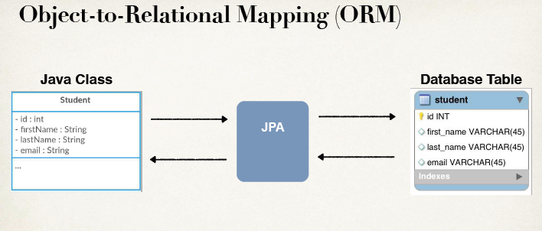

**Entity Class: -**

• Java class that is mapped to a database table.

• The Entity class must be annotated with **@Entity**

• Must have a public or protected no-argument constructor

• The class can have other constructors

**N.B:** Constructors in Java – Refresher

• Remember about constructors in Java

• If you don’t declare any constructors then, Java will provide a no-argument constructor for free

• If you declare constructors with arguments then, you do NOT get a no-argument constructor for free. In this case, you have to explicitly declare a no-argument constructor.

**Java Annotations**

• Step 1: Map class to database table

• Step 2: Map fields to database columns

**Step 1: Map class to database table**

**@Entity**

**@Table(name="student")**

**public class** Student {

...

}

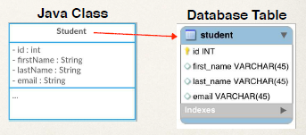

**Step 2: Map fields to database columns**

**@Entity**

**@Table(name="student")**

**public class** Student {

**@Id**

**@Column(name="id")**  // Name of the database column

private int id;

**@Column(name="first_name")**

private String firstName;

...

}

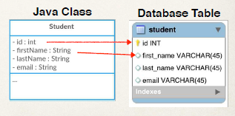

**@Table** and **@Column** (Optional)

• Actually, the use of **@Column** is optional

• If not specified, the column name is the same name as Java field

• In general, I don’t recommend this approach

• If you refactor the Java code, then it will not match existing database columns

• This is a breaking change and you will need to update database column

• Same applies to **@Table**, database table name is same as the class.

***Terminology***

• **Primary Key** –

Uniquely identifies each row in a table.

Must be a unique value.

Cannot contain NULL values

**MySQL - Auto Increment**

**CREATE TABLE student (**

**id int NOT NULL AUTO_INCREMENT,**

**first_name varchar(45) DEFAULT NULL,**

**last_name varchar(45) DEFAULT NULL,**

**email varchar(45) DEFAULT NULL,**

**PRIMARY KEY (id)**

**)**

• In MySQL database we can use Auto Increment. So, we can define our primary key and then we can specify that it’s an auto increment.

• Create table student, we have the column ID, define it of type integer, it is NOT Null and specify it’s Auto increment.

**id int NOT NULL AUTO_INCREMENT,**

**….**

• Behind the scenes, MySQL will keep track of automatically incrementing this ID, and making sure it’s a unique value.

• In the bottom for primary key, we specify that our given column ”id” is the **Primary key** for this given table

**….**

**PRIMARY KEY (id) }**

**JPA Identity - Primary Key**

• In JPA we have to specify the actual primary key **or** the identity (Id) here.

• So, we make use of **@Id** annotation.

• Then we specify how this given **Id** or primary-key value is generated. Through **GenerationType.IDENTITY,** we specify, this ID value will be generated by the database and managed by the database. There’s no need for our code to manually try and keep track of that given id. It’s a **GeneratedValue.**

**@****GeneratedValue(strategy=GenerationType.IDENTITY)**

**@Entity**

**@Table(name="student")**

**public class** Student {

**@Id**

**@GeneratedValue(strategy=GenerationType.IDENTITY)**

**@Column(name="id")**  // Name of the database column

private int id;

**@Column(name="first_name")**

private String firstName;

...

}

**ID Generation Strategies:**

|  |  |
| --- | --- |
| **Name** | **Description** |
| **GenerationType.AUTO** | Pick an appropriate strategy for the particular  database |
| **GenerationType.IDENTITY** | Assign primary keys using database identity  column |
| **GenerationType.SEQUENCE** | Assign primary keys using a database sequence |
| **GenerationType.TABLE** | Assign primary keys using an underlying database table to ensure uniqueness |

• We can apply other Generation types based on the application requirement

**CUSTOM generation strategy –** Based on very specific requirement or logic to generate ID. And nothing that JPA provides out of the box matches our requirement.

• We can define your own CUSTOM generation strategy :-) for generating our Id.

• We simply Create a custom implementation of **IdentifierGenerator** interface.

**org.hibernate.id.IdentifierGenerator**

• We Override the method or implement the method **generate()**. Then inside this generate() method we give our own custom logic for generating a given id.

**public Serializable generate(…)**

• Basically, it gives us an extension point, where we can create our own custom generation strategy for creating our Ids.

File: *Student.java*

package com.sharada.cruddemo.entity;  
  
import jakarta.persistence.*;  
  
@Entity  
@Table(name="student")  
public class Student {  
  
 // Define fields & Map these fields to database table columns  
  
 @Id  
 @GeneratedValue(strategy = GenerationType.*IDENTITY*)  
 @Column(name="id")  
 private int id;  
  
 @Column(name="first_name")  
 private int firstName;  
  
 @Column(name="last_name")  
 private int lastName;  
  
 @Column(name="email")  
 private int email;  
  
 // define constructors  
  
 public Student() {  
  
 }  
  
 public Student(int firstName, int lastName, int email) {  
 this.firstName = firstName;  
 this.lastName = lastName;  
 this.email = email;  
 }  
  
 // Define getters/setters  
  
 public int getId() {  
 return id;  
 }  
  
 public void setId(int id) {  
 this.id = id;  
 }  
  
 public int getFirstName() {  
 return firstName;  
 }  
  
 public void setFirstName(int firstName) {  
 this.firstName = firstName;  
 }  
  
 public int getLastName() {  
 return lastName;  
 }  
  
 public void setLastName(int lastName) {  
 this.lastName = lastName;  
 }  
  
 public int getEmail() {  
 return email;  
 }  
  
 public void setEmail(int email) {  
 this.email = email;  
 }  
  
  
 // define toString() method  
  
 @Override  
 public String toString() {  
 return "Student{" +  
 "id=" + id +  
 ", firstName=" + firstName +  
 ", lastName=" + lastName +  
 ", email=" + email +  
 '}';  
 }  
}

Can use **LOMBOK** for minimizing the code.

**Save a Java Object: -**

**Sample Application with features - CRUD**

**•** **Create** a new Student

**• Read** a Student

**• Update** a Student

**• Delete** a Student

**Data Access Object (DAO): -**

• Data Access Object **(DAO)** is responsible for interfacing with the database.

• This is a common design pattern: **Data Access Object (DAO)**

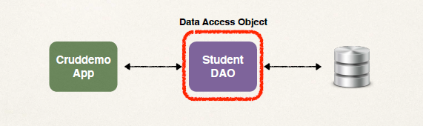

• Our application will communicate with the DAO and DAO will talk with our actual Database.

• So, DAO is a helper class for communicating with the database.

**Student Data Access Object** has numbers of methods for different operation.

|  |
| --- |
| **Methods** |
| save(…) |
| findById(…) |
| findAll() |
| findByLastName(…) |
| update(…) |
| delete(…) |
| deleteAll() |

**JPA Entity Manager: -**

• Our DAO needs a **JPA Entity Manager**.

• **JPA Entity Manager** is the main component for saving/retrieving entities.

• Our JPA Entity Manager needs a Data Source

• The **Data Source** defines database connection info

• JPA Entity Manager and Data Source are **automatically created by Spring Boot**

• Based on the info. in Maven .pom file and application.properties file (JDBC URL, user id, password, etc …) it create and connect with the database.

• Then, we can autowire/inject the JPA Entity Manager into our Student DAO.

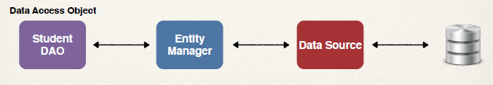

**DAO - Create an Object**

**Development Process (Step-By-step)**

• Step 1: Define DAO interface

• Step 2: Define DAO implementation

• Inject the entity manager

• Step 3: Update main app

**Step 1: Define DAO interface**

• Basically a java interface, defined with a save (…)method and passing the student object in it.

**save(Student theStudent) { …}**

• Here **Student**  is our java class – our JPA entity that mapped to the given database table. We have already done the mapping work.

**import com.sharada.cruddemo.entityStudent;**

**public interface StudentDAO {**

**void save(Student theStudent);**

**}**

**Step 2: Define DAO implementation**

**import com.luv2code.cruddemo.entity.Student;**

**import jakarta.persistence.EntityManager;**

**import org.springframework.beans.factory.annotation.Autowired;**

**@Repository**

**public class StudentDAOImpl implements StudentDAO {** // Implement our DAO interface.

// Define field for the Entity manager

**private EntityManager entityManager;**

// Constructor for DAO implementation

// Specified @Autowired to Inject Entity Manager into our DAO within this constructor.

**@Autowired**

**public StudentDAOImpl(EntityManager theEntityManager) {**

**entityManager = theEntityManager;**

**}**

// Implementation of the save method. Here we use the JPA entity manger to save the passed java student object to the database.

// Added **@Transactional** annotation to Handle transaction management.

**@Override**

**@Transactional**

**public void save(Student theStudent) {**

**entityManager.persist(theStudent);**

**}**

**}**

**N.B:-**

• Whenever we are trying to change the data – **update or delete operation, with custom methods**, we use **@Transactional** and **@Modifying** annotation to secure the transaction, in case any issue occurs in between the change it will roll back the changes itself.

**Spring @Transactional**

• Spring provides an **@Transactional** annotation.

• Automagically begin and end a transaction for your JPA code

• No need for you to explicitly do this in your code

• This Spring magic happens behind the scenes.

**@Modifying**

• We tell the Spring boot that, this method is going to modify the data, please execute the query for this method inside the transaction.

• When Spring run the query inside Transaction, if any error occurs at runtime, then any partial changes done by queries will be rolled back, because entire transaction will be rolled back by Spring Data JPA.

**Specialized Annotation for DAOs**

• Spring provides the **@Repository** annotation, that basically a sub-annotation of @Component.

• Spring @Repository annotation is used to indicate that the class provides the mechanism for storage, retrieval, search, update and delete operation on objects.

• **@Repository** is for annotating DAOs. It is applied to DAO implementations.

• Then Spring will automatically register the DAO implementation through component-scanning.

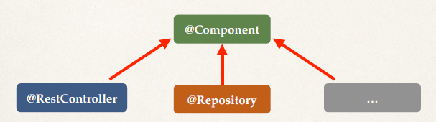

• Through this annotation @Repository Spring also provides **translation of any JDBC related exceptions**.

• **Translation** means if we have any check JDBC exception then Spring will translate these to unchecked exception. It makes the coding easier for interfacing with database.

**Step 3: Update main app**

**@SpringBootApplication**

**public class CruddemoApplication {**

**public static void main(String[] args) {**

**SpringApplication.*run*(CruddemoApplication.class, args);**

**}**

**@Bean**

**public CommandLineRunner commandLineRunner(StudentDAO studentDAO) {**

**return runner -> {**

**createStudent(****studentDAO);**

**}**

**private void createStudent(StudentDAO studentDAO) {**

***// create the student object***

**System.*out*.println("Creating new student object...");**

**Student tempStudent = new Student("Paul", "Doe", "paul@luv2code.com");**

***// save the student object***

**System.*out*.println("Saving the student...");**

**studentDAO.save(tempStudent);**

***// display id of the saved student***

**System.*out*.println("Saved student. Generated id: " + tempStudent.getId());**

**}**

**}**

• In the **CommandLineRunner** we inject our student DAO. Then call the method **createStudent(studentDAO).**

• We defined the **createStudent (…)** in the same class. Inside the **createStudent (…)** method we create the new student object using the new key word.

• We save the object using the DAO.

• Then we display the Id of saved student.

• **How do we see the data in student table?**

*Query*:

**SELECT * FROM student_tracker.student;**

• **How do we change the AUTO_INCREMENT values?**

- It will start to enter new entries in table from id row 3000

*Query:*

**ALTER TABLE student_tracker.student AUTO_INCREMENT=3000;**

• **How do we RESET the AUTO_INCREMENT values to 1?**

- It will remove all data from the database table and Reset Auto Increment starts with 1.

Query:

**TRUNCATE student_tracker.student;**

**Retrieving an Object: -**

**JPA CRUD Apps**

• **Create** objects

• **Read** objects

• **Update** objects

• **Delete** objects

**Retrieving a Java Object with JPA**

***// retrieve/read from database using the primary key***

***// in this example, retrieve Student with primary key: 1***

**Student myStudent = entityManager.find(Student.class, 1);**

• Here we retrieve a student object with primary key: 1. Finding it by providing the name of entity manager class and primary key.

* Name of the **Entity class** : Student.class
* **Primary key**: 1

• In any event it could not find the value a student, then it’ll return null with that given primary key

**Development Process (Step-By-Step)** - ***Retrieving an Object using DAO: -***

1. Add new method to DAO interface

2. Add new method to DAO implementation

3. Update main app

**Step 1: Add new method to DAO interface**

**import com.luv2code.cruddemo.entity.Student;**

**public interface StudentDAO {**

**…**

**Student findById(Integer id);** // passing in an integer of the id

**}**

**Step 2: Define DAO implementation**

**import com.luv2code.cruddemo.entity.Student;**

**import jakarta.persistence.EntityManager;**

**…**

**public class StudentDAOImpl implements StudentDAO {**

**private EntityManager entityManager;**

**…**

**@Override**

**public Student findById(Integer id) {**

**return entityManager.find(Student.class, id);**

**}**

**}**

• No need to add **@Transactional** since we are doing a query, we are not performing any updates or modification to the database. Simply read on.

**Step 3: Update main app**

**@SpringBootApplication**

**public class CruddemoApplication {**

**…**

**@Bean**

**public CommandLineRunner commandLineRunner(StudentDAO studentDAO) {**

**return runner -> {**

**readStudent(studentDAO);**

**};**

**}**

**…**

• Add our custom code inside commandLineRunner block. Call a method ‘readStudent’ and passing the DAO.

**private void readStudent(StudentDAO studentDAO) {**

***// create a student object***

**System.*out*.println("Creating new student object...");**

**Student tempStudent = new Student("Daffy", "Duck", "daffy@luv2code.com");**

***// save the student object***

**System.*out*.println("Saving the student...");**

**studentDAO.save(tempStudent);**

***// display id of the saved student***

**System.*out*.println("Saved student. Generated id: " + tempStudent.getId());**

***// retrieve student based on the id: primary key***

**System.*out*.println("\nRetrieving student with id: " + tempStudent.getId());**

**Student myStudent = studentDAO.findById(tempStudent.getId());**

**System.*out*.println("Found the student: " + myStudent);**

**}**

• Process involved in the **readStudent(…)** method:

- Create a Student object;

- Save the student;

- Display the id (primary key) of the saved student;

- then, retrieve the student object based on the id we have;

- print out the given student

**Query Objects: -**

**JPA Query Language (JPQL)**

• JPA has its query language called **JPA Query Language** (JPQL)

• Query language for retrieving objects

• Similar in concept to SQL (select data from a given table. We can set constraints or selectors here)

• **where, like, order by, join, in, etc…**

• However, JPQL is based on **entity name** and **entity fields** as opposed to direct table names and table columns.

**Retrieving all Students using JPQL: -**

**TypedQuery<Student> theQuery =** **entityManager.createQuery("****FROM Student", Student.class);**

**List<Student> students =** **theQuery.getResultList();**

• Here we use **entityManager** and call ‘**createQuery’** and then we give ‘**From Student**’.

• ***FROM Student*** –Here **Student** is the name of JPA Entity … the class name, and then we give **‘,Student.class’** – this will make sure this is a typed query - **TypedQuery**. Then we make assignment of it to lefthand side to ***theQuery***

• Note: this **Student** is NOT the name of the database table. **All JPQL syntax is based on entity name and entity fields, not on table name and column name.**

• Once the query created, we can retrieve the data by saying ‘**theQuery.getResultList()**’. It will give us a list of students, then we can use it in our application accordingly.

For Example: **Retrieving Students: lastName = ‘Doe’**

**TypedQuery<Student> theQuery = entityManager.createQuery(**

**"FROM Student WHERE** **lastName=‘Doe’", Student.class);**

**List<Student> students = theQuery.getResultList();**

• Here **lastName** is Field name of JPA Entity.

For Example: **Retrieving Students using OR predicate:**

**TypedQuery<Student> theQuery = entityManager.createQuery(**

**"FROM Student WHERE lastName=‘Doe’ OR firstName=‘Daffy’", Student.class);**

**List<Student> students = theQuery.getResultList();**

• Here **lastName** & **firstName** is Field name of JPA Entity.

For Example: **Retrieving Students using LIKE predicate:**

**TypedQuery<Student> theQuery = entityManager.createQuery(**

**"FROM Student WHERE** **email LIKE ‘%luv2code.com’", Student.class);**

**List<Student> students = theQuery.getResultList();**

• Here **email** is Field name of JPA Entity. It will check for match of email addresses that ends with *luv2code.com*

**JPQL - Named Parameters:**

**public List<Student> findByLastName(String theLastName) {**

**TypedQuery<Student> theQuery = entityManager.createQuery(**

**"FROM Student WHERE lastName = :****theData", Student.class);**

**theQuery.setParameter("theData", theLastName);**

**return theQuery.getResultList();**

**}**

• Here JPQL Named Parameters are prefixed with a colon **:** like **:theData.** Think of this as a placeholder that is filled in later.

• **theData** is a JPQL Named Parameter in this example.

**Development Process (**Step-By-Step**)**

1. Add new method to DAO interface

2. Add new method to DAO implementation

3. Update main app

**Step 1: Add new method to DAO interface**

**import com.luv2code.cruddemo.entity.Student;**

**import java.util.List;**

**public interface StudentDAO {**

**…**

**List<Student> findAll();**

**}**

**Step 2: Define DAO implementation**

**import com.luv2code.cruddemo.entity.Student;**

**import jakarta.persistence.EntityManager;**

**import jakarta.persistence.TypedQuery;**

**import java.util.List;**

**…**

**public class StudentDAOImpl implements StudentDAO {**

**private EntityManager entityManager;**

**…**

**@Override**

**public List<Student> findAll() {**

**TypedQuery<Student> theQuery = entityManager.createQuery(**

**“FROM Student", Student.class);**

**return theQuery.getResultList();**

**}**

**}**

**Step 3: Update main app**

**public class CruddemoApplication {**

**public static void main(String[] args) {**

**SpringApplication.*run*(CruddemoApplication.class, args);**

**}**

**@Bean**

**public CommandLineRunner commandLineRunner(StudentDAO studentDAO) {**

**return runner -> {**

**queryForStudents(studentDAO);**

**};**

**}**

**private void queryForStudents(StudentDAO studentDAO) {**

***// get list of students***

**List<Student> theStudents = studentDAO.findAll();**

***// display list of students***

**for (Student tempStudent : theStudents) {**

**System.*out*.println(tempStudent);**

**}**

**}**

**}**

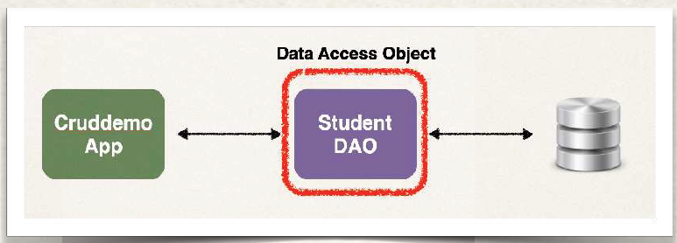

**Updating an Object: -**

**JPA CRUD Apps**

• **Create** objects

• **Read** objects

• **Update** objects

• **Delete** objects

For Example: **Update a student:**

(Update single object)

**Student theStudent =** **entityManager.find(Student.class, 1);**

***// change first name to "Scooby"***

**theStudent.setFirstName("Scooby");**

**entityManager.merge(theStudent);** // Update the entity

• First find the object using **entityManager.find (…)** method.

• Then we call the *setter method* to change the value of the object.

• Then we perform the **entityManager.merge(…)** saying entity mangerto update theentity.

For Example: **Update last name for all students**

(Update multiple objects)

**int numRowsUpdated = entityManager.createQuery(**

**"UPDATE Student SET lastName = ‘Tester’ ”)**

**.executeUpdate();**

• Here we update the last name of all students with ‘Tester’.

• Then we call the **.executeUpdate()** method to execute the query statement. Then it will return the number of rows it has updated.

**Development Process (Step-By-Step)**

1. Add new method to DAO interface

2. Add new method to DAO implementation

3. Update main app

**Step 1: Add new method to DAO interface**

**import com.luv2code.cruddemo.entity.Student;**

**public interface StudentDAO {**

**…**

**void update(Student theStudent);**

**}**

**Step 2: Define DAO implementation**

**import com.luv2code.cruddemo.entity.Student;**

**import jakarta.persistence.EntityManager;**

**import org.springframework.transaction.annotation.Transactional;**

**…**

**public class StudentDAOImpl implements StudentDAO {**

**private EntityManager entityManager;**

**…**

**@Override**

**@Transactional**

**public void update(Student theStudent) {**

**entityManager.merge(theStudent);**

**}**

**}**

• Add **@Transactional** since we are performing an update. It is not necessary on reading data.

**Step 3: Update main app**

**public class CruddemoApplication {**

**…**

**@Bean**

**public CommandLineRunner commandLineRunner(StudentDAO studentDAO) {**

**return runner -> {**

**updateStudent(studentDAO);**

**};**

**}**

**…**

**private void updateStudent(StudentDAO studentDAO) {**

***// retrieve student based on the id: primary key***

**int studentId = 1;**

**System.*out*.println("Getting student with id: " + studentId);**

**Student myStudent = studentDAO.findById(studentId);**

**System.*out*.println("Updating student...");**

***// change first name to "Scooby"***

**myStudent.setFirstName("Scooby");**

**studentDAO.update(myStudent);**

***// display updated student*System.*out*.println("Updated student: " + myStudent);**

**}**

**Deleting an Object: -**

**JPA CRUD Apps**

• **Create** objects

• **Read** objects

• **Update** objects

• **Delete** objects

For Example: **Delete a Student:**

(Delete single object)

***// retrieve the student***

**int id = 1;**

**Student theStudent = entityManager.find(Student.class, id);**

***// delete the student***

**entityManager.remove(theStudent);**

• Here we remove the single student with the id or primary key 1.

For Example: **Delete based on a condition:**

(Delete single/multiple object with a condition)

**int numRowsDeleted = entityManager.createQuery(**

**"DELETE FROM Student WHERE lastName=‘Smith’")**

**.executeUpdate();**

• Here we remove all students with last name ‘Smith.

• Then we call the **.executeUpdate()** method to execute the query statement. Then it will return the number of rows it has deleted. Method name “Update” is a generic term, we are modifying the database.

For Example: **Delete All Students:**

(Delete multiple objects)

**int numRowsDeleted = entityManager**

**.createQuery("DELETE FROM Student")**

**.executeUpdate();**

**Development Process** (Step-By-Step)

1. Add new method to DAO interface

2. Add new method to DAO implementation

3. Update main app

**Step 1: Add new method to DAO interface**

**import com.luv2code.cruddemo.entity.Student;**

**public interface StudentDAO {**

**…**

**void delete(Integer id);**

**}**

**Step 2: Define DAO implementation**

**import com.luv2code.cruddemo.entity.Student;**

**import jakarta.persistence.EntityManager;**

**import org.springframework.transaction.annotation.Transactional;**

**…**

**public class StudentDAOImpl implements StudentDAO {**

**private EntityManager entityManager;**

**…**

**@Override**

**@Transactional**

**public void delete(Integer id) {**

**Student theStudent = entityManager.find(Student.class, id); entityManager.remove(theStudent);**

**}**

**}**

**Step 3: Update main app**

**@SpringBootApplication**

**public class CruddemoApplication {**

**…**

**@Bean**

**public CommandLineRunner commandLineRunner(StudentDAO studentDAO) {**

**return runner -> {**

**deleteStudent(studentDAO);**

**};**

**}**

**…**

**private void deleteStudent(StudentDAO studentDAO) {**

***// delete the student***

**int studentId = 3;**

**System.*out*.println("Deleting student id: " + studentId);**

**studentDAO.delete(studentId);**

**}**

**Create Database Tables from Java Code**

**Create database tables:** *student*

Previously, we created database tables by running a SQL script. We run it in MySQL Workbench.

• JPA/Hibernate provides an option to **automagically** create database tables

• **Creates tables based on Java code with** **JPA/Hibernate annotations**

• Useful for development and testing

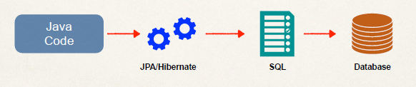

**Configuration:**

• In Spring Boot configuration file: ***application.properties***

**spring.jpa.hibernate.ddl-auto=create**

• When you run your app, JPA/Hibernate will **drop** tables then **create** them for entity classes.

• This all based on the JPA/Hibernate annotations in your Java code

**Creating Tables based on Java Code**

**@Entity**

**@Table(name="student")**

**public class Student {**

**@Id**

**@GeneratedValue(strategy=GenerationType.*IDENTITY*)**

**@Column(name="id")**

**private int id;**

**@Column(name="first_name")**

**private String firstName;**

**@Column(name="last_name")**

**private String lastName;**

**@Column(name="email")**

**private String email;**

**…**

**// constructors, getters / setters**

**}**

• Hibernate will use the information from our Entity class to generate the SQL, execute it and apply it on the given database behind the scenes.

*SQL query:*

**create table student (id integer not null auto_increment,**

**email varchar(255), first_name varchar(255),**

**last_name varchar(255), primary key (id))**

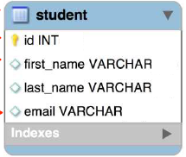

**Configuration - application.properties**

• Different property values we can set for database table opertaion

**spring.jpa.hibernate.ddl-auto=PROPERTY-VALUE**

|  |  |
| --- | --- |
| **Property Value** | **Property Description** |
| none | No action will be performed |
| create-only | Database tables are only created |
| drop | Database tables are dropped |
| create | Database tables are dropped followed by database tables creation |
| create-drop | Database tables are dropped followed by database tables creation.  On application shutdown, drop the database tables.  N.B: Used for Junit testing |
| validate | Validate the database tables schema |
| update | Update the database tables schema |

**Basic Projects**

• For basic projects, can use auto configuration

**spring.jpa.hibernate.ddl-auto=create**

• Database tables are dropped first and then created from scratch

**Note**: When database tables are dropped, all data is lost

• If you want to create tables once … and then keep data, use: update

**spring.jpa.hibernate.ddl-auto=update**

• However, will ALTER database schema based on latest code updates

• Be VERY careful here … only use for basic projects

**Warning**

• Don't do this on Production databases!!! - **spring.jpa.hibernate.ddl-auto=create**

• You don't want to drop your Production data

• All data is deleted!!!

• **Instead for Production, you should have DBAs run SQL scripts**

Use Case

• Automatic table generation is useful for

• Database integration testing with in-memory databases

• Basic, small hobby projects

**Recommendation**

• In general, I don’t recommend auto generation for enterprise, real-time projects

• You can VERY easily drop PRODUCTION data if you are not careful

• I recommend SQL scripts

• Corporate DBAs prefer SQL scripts for governance and code review

• The SQL scripts can be customized and fine-tuned for complex database designs

• The SQL scripts can be version-controlled

• Can also work with schema migration tools such as Liquibase and Flyway

**REST APIs - REST Web Services**

**We will learn how to …**

• Create REST APIs / Web Services with Spring

• Discuss REST concepts, JSON and HTTP messaging

• Install REST client tool: **Postman**

• Develop REST APIs / Web Services with **@RestController**

• Build a CRUD interface to the database with Spring REST

**Practical Results:**  Introduction to Spring REST development. Not an A to Z reference … for that you can see Spring Reference Manual <https://projects.spring.io/spring-framework/>

**Business Problem**

• Build a client app that provides the weather report for a city

• Need to get weather data from an external service (There is no local database for weather info. as it’s keep changing)

**Application Architecture**

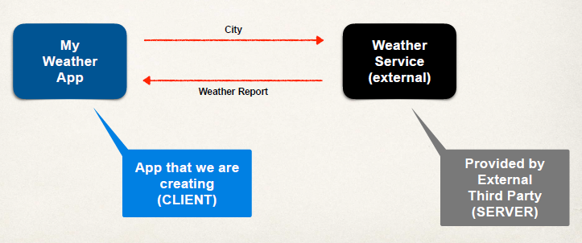

• We pass over a string for ‘city’ and the weather service will provide us the actual weather report of that city.

**Questions**

**• How will we connect to the Weather Service?**

**• What programming language do we use?**

**• What is the data format?**

**Answers**

**• How will we connect to the Weather Service?**

• We can make REST API calls over HTTP

• **REST**: **RE**presentational **S**tate **T**ransfer

• Lightweight approach for communicating between applications

**Answers**

**• What programming language do we use?**

• REST is language independent

• The client application can use ANY programming language

• The server application can use ANY programming language

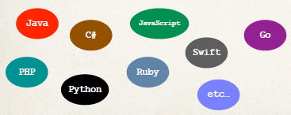

**Answers**

**• What is the data format?**

• REST applications can use any data format

• Commonly see XML and JSON

• JSON is most popular and modern

• JavaScript Object Notation

**Possible Solution**

• Use online Weather Service API provided by: openweathermap.org

• Provide weather data via an API

• Data is available in multiple formats: JSON, XML etc …

• **Call Weather Service:**

• The **API documentation** gives us the following:

• Pass in the city name

**api.openweathermap.org/data/2.5/weather?q={city name}**

**OR**

**api.openweathermap.org/data/2.5/weather?q={city name},{country code}**

**• Response - Weather Report:**

• The Weather Service responds with **JSON (Name & Value pair)**

**{**

**...**

**"temp": 14,**

**"temp_min": 11,**

**"temp_max": 17,**

**"humidity": 81,**

**"name": "London",**

**...**

**}**

**Multiple Client Apps:**

**Benefit of using REST API or REST Webservice: -** This weather service is developed and provided by one group ‘open weather map’. They simply provided the data feed as an external service. Then we can have different types of clients that can access it. We can create a client application using Spring MVC, Java access in this application, OR we could make use of a C# application talking to this weather service. Also, we can use an iPhone app using Swift communicating this weather service.

**Remember**: REST calls can be made over HTTP. And also, REST is language independent. It gives us the flexibility of implementation language.

**Example: - Currency Converter App**

To Convert US Dollar to Indian Rupees

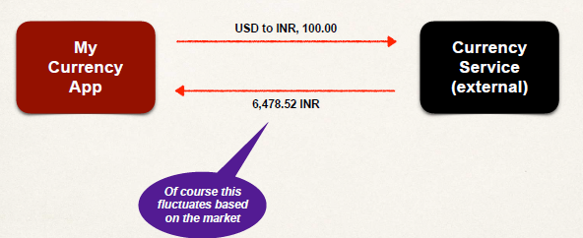

**Example: - Movie Tickets App**

To have movie information in the area.



**Example: - Customer Relationship Manager (CRM) App**

• We have **Customer Relationship Manager (CRM)** App and **CRM** Service, basically they can access the list of customers. Then we can send that list of customers. Instead of doing that on a HTML page or JSP page or webpage, we are simply pass on that JSON data or whatever data format we chose. And then the CRM app can render it accordingly. So, it could be a web app, a mobile app or any other kind of application that.

• Sending customer data by a REST service. Salesforce company have a huge platform based on CRM. They also have a REST API for providing customer data from a given application.

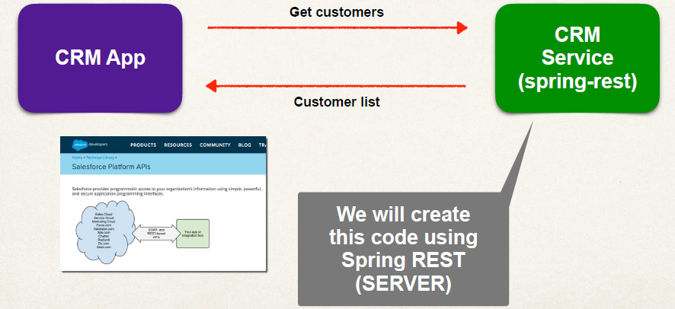

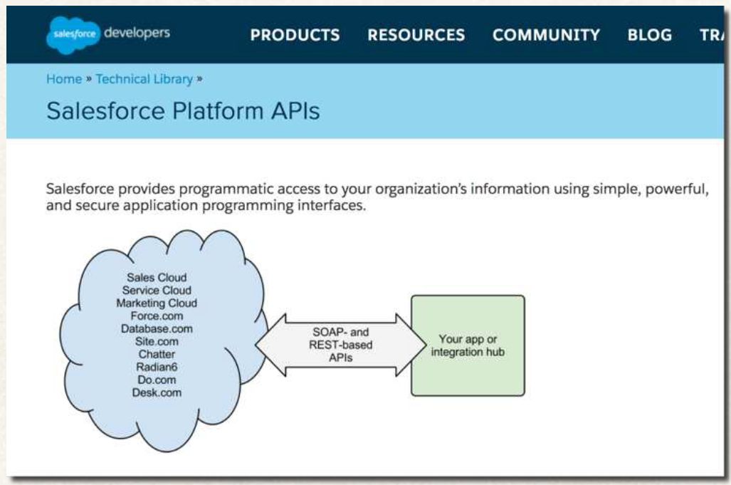

**• What do we call it?**

**REST API ; RESTful API ; REST Web Services ; RESTful Web Services ; REST Services ; RESTful Services**

• Generally, **all mean the SAME thing**. We are building an API or service and providing an endpoint and providing data based on input or request.

**JSON Basics – Syntax**

**What is JSON?**

• **J**ava**S**cript **O**bject **N**otation

• Lightweight data format for storing and exchanging data … plain text

• **Language independent** … not just for **JavaScript**

• Can use with any programming language: **Java, C#, Python** etc …

• JSON is just plain text data

**Simple JSON: -**

• Curley braces define objects in JSON

• Object members are name / value pairs

• Delimited by colons **:**

• Name is **always** in double-quotes **“ ”**

Example:

**{**

**"id": 14,**

**"firstName": "Mario",**

**"lastName": "Rossi",**

**"active": true**

**}**

• **JSON Values: -**

• Numbers: no quotes

• String: in double quotes “…”

• Boolean: **true, false**

• Nested JSON object

• Array: in square brackets [… ]

• **null**

**{**

**"id": 14,**

**"firstName": "Mario",**

**"lastName": "Rossi",**

**"active": true,**

**"courses" : null**

**}**

**Nested JSON Objects: -**

• Nested : One item/field inside another. We can nest it at many levels as we need for our **JSON Object Model.**

Example:

**{**

**"id": 14,**

**"firstName": "Mario",**

**"lastName": "Rossi",**

**"active": true,**

**"address" : {**

**"street" : "100 Main St",**

**"city" : "Philadelphia",**

**"state" : "Pennsylvania",**

**"zip" : "19103",**

**"country" : "USA"**

**}**

**}**

**JSON Arrays: -**

• We can have an array of any type of values.

• Arrays use square brackets […]

**{**

**"id": 14,**

**"firstName": "Mario",**

**"lastName": "Rossi",**

**"active": true,**

**"languages" : ["Java", "C#", "Python", "Javascript"]**

**}**

**REST HTTP Basics**

• Most common use of REST is over HTTP

• Leverage HTTP methods for CRUD operations

**HTTP Method CRUD Operation**

**POST : C**reate a new entity

**GET : R**ead a list of entities or single entity

**PUT : U**pdate an existing entity

**DELETE : D**elete an existing entity

• **HTTP Messages**

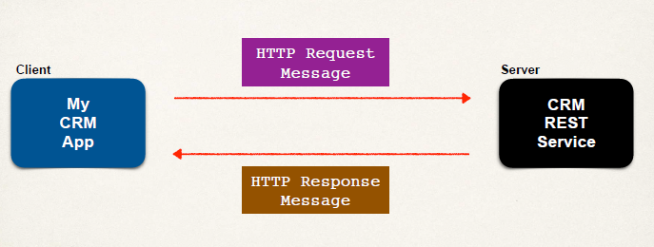

• Server process the Request and give a Response message.

• **HTTP Request Message**

• Request line: the HTTP command

• Header variables: request metadata

• Message body: contents of message

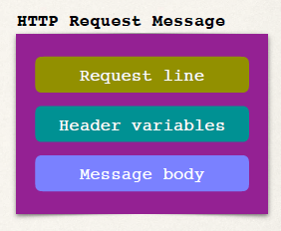

• **HTTP Response Message**

• Response line: server protocol and status code. (**HTTP status code**, like 200, 404 or 500)

• Header variables: response metadata. (Info. about the data – content type, XML, JSON; Size or Length of data)

• Message body: contents of message. (list of data required in JSON or XML based on configuration)

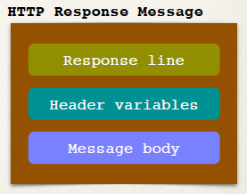

**HTTP Response - Status Codes**

|  |  |  |
| --- | --- | --- |
| **Code Range** | **Description** | |
| **100 - 199** | Informational | |
| **200 - 299** | Successful | |
| **300 - 399** | Redirection | |
| **400 - 499** | Client error | **401 Authentication Required**; **404 File Not Found** |
| **500 - 599** | Server error | **500 Internal Server Error** |

• **MIME Content Types**

• **M**ultipurpose **I**nternet **M**ail-**E**xtension : This is the message format for the actual payload.

• The message format is described by MIME content type.

• it simply describes the actual content or the format of the message being returned.

• Basic Syntax: type/sub-type

• Examples

• text/html, text/plain

• application/json, application/xml, …

• This information is return back to the client and the client can render or process it accordingly.

• For example,

* if we return back text/html to a web browser, then a web browser will render that based on HTML tags.
* if we return back text/plain to a web browser, then a web browser will simply show the plain text in the browser. We can also make use of RESTful clients for that.
* Similarly through application/json OR application/xml, we are saying the client this content is coming back in json OR XML format to you. Then the client can process it accordingly.

• **Client Tool: -**

• We need a **client tool**

• Using the client tool we can send HTTP requests to the REST Web Service / API, then it will give the response. And we can view it there in the tool.

• Plenty of tools available: **curl** – a command line tool, **Postman** – a GUI tool, etc …

• **Postman**

• Postman is really a popular tool used for real time projects. “Postman makes API Development simple”. It’s easy to use.

• We can use it for testing out and accessing our REST applications.

[**www.getpostman.com**](http://www.getpostman.com)

- It has a Free developer plan.



• The Headers found in the response are set by server.

**Spring REST Controller**

For Example: Spring REST Hello World

• We have our REST Client and REST Service.

• We will make a request for a /test/hello.

• Then the REST service respond with ‘Hello World!’

• We will write code for Rest Service

• For REST Client we will use either web browser or Postman

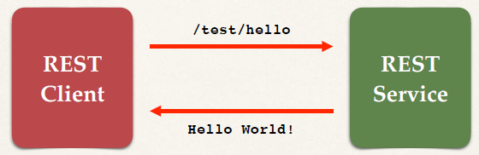

**Spring REST Controller**

**@RestController**

**@RequestMapping("/test")**

**public class DemoRestController {**

**@GetMapping("/hello")**

**public String sayHello() {**

**return "Hello World!";**

**}**

**}**

• With annotation **@RestController,**we add REST support.

• We defined this RESTful endpoint or path that we can access. Here we can access the REST endpoint by simply going to path */test/hello*

• Then it returns content to the client “Hello World!”

**Testing with REST Client - Postman**

• We can test this with the **REST client** using **Postman**.

• In Postman we drop URL of our localhost with path to REST endpoint then we can get the response.

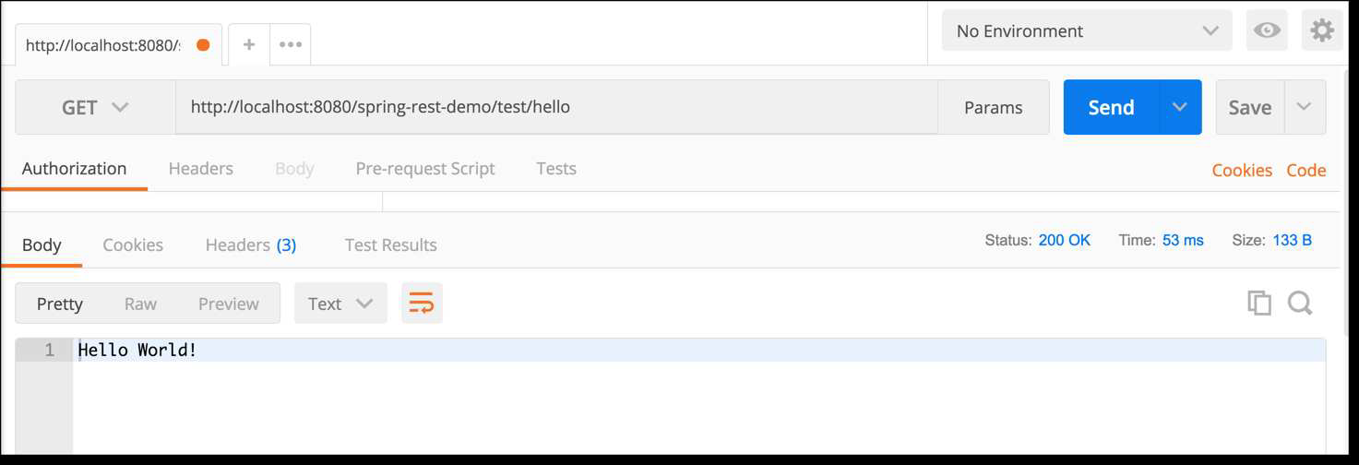

• The same we can test on our web browser by giving the URL path to REST endpoint.



**Web Browser vs Postman:**

• For simple REST testing for GET requests

• Web Browser and Postman are similar

• However, for advanced REST testing: POST, PUT etc …

• Postman has much better support

• POSTing JSON data, setting content type

• Passing HTTP request headers, authentication etc …

**Spring REST Controller - Dev Process**

**Development Process** (Step-By-Step):

1. Add Maven dependency for Spring Boot Starter Web

2.Create Spring REST Service using @RestController

**Step 1: Add Maven Dependency**

*File: pom.xml*

**<!-- Add Spring Boot Starter Web -->**

**<dependency>**

**<groupId>org.springframework.boot</groupId>**

**<artifactId>spring-boot-starter-web</artifactId>**

**</dependency>**

• At Spring Initializr website, we can also select the “Web” dependency.

**Step 2: Create Spring REST Service**

**@RestController**

**@RequestMapping("/test")**

**public class DemoRestController {**

**@GetMapping("/hello")**

**public String sayHello() {**

**return "Hello World!";**

**}**

**}**

**Java JSON Data Binding**

**Java JSON Data Binding:**

• Data binding is the process of converting one format to another format - JSON data to a Java POJO.

Or alternative converting a Java POJO to a JSON data.

• Also known as ***Mapping***

Serialization / Deserialization

Marshalling / Unmarshalling

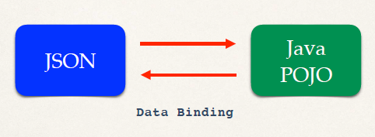

• **Java POJO**: Plain Old Java Object. (Any old java class)

**JSON Data Binding with Jackson**

• Spring uses the **Jackson Project** behind the scenes.

• Jackson handles data binding between JSON and Java POJO

• Details on Jackson Project:

* Jackson is a separate project for doing data binding.
* There is a lot of synergy between Jackson and Spring
* It has support for doing data binding with XML, JSON.
* Very popular project for any type of JSON development in the java world or any REST development.

<https://github.com/FasterXML/jackson-databind>

• By default, Jackson will call appropriate getter/setter method when it is handling the conversion.

JSON to POJO – call setter methods on POJO

POJO to JSON – call getter methods on POJO

(Jackson will handle getting the data sent out accordingly to a JSON string either to a memory or to a given file)

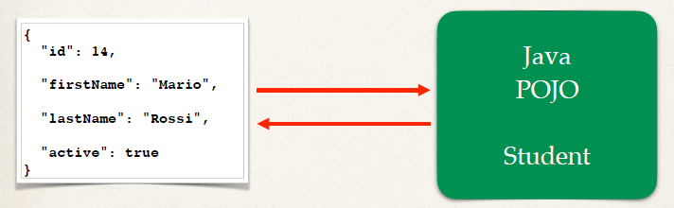

**Note:** Jackson calls the setXXX methods. It does NOT access internal private fields directly

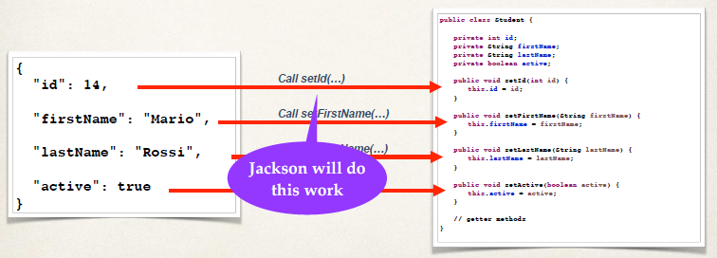

**Spring and Jackson Support**

• When building Spring REST applications, Spring will automatically handle Jackson Integration.

(Spring Boot Starter Web automatically includes dependency for Jackson)

• JSON data being passed to REST controller is converted to POJO automatically

• Java object being returned from REST controller is converted to JSON automatically behind the scenes.

**Spring REST Service – Students**

**Create a New Service**

• Return a list of students

**GET** /api/students **Returns a list of students**

**Spring REST Service**

• REST client accesses the request mapping **/api/students** and REST service return a list of students.

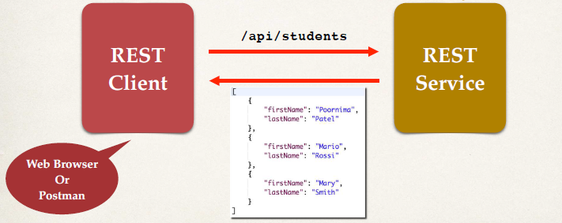

**Convert Java POJO to JSON**

• Our REST Service will return List<Student>

• Need to convert List<Student> to JSON

• Jackson can help us out with this …

**Student POJO (class)**

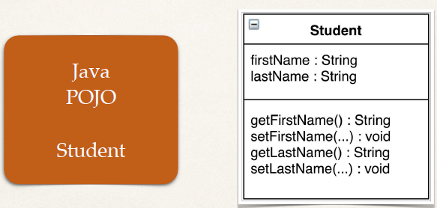

**Behind the scenes**

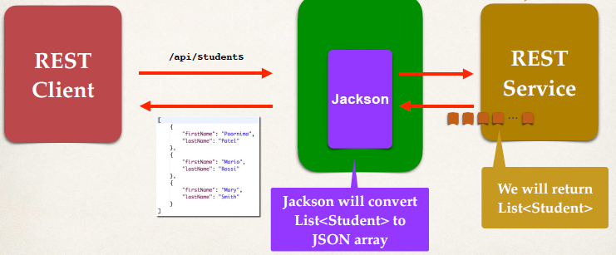

**Development Process** (Step-By-Step)

1. Create Java POJO class for Student

2. Create Spring REST Service using @RestController

**Step 1: Create Java POJO class for Student**

• In POJO class we will add Fields, Constructors and Getter/Setters methods.

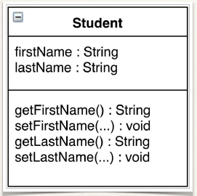

*File: Student.java*

**public class Student {**

**private String firstName;**

**private String lastName;**

**public Student() {**

**}**

**public Student(String firstName, String lastName) {**

**this.firstName = firstName;**

**this.lastName = lastName;**

**}**

**public String getFirstName() {**

**return firstName;**

**}**

**public void setFirstName(String firstName) {**

**this.firstName = firstName;**

**}**

**public String getLastName() {**

**return lastName;**

**}**

**public void setLastName(String lastName) {**

**this.lastName = lastName;**

**}**

**}**

**Step 2: Create @RestController**

• We'll hard code for student data list for now … we can add DB later.

• Jackson will convert return List<Student> to JSON array.

*File: StudentRestController.java*

**@RestController**

**@RequestMapping("/api")**

**public class StudentRestController {**

**// define endpoint for "/students" - return list of students**

**@GetMapping("/students")**

**public List<Student> getStudents() {**

**List<Student> theStudents = new ArrayList<>();**

**theStudents.add(new Student("Poornima", "Patel"));**

**theStudents.add(new Student("Mario", "Rossi"));**

**theStudents.add(new Student("Mary", "Smith"));**

**return theStudents;**

**}**

**}**

**Spring REST - Path Variables**

**Path Variables**

• Retrieve a single student by id

**GET** /api/students/ **{studentId}** **Returns / Retrieve a single student**

/api/students/**0**

/api/students/**1**

/api/students/**2**

**Development Process**

1. Add request mapping to Spring REST Service

๏ Bind path variable to method parameter using **@PathVariable**

**Step 1: Add Request Mapping**

• Here the getter method **getStudent** (…) will return the student at given student index.

• Bind the path variable coming-in on the URL. Bind it and assign it to the variable as a method parameter ‘**studentId**’ (by default, must match).

*File: StudentRestController.java*

**@RestController**

**@RequestMapping("/api")**

**public class StudentRestController {**

**// define endpoint for "/students/{studentId}" - return student at index**

**@GetMapping("/students/{studentId}")**

**public Student getStudent(@PathVariable int studentId) {**

**List<Student> theStudents = new ArrayList<>();**

**// populate theStudents**

**…**

**return theStudents.get(studentId);**

**}**

**}**

**Spring REST - Exception Handling**

• Like we get the error for

java.lang.IndexOutOfBoundsException: Index 40 out of bounds for length 3

**Error on Browser: -**

**Whitelabel Error Page**

This application has no explicit mapping for /error, so you are seeing this as a fallback.

Sat Jan 27 12:26:24 IST 2024

There was an unexpected error (type=Internal Server Error, status=500).

**Error on Postman: -**

{

    "timestamp": "2024-01-27T06:55:16.559+00:00",

    "status": 500,

    "error": "Internal Server Error",

    "path": "/api/students/40"

}

• We need to **Handle the exception and return error as JSON.**

• Instead of the Error message on browser it will show us the error as JSON.

•

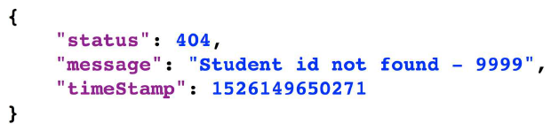

**Development Process** (Step by Step)

1. Create a custom error response class

2. Create a custom exception class

3. Update REST service to throw exception if student not found

4. Add an exception handler method using springs annotation **@ExceptionHandler**

**Step 1: Create custom error response class**

• The custom error response class will be sent back to client as JSON

• We will define as Java class (POJO).

We will keep track of three fields here *Status, Message* and *TimeStamp.*

• Jackson will handle converting this POJO to JSON, which will go back to the client.

**N.B:**  With this POJO here we can track any custom field we want to track. As it’s regular java POJO, it can easily extend and easily add our own custom filed.

*File:* ***StudentErrorResponse****.java*

**public class StudentErrorResponse {**

**private int status;**

**private String message;**

**private long timeStamp;**

**// constructors**

**// getters / setters**

**}**

 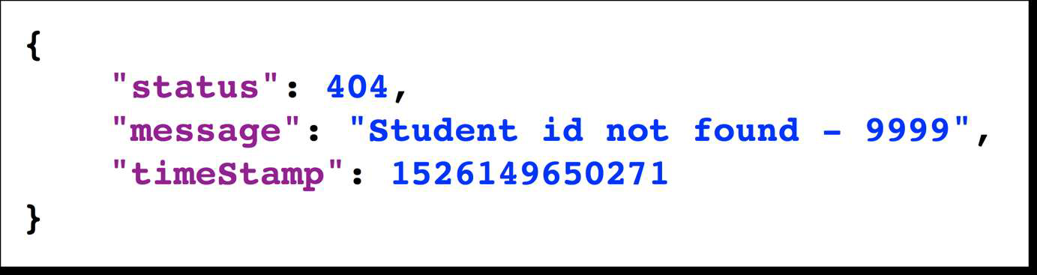

**Step 2: Create custom student exception**

• The custom student exception will used by our REST service

• In our code, if we can't find student, then we'll throw an exception

• Need to define a custom student exception class

• StudentNotFoundException

*File:* ***StudentNotFoundException****.java*

**public class StudentNotFoundException** **extends RuntimeException {**

**public StudentNotFoundException(String message) {**

**super(message);**

**}**

**}**

• Here our exception class **StudentNotFoundException** extends **RuntimeException.**

• Then we define a constructor. Inside this constructor we call super class constructor for the message.

• Since, we are using in-heritance we don’t need to write much code here.

• It is a very common approach for creating exceptions.

**Step 3: Update REST service to throw exception**

*File:* ***StudentRestController.java***

@RestController

@RequestMapping("/api")

public class StudentRestController {

**@GetMapping("/students/{studentId}")**

**public Student getStudent(@PathVariable int studentId) {**

**// check the studentId against list size**

**if ( (studentId >= theStudents.size()) || (studentId < 0) ) {**

**throw new StudentNotFoundException("Student id not found - " + studentId);**

**}**

**return theStudents.get(studentId);**

**}**

…

**}**

• Now suppose we get a bad request with index 9999. And our RSET service throw an exception. But the next thing is **exception handler,** who is going to handle the exception. And how it will send the appropriate JSON to the client.

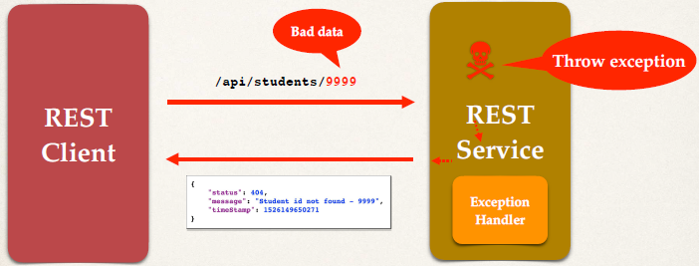

**Step 4: Add exception handler method**

• Define exception handler method(s) with **@ExceptionHandler** annotation from spring.

• This Exception handler will return a **ResponseEntity**

• ResponseEntity is a wrapper for the HTTP response object

• ResponseEntity provides fine-grained control to specify actual:

• HTTP status code, HTTP headers and Response body

• So, we have bit more control over, how we send back the response to the calling program.

*File: StudentRestController.java*

@RestController

@RequestMapping("/api")

public class StudentRestController {

**…**

**@ExceptionHandler**

**public ResponseEntity<StudentErrorResponse> handleException(StudentNotFoundException exc) {**

**StudentErrorResponse error = new StudentErrorResponse();**

**error.setStatus(HttpStatus.*NOT_FOUND*.value());**

**error.setMessage(exc.getMessage());**

**error.setTimeStamp(System.*currentTimeMillis*());**

**return new ResponseEntity<>(error, HttpStatus.*NOT_FOUND*);**

**}**

**}**

• **Exception handling method:** Through annotation **@ExceptionHandler** we specify this method is an Exception handling method.

• Here method name is **handleException.**

• **Type of the response body:** We also specify the Type of the response body.

• **ResponseEntity** <**StudentErrorResponse>** This is the type of data we are going to pass back in the response body.

• **Exception type to handle/catch:** We also tell, these are the type exceptions that we can handle for this given handler method.

• And here we have that is **StudentNotFoundException**

• So, any **StudentNotFoundException** are thrown, this actual handler method will catch it and work on it accordingly

• **error**: Error response body

• Jackson will convert the returned error response into JSON.

**Spring REST - Global Exception Handling**

It works, but …

• Exception handler code is only for the specific REST controller

• Large projects will have multiple controllers. It can't be reused by other controllers :-(

• We need **global** exception handlers.

• Promotes reuse

• Centralizes exception handling

• Also, minimize the use duplicate code for multiple controllers on large project.

**Spring @ControllerAdvice**

• **@ControllerAdvice** is similar to an interceptor / filter

• Pre-process requests to controllers

• Post-process responses to handle exceptions

• Perfect for global exception handling

• This is Real-time use of AOP to pre-process and post-process on controllers.

**Spring REST Exception Handling: -**

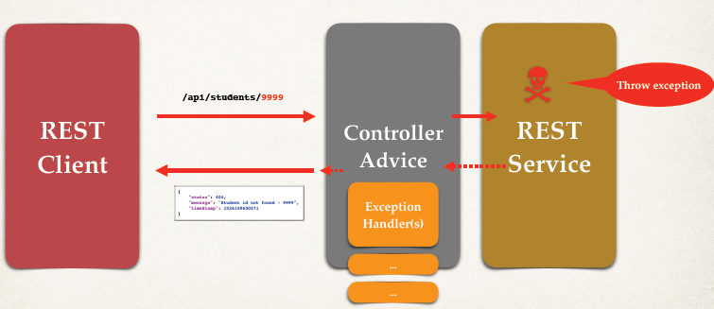

• We have REST Client and REST Service. We make a request across to the actual service.

• Then we have the Controller-Advice between them to kind of, pre-process the request.

• Then the REST service will execute. If there is something wrong, we will throw an exception.

• And now, instead of the exception handlers being in the REST service, Exception-Handlers are moved out and placed in the **controller advice**. This will give us support for global exception handling.

• No need to write exception handling in each REST service, we can place it at one global location to handle all those requests. We can do it by help of Controller advice.

**Development Process** (Step-By-Step)

1. Create new @ControllerAdvice

2.Refactor REST service … remove exception handling code

3. Add exception handling code to @ControllerAdvice

• Create an Exception handler class and annotated it with **@ControllerAdvice.**

• @ControllerAdvice from actual Spring framework.

• Put the @ExceptionHandler method inside the controller Advice class.

File: StudentRestExceptionHandler.java

**@ControllerAdvice**

**public class StudentRestExceptionHandler {**

…

**@ExceptionHandler**

**public ResponseEntity<StudentErrorResponse> handleException(StudentNotFoundException exc) {**

**StudentErrorResponse error = new StudentErrorResponse();**

**error.setStatus(HttpStatus.*NOT_FOUND*.value());**

**error.setMessage(exc.getMessage());**

**error.setTimeStamp(System.*currentTimeMillis*());**

**return new ResponseEntity<>(error, HttpStatus.*NOT_FOUND*);**

**}**

**}**

**Spring REST API Design**

**REST API Design:**

• For real-time projects, **who will use your API?**

• Also, **how will they use your API?**

• Design the API based on requirements

**API Design Process** (Step-By-Step)

1. Review API requirements

2. Identify main resource / entity

3. Use HTTP methods to assign action on resource

**Step 1: API requirements:**

Create a REST API for the Employee Directory

REST clients should be able to

• Get a list of employees

• Get a single employee by id

• Add a new employee

• Update an employee

• Delete an employee

- We are going to need full CRUD support here for the API.

**Step 2: Identify main resource / entity**

• To identify main resource / entity, look for the most prominent "noun"

• For our project, it is "employee"

• Convention is to use plural form of resource / entity: **employees**

**/api/employees**

**Step 3: Use HTTP methods to assign action on resource**

Full **CRUD** methods.

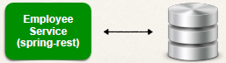

HTTP Method CRUD Action

**POST** **C**reate a new entity

**GET** **R**ead a list of entities or single entity

**PUT** **U**pdate an existing entity

**DELETE** **D**elete an existing entity

**Employee Real-Time Project:**

HTTP Method Endpoint CRUD Action

POST **/api/employees** Create a new employee

GET **/api/employees** Read a list of employees

GET **/api/employees/{employeeId}** Read a single employee

PUT **/api/employees** Update an existing employee

DELETE **/api/employees/{employeeId}** Delete an existing employee

• For POST and PUT, we will send employee data. We can send it over as JSON data.

**Anti-Patterns**

• DO NOT DO THIS … these are REST anti-patterns, bad practice

• Don't include actions in the endpoint like below. Instead, use HTTP methods to assign actions.

/api/employeesList

/api/deleteEmployee

/api/addEmployee

/api/updateEmployee

**More API Examples: -**

• On the following slides, we’ll look at APIs from other real-time projects.

• **PayPal**

PayPal Invoicing API

<https://developer.paypal.com/docs/api/invoicing/>

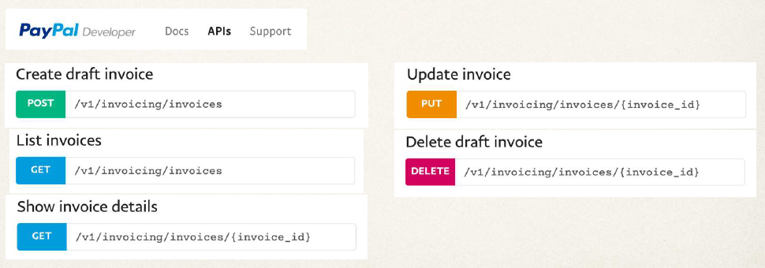

• **GitHub**

GitHub Repositories API

<https://developer.github.com/v3/repos/#repositories>

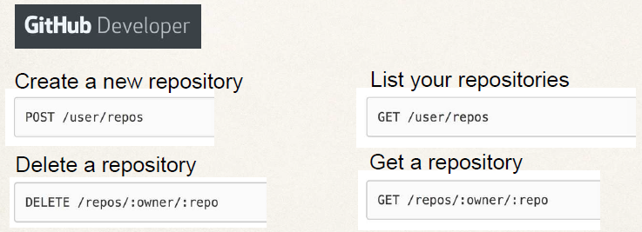

• **SalesForce**

SalesForce REST API - **Industries REST API**

<https://sforce.co/2J40ALH>



Different Endpoints:

Retrieve All Individuals

**GET** /services/apexrest/v1/individual/

Retrieve One Individual

**GET** /services/apexrest/v1/individual/{individual_id}

Create an individual

**POST** /services/apexrest/clinic01/v1/individual/

Update an individual

**PUT** /services/apexrest/clinic01/v1/individual/

**Spring Boot REST API - Real Time Project**

**Real-Time Project:**

REST API *with Spring Boot* that connects to a database.

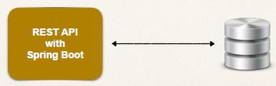

**API requirements:**

Create a REST API for the Employee Directory

REST clients should be able to

• Get a list of employees

• Get a single employee by id

• Add a new employee

• Update an employee

• Delete an employee

HTTP Method Endpoint CRUD Action

POST **/api/employees** **C**reate a new employee

GET **/api/employees** **R**ead a list of employees

GET **/api/employees/{employeeId}** **R**ead a single employee

PUT **/api/employees** **U**pdate an existing employee

DELETE **/api/employees/{employeeId}** **D**elete an existing employee

**Development Process** (Step-By-Step)

1. Set up Database Dev Environment

2. Create Spring Boot project using Spring Initializr

3. Get list of employees

4. Get single employee by ID

5. Add a new employee

6. Update an existing employee

7. Delete an existing employee

**Application Architecture**

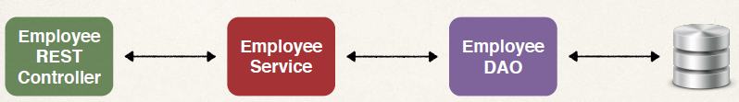

**Step 1: Setup Database Table**

1. File: employee.sql

2. Create a new database table: **employee.** This table has four field- **id, first_name, last_name** and **email**

3. Also load table with sample data.

**employee.sql**

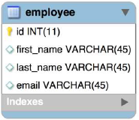

**Step 2: Create Spring Boot project using Spring Initializr**

<https://start.spring.io/>

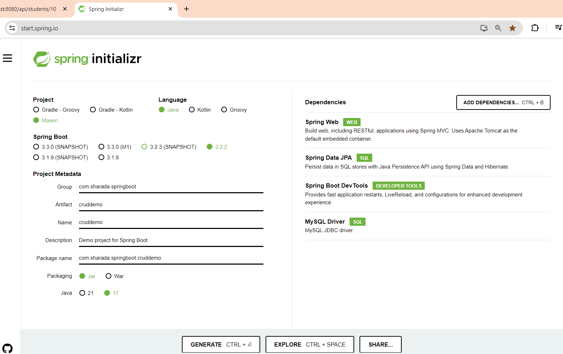

• We also added the **MySQL Driver** Dependency, so MySQL JDBC Drivers will automatically added to our project.

**Create JPA DAO in Spring Boot**

**Application Architecture**

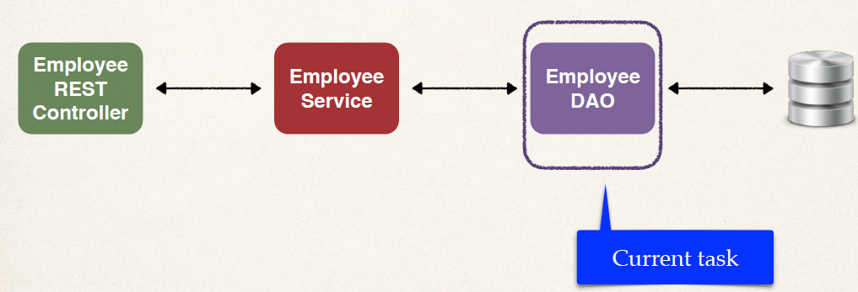

• Build a DAO layer for this.

• Now we use Standard JPA API.

**Step 3 to 7:**

3. Get list of employees

4. Get single employee by ID

5. Add a new employee

6. Update an existing employee

7. Delete an existing employee

**DAO Interface**

**public interface EmployeeDAO {**

**List<Employee> findAll();**

**}**

**DAO Impl**

**@Repository**

**public class EmployeeDAOJpaImpl implements EmployeeDAO {**

**private EntityManager entityManager;**

**@Autowired**

**public EmployeeDAOJpaImpl(EntityManager theEntityManager) {**

**entityManager = theEntityManager;**

**}**

**…**

**}**

• Implement the employee DAO interface. We are using same interface, so we have a consistent API.

• We make use of our filed here, private entity manager.

• Then we setup constructor here. We are doing Constructor injection here for EntityManager.

**N.B:**

• **EntityManager** is automatically created by spring boot. EntityManager is main component for creating queries and executing queries, etc …

• EntityManager is from Jakarta Persistence API (JPA)

**Step 3: Get list of employees** using standard JPA API:

• Create a query JPQL

**@Override**

**public List<Employee> findAll() {**

**// create a query**

**TypedQuery<Employee> theQuery =**

**entityManager.createQuery("from Employee", Employee.class);**

**// execute query and get result list**

**List<Employee> employees = theQuery.getResultList();**

**// return the results**

**return employees;**

**}**

**Development Process** (Step-By-Step) for DAO:

1. Update db configs in *application.properties*

2. Create Employee entity

3. Create DAO interface

4. Create DAO implementation

5. Create REST controller to use DAO

**N.B:** We need a rest controller to use DAO.

**Define Services with @Service**

**Refactor: Add a Service Layer:**

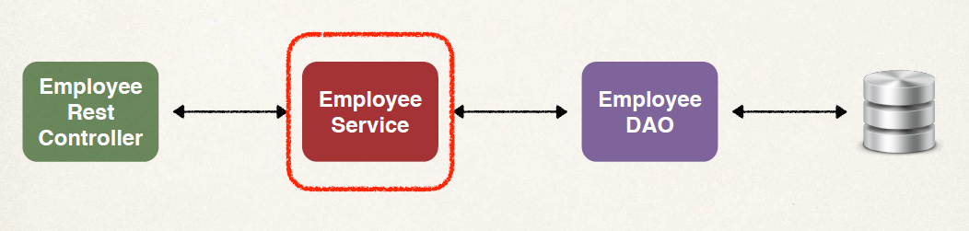

• We are adding Service layer, this service stays in between Controller and DAO.

• Service layer is actually an implementation of Service Facade design pattern.

**Purpose of Service Layer**

✤ Service Facade design pattern

✤ **Intermediate layer for custom business logic**

✤ We can also use it to Integrate data from multiple sources (DAO/repositories)

**Integrate Multiple Data Sources**

• Integrating data from multiple sources.

For example: - We have our employee service, and we need to pull in data about an employee from different type of data source.

• Employee DAO which gives us the basic information of employee like first-name, last-name and email…

• We also may need to get a list of skills for an employee, we can make use of the skills DAO.

• Similarly, we can make use of the payroll DAO to retrieve salary information for an employee.

• Then we integrate all of this together, so we can provide the controller a single view of all the data that we have integrated from multiple backend data sources and pull together.

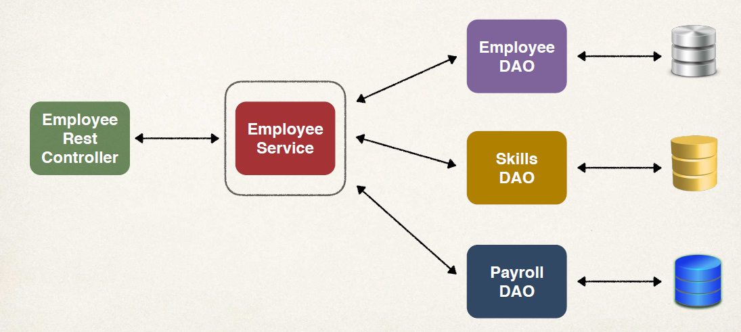

**Most Times - Delegate Calls**

• Most of the time when we start, we have a very simple architecture – We have our service, that delegates the call to DAO. This is actually a best practice to create a Service layer and a DAO layer.

• Once we have a basic architecture in place, we can easily expand and extend on it. This is actually a best practice for large scale enterprise applications.

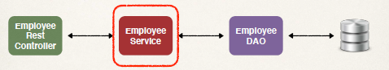

**Specialized Annotation for Services**

• Spring provides the @Service annotation. **@Service** is applied to Service implementations.

• Spring will automatically register the Service implementation, thanks to component-scanning.

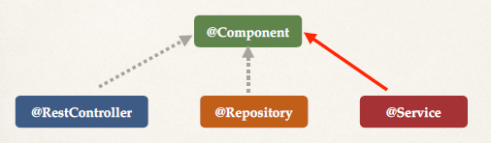

**Development Process** (Step-By-Step) – For Employee Service

1. Define Service interface

2. Define Service implementation

- Inject the EmployeeDAO

**Step 1: Define Service interface**

public interface EmployeeService {

List<Employee> findAll();

}

**Step 2: Define Service implementation**

• We have @Service annotation at the top. @Service - enables component scanning. Spring will automatically register this component.

• Then we inject our DAO using constructor injection.

• Then we write appropriate code for the method

**@Service**

**public class** EmployeeServiceImpl **implements** EmployeeService {

*// inject EmployeeDAO …*

**@Override**

**public** List<Employee> findAll() {

return employeeDAO.findAll();

}

}

**N.B:**

• Now we use a basic architecture of DAO and Service layer to make method call to interact with DB.

• The method call we were doing in REST controller by DAO object, that now we are doing inside the Service implementation class. And in REST controller we are calling the service method.

**DAO: Find, Add, Update and Delete**

**Service Layer - Best Practice:**

✤ Best practice is to apply transactional boundaries at the service layer

✤ It is the service layer’s responsibility to manage **transaction boundaries**

✤ It means for implementation code

✤ Apply **@Transactional** on service methods

✤ Remove @Transactional on DAO methods if they already exist

• Effectively we are shifting the @Transactional annotation from the DAO methods over to the Service methods, and remove @Transactional on DAO methods if they already exist. It is the best practice to manage the Transactions when we follow the architecture of Service and DAO layer.

**Additional DAO methods:**

Requirement for our project: -

**Step 4 to 7:**

3. Get list of employees

4. Get single employee by ID

5. Add a new employee

6. Update an existing employee

7. Delete an existing employee

• We will create the DAO methods for these.

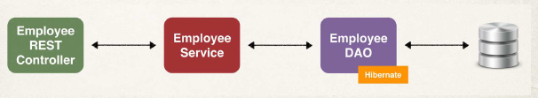

**4. DAO: Get a single employee: -**

**@Override**

**public Employee findById(int theId) {**

**// get employee**

**Employee theEmployee = entityManager.find(Employee.class, theId);**

**// return employee**

**return theEmployee;**

**}**

• Passing the employee ID in the method to find a single employee.

**5 & 6. DAO: Add or Update employee: -**

**@Override**

**public Employee save(Employee theEmployee) {**

**// save or update the employee**

**Employee dbEmployee = entityManager.merge(theEmployee);**

**// return dbEmployee**

**return dbEmployee;**

**}**

• We are passing the employee details that we want to add or update.

• We make use of **entityManager.merge** and pass the employee. Here the merge(…) method will perform a save or update, depending upon the ID of the entity.

• If the ID of the entity is equal to zero, then it will save or insert that given entity into the database, that like a new entry there. Else, if the id of entity is not zero it will do an update.

if id == 0

then save/insert

else update

• Return dbEmployee It has updated id from the database (in the case of insert). We make sure return the correct one. Because effectively we need the latest version from the database not the one that passed on.

• As we know we don’t use @Transactional here at DAO layer, because it will be handled at Service layer. The Transaction is managed at the service layer.

**7. DAO: Delete an existing employee**

**@Override**

**public void deleteById(int theId) {**

**// find the employee by id**

**Employee theEmployee = entityManager.find(Employee.class, theId);**

**// delete the employee**

**entityManager.remove(theEmployee);**

**}**

• We Pass an employee ID. We first the employee **entityManager.find(…,…)** , then we say entity manager to remove the employee **entityManager.remove(…).**

**Service: Find, Add, Update and Delete**

**Service Methods**

• Similarly, also add methods to service implementations like we added in the DAO implementation.

**Development Process (Step-By-Step)**

1. Set up Database Dev Environment

2. Create Spring Boot project using Spring Initializr

3. Get list of employees

4. Get single employee by ID

5. Add a new employee

6. Update an existing employee

7. Delete an existing employee

**N.B:** Above highlighted are **Service Methods** we add in service implementation class.

**Rest Controller Methods – Find and Add**

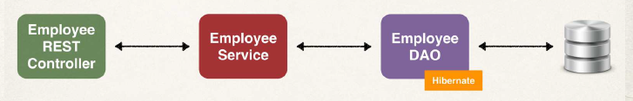

**Development Process** (Step-By-Step)

1. Set up Database Dev Environment

2. Create Spring Boot project using Spring Initializr

3. Get list of employees

**4. Get single employee by ID**

**5. Add a new employee**

6. Update an existing employee

7. Delete an existing employee

**N.B: :** We are going to write code for above highlighted are **Rest Controller methods.**

|  |  |  |
| --- | --- | --- |
| **HTTP Method** | **Endpoint** | **CRUD Action** |
| POST | /api/employees | **C**reate a new employee |
| GET | /api/employees | **R**ead a list of employees |
| GET | /api/employees/{employeeId} | **R**ead a single employee |
| PUT | /api/employees | **U**pdate an existing employee |
| DELETE | /api/employees/{employeeId} | **D**elete an existing employee |

**Read a Single Employee:**

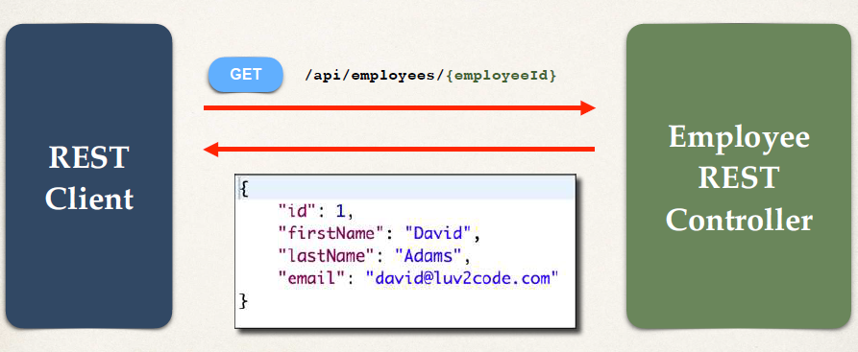

**Create a New Employee:**

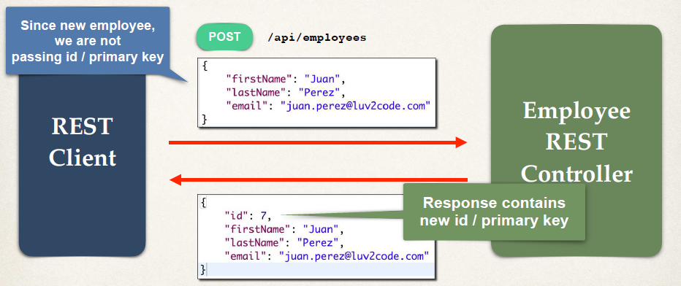

**Sending JSON to Spring REST Controllers:**

• When sending JSON data to Spring REST Controllers, we have to make sure we send the correct http request header. The header is content type of **application/json**

• For controller to process JSON data, need to set a HTTP request header

• **Content-type: application/json**

• Need to configure REST client to send the correct HTTP request header, so it process the data accordingly.

**Postman - Sending JSON in Request Body: -**

• We can use Postman app as a clint.

• Must set HTTP request header in Postman. We can select *Body* > *raw* data > choose content type of *JSON (application/json).*

• Based on these configs, Postman will automatically set the correct HTTP request header.

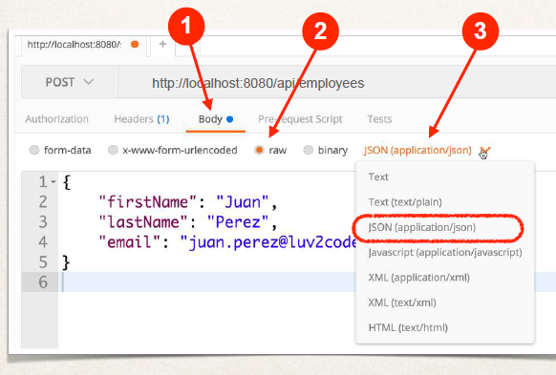

**Step 4: Get single employee by ID**

**Step 5: Add a new employee**

package com.sharada.springboot.cruddemo.rest;  
  
import com.sharada.springboot.cruddemo.entity.Employee;  
import com.sharada.springboot.cruddemo.service.EmployeeService;  
import org.springframework.web.bind.annotation.*;  
  
import java.util.List;  
  
@RestController  
@RequestMapping("/api")  
public class EmployeeRestController {  
  
  
 private EmployeeService employeeService;  
  
 public EmployeeRestController(EmployeeService theEmployeeService) {  
 this.employeeService = theEmployeeService;  
 }  
  
 // expose gateway "/employees" and return a list of employees  
 @GetMapping("/employees")  
 public List<Employee> findAllEmployeeslist() {  
 return employeeService.findAll();  
 }  
  
  
 // Read single Employee  
 // add mapping for GET /employees/{employeeId}  
 @GetMapping("/employees/{employeeId}")  
 public Employee getEmployee(@PathVariable int employeeId) {  
  
 Employee theEmployee = employeeService.findById(employeeId);  
  
 if(theEmployee == null) {  
 throw new RuntimeException("Employee id not found - " + employeeId);  
 }  
  
 return theEmployee;  
 }  
  
 // Add a new Employee  
 // add mapping for POST /employees  
 @PostMapping("/employees")  
 public Employee addEmployee(@RequestBody Employee theEmployee) {  
  
 // also just in case they pass an id in JSOn ... set id to 0  
 // this is to force save of new item ... instead of update  
  
 theEmployee.setId(0);  
  
 Employee dbEmployee = employeeService.save(theEmployee);  
  
 return dbEmployee;  
 }  
}

• GET method is used, when we are trying to fetch some data from database through the request.

• We use annotation **@GetMapping** to handle GET operation.

• POST method is used, when we are sending some data in the request to add a new data or do insert in database

• We use annotation **@PostMapping** to handle POST operation.

• We use annotation **@PathVariable** when take data came in request url path …/{…} as input and use it in our method.

• We use annotation **@RequestBody** when a set of data (like JSON, etc,..) came through request and we take it as input to perform POST or PUT operation (insert or update) on database.

**Rest Controller Methods - Update and Delete**

**Development Process** (Step-By-Step)

1. Set up Database Dev Environment

2. Create Spring Boot project using Spring Initializr

3. Get list of employees

4. Get single employee by ID

5. Add a new employee

**6. Update an existing employee**

**7. Delete an existing employee**

**N.B:** We are going to write code for above highlighted are **Rest Controller methods**.

|  |  |  |
| --- | --- | --- |
| **HTTP Method** | **Endpoint** | **CRUD Action** |
| POST | /api/employees | **C**reate a new employee |
| GET | /api/employees | **R**ead a list of employees |
| GET | /api/employees/{employeeId} | **R**ead a single employee |
| **PUT** | /api/employees | **U**pdate an existing employee |
| **DELETE** | /api/employees/{employeeId} | **D**elete an existing employee |

**Update Employee**

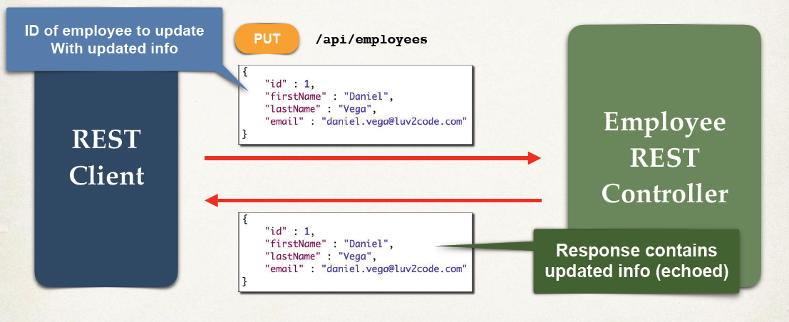

**Delete Employee**

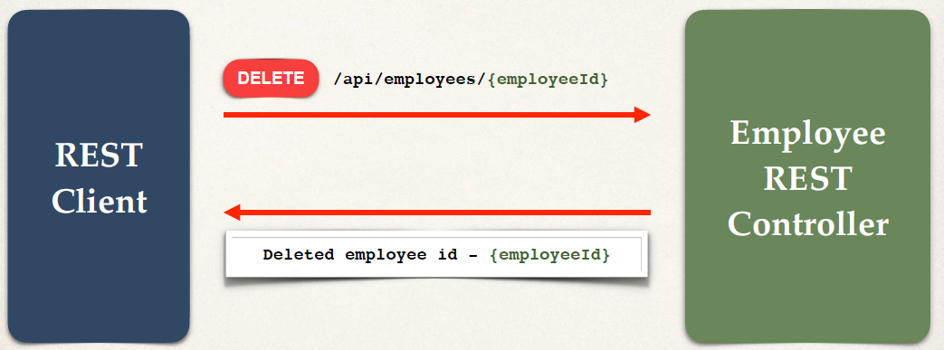

**Step 6: Update an existing employee**

**Step 7: Delete an existing employee**

// add mapping for PUT /employees - update existing employee  
  
@PutMapping("/employees")  
public Employee updateEmployee(@RequestBody Employee theEmployee) {  
  
 Employee dbEmployee = employeeService.save(theEmployee);  
  
 return dbEmployee;  
}  
  
// add mapping for DELETE /employees/{employeeId} - delete employee  
  
@DeleteMapping("/employees/{employeeId}")  
public String deleteEmployee(@PathVariable int employeeId) {  
  
 Employee tempEmployee = employeeService.findById(employeeId);  
  
 // throw exception if null  
 if(tempEmployee == null) {  
 throw new RuntimeException("Employee id not found -" + employeeId);  
 }  
  
 employeeService.deleteById(employeeId);  
  
 return "Deleted employee id - " + employeeId;  
}

• Same method **save(…)** called for both **POST** and **PUT** operation. And the save(…) method use the method **Entitymanager.merge (…)** in DAO implementing class. Remember the method **merge(…)** do insert or update on database based on the id or primary key (passed in entity parameter).

• DELETE method is used, when we are trying to Delete some data from database passing the id or primary key.

• We use annotation **@DeleteMapping** to handle DELETE operation.

**Spring Data JPA in Spring Boot**

**Spring Data JPA**

**Application Architecture:**

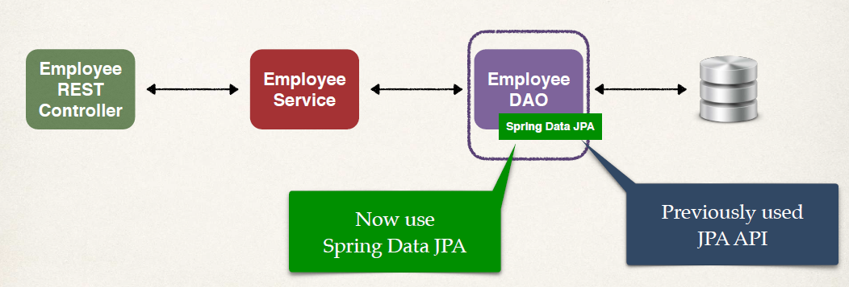

• Now we are going to use **Spring Data JPA** for backend DAO.

**The Problem**

• We saw how to create a DAO for Employee

• What if we need to create a DAO for another entity?

• Customer, Student, Product, Book …

• Do we have to repeat all of the same code again???

**Creating DAO**

• You may have noticed a pattern with creating DAOs. Most of them will be same, same methods and all for other entities. Only difference is the entity type and primary key.

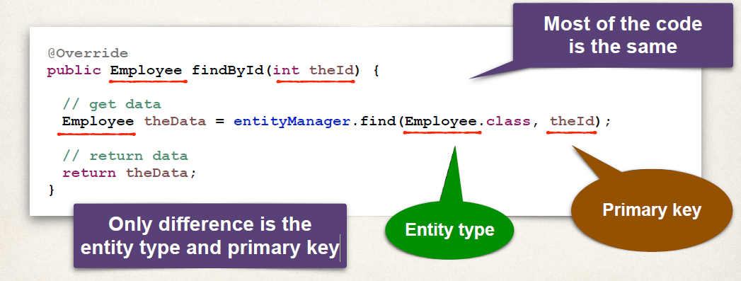

**My Wish there is an easier solution…**

• I wish we could tell Spring: “**Create a DAO for me. I will simply Plug in my entity type and primary key. And it will give me all of the basic CRUD features for free**”

**My Wish Diagram**

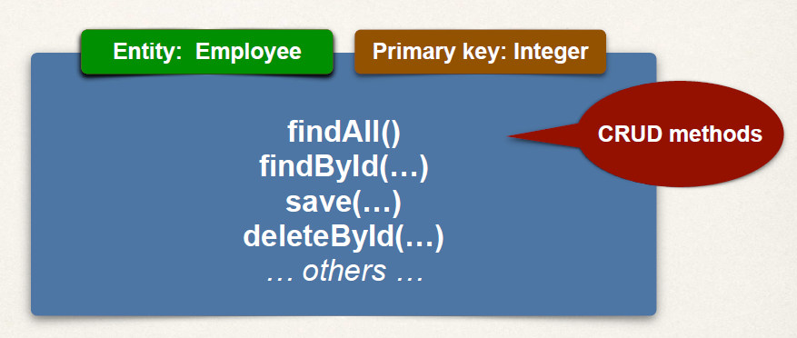

**Spring Data JPA – Solution**

• There is a solution that is **Spring Data JPA.** It is one of the project of spring.io website.

• We can use it in spring and spring boot.<https://spring.io/projects/spring-data-jpa>

• So basically, we will create a DAO and just plug in our **entity type** and **primary key**

• Spring will give you a CRUD implementation for FREE …. like MAGIC!!

• Helps to minimize boiler-plate DAO code … yaaay!!!

• We can actually get more than 70% reduction in code by using Spring Data JPA … depending on use case

**JpaRepository**

• Spring Data JPA provides the interface: **JpaRepository**

• It Exposes methods (some by inheritance from parents) and these are CRUD methods, that we can use.

• It expose methods - findAll() ; findById(…) ; save(…) ; deleteById(…) ; others

• We simply plugin our **entity type** and the **type of our** **primary key** then, we magically get access to all of these CRUD methods for free, without having to write any implementation code.

**Development Process** (Step-By-Step)

1. Extend **JpaRepository** interface

2. Use our Repository in our application

**N.B:** There is no need for an implementation class.

**Step 1: Extend JpaRepository interface**

• **JpaRepository Docs:** Full list of methods available … see JavaDoc for JpaRepository

[www.luv2code.com/jpa-repository-javadoc](http://www.luv2code.com/jpa-repository-javadoc)

• Plugin our **entity type: Employee** and the **type of our** **primary key: Integer.**

**public interface EmployeeRepository extends JpaRepository<Employee, Integer> {**

**// that's it ... no need to write any code LOL!**

**}**

**Step 2: Use Repository in your app**

**@Service**

**public class EmployeeServiceImpl implements EmployeeService {**

**private EmployeeRepository employeeRepository;**

**@Autowired**

**public EmployeeServiceImpl(EmployeeRepository theEmployeeRepository) {**

**employeeRepository = theEmployeeRepository;**

**}**

// Directly calling the findAll(…) method without writing

**@Override**

**public List<Employee> findAll() {**

**return employeeRepository.findAll();**

**}**

**…**

**}**

• To use our Repository in our application, we basically setup our service. – **EmployeeServiceImpl**

• Then we make use of our new repository that we just created **EmployeeRepository.**

• Then we setup some constructor injection

• Then with our application architecture, Employee service will use our Employee Repository and our repository make use of Spring Data JPA to give us that DAO functionality.

• We are calling a method (like findAll(…) )on our repository that magically available via repository by simply extending of JPA repository interface.

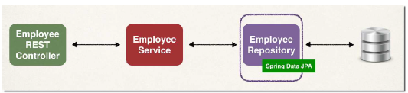

**Advanced Features of Spring data JPA**

• Advanced features available for

• Extending and adding custom queries with JPQL

• Query Domain Specific Language (Query DSL)

• Defining custom methods (low-level coding) required for specific business requirement.

• We can find more details on advance features of Spring data JPA - URL [www.luv2code.com/spring-data-jpa-defining-custom-queries](http://www.luv2code.com/spring-data-jpa-defining-custom-queries)

**N.B:**

• "**Optional**" this feature introduced in java 8. JPA Repository makes use of Optional.

• Optional is a Different pattern instead of having to check for nulls. We can make use of *Optional* to see if the value is present.

• it’s a basic approach for getting data without having to explicitly check for null.

• We can find more details on “*Optional*”on URL [www.luv2code.com/java-optional-tutorial](http://www.luv2code.com/java-optional-tutorial)

• “***Optional***” used in **findById(…)** method in service implementation class.

@Override  
public Employee findById(int theId) {  
 Optional<Employee> result = employeeRepository.findById(theId);  
  
 Employee theEmployee = null;  
  
 if(result.isPresent()) {  
 theEmployee = result.get();  
 }  
 else {  
 // we didn't find the employee  
 throw new RuntimeException("Did not find employee id - " + theId)  
 }

• We remove annotation @Transactional, since JPA Repository provides this functionality.

**Spring Data REST in Spring Boot**

**Spring Data REST**

**Spring Data JPA**

• Earlier, we saw the magic of Spring Data JPA

• This helped to eliminate boilerplate code

**Can this apply to REST APIs?**

**The Problem**

• We saw how to create a REST API for Employee.

• We setup our Employee REST controller – inject a service – setup the GET mappings, POST mappings and so on … Then we setup our service interface and service implementation.

• Then we have our application architecture with our REST Controller – our Service – our Repository.



• So, what happen we need to create REST API for another entity?

Like for Customer, Student, Product, Book, … Do we have to repeat all the same code again ??

We don’t want to do that over again & again for each entity …

**My Wish there is an easier solution…**

• I wish we could tell Spring: “**Create a REST API for me. Use my existing JpaRepository (entity, primary key). Give me all of the basic REST API CRUD features for free**”

**Spring Data REST – Solution**

• **Spring Data REST** is the solution !!!!

<https://spring.io/projects/spring-data-rest>

• We can use it with regular Spring or Spring Boot

• It Leverages your existing **JpaRepository**

• Spring will give you a REST CRUD implementation for FREE …. Like MAGIC!!

• Helps to minimize boiler-plate REST code!!!

• No new coding required !!! to get set up with the Spring Data Rest.

**REST API**

• Spring Data REST will expose these endpoints for free!. No more manual mapping required for these endpoints.

|  |  |  |
| --- | --- | --- |
| **HTTP Method** | **Endpoint** | **CRUD Action** |
| **POST** | **/api/employees** | **Create a new employee** |
| **GET** | **/api/employees** | **Read a list of employees** |
| **GET** | **/api/employees/{employeeId}** | **Read a single employee** |
| **PUT** | **/api/employees** | **Update an existing employee** |
| **DELETE** | **/api/employees/{employeeId}** | **Delete an existing employee** |

**Spring Data REST - How Does It Work in background?**

• Spring Data REST will scan your project for **JpaRepository** sub-interfaces.

• And it’ll Expose REST APIs for each entity type for your JpaRepository

**public interface EmployeeRepository extends JpaRepository<Employee, Integer> {**

**}**

**REST Endpoints**

• By default, Spring Data REST will create endpoints based on entity type

• It will use Simple pluralized form for endpoints– for example **/employees** for entity **Employee.**

• First character of Entity type is lowercase

• Then just adds an "s" to the entity

**Development Process** (Step-By-Step)

1. Add Spring Data REST to your Maven POM file

**Step 1: Add Spring Data REST to POM file**

**<dependency>**

**<groupId>org.springframework.boot</groupId>**

**<artifactId>spring-boot-starter-data-rest</artifactId>**

**</dependency>**

• Spring Data REST will scan for JpaRepository and expose these endpoints for free. Absolutely NO CODING required.

**In A Nutshell**

• So, for Spring Data REST, you only need 3 items

1. **Entity**: *Employee*

2. **JpaRepository**: *EmployeeRepository extends JpaRepository*

3. **Maven POM dependency** for: *spring-boot-starter-data-rest*

**Application Architecture:**

• Changes in Application architecture here,

• Before we have **Employee REST controller** <–> **Employee Service** <-> **Employee Repository.**

- By help of Spring Data JPA we handled the DAO.

• After using Spring Data REST, it will give us the required endpoints /employees, etc.. for free. No additional code required to get this given REST endpoints.

- So as per new architecture, we can delete the code for endpoints mapping from our Employee REST controller and also delete the Employee Service. Because we no longer need it since, Spring Data REST will provide that functionality

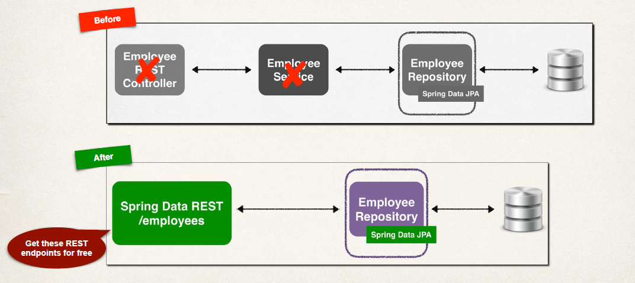

• We directly hit the URL or endpoint to check the result <http://localhost:8080/employees>

**HATEOAS**

• Spring Data REST endpoints are HATEOAS compliant.

• **HATEOAS**: **H**ypermedia **a**s **t**he **E**ngine **o**f **A**pplication **S**tate

• Hypermedia-driven sites provide information to access REST interfaces

• Think of it as meta-data for REST data that is coming back from these given REST APIs.

• For more details check <https://spring.io/understanding/HATEOAS>

• Spring Data REST response using HATEOAS.

• For example, REST response from: **GET /employees/3 ,**to get a single employee. It will return this JSON data as a response.

**{**

**"firstName": "Avani",**

**"lastName": "Gupta",**

**"email": "avani@luv2code.com",**

**"_links": {**

**"self": {**

**"href": "http://localhost:8080/employees/3"**

**},**

**"employee": {**

**"href": "http://localhost:8080/employees/3"**

**}**

**}**

**}**

- At top, here we have our actual content **Employee data** for given employee

- **HATEOAS Meta Data**: At bottom we have **response meta data**. These metadata here basically has **links to the actual entry or the data**.

• For a collection, meta-data includes page size, total elements, pages etc

• For example, REST response from: **GET /employees**

**{**

**"_embedded": {**

**"employees": [**

**{**

**"firstName": "Leslie",**

**...**

**},**

**...**

**]**

**},**

**"page": {**

**"size": 20,**

**"totalElements": 5,**

**"totalPages": 1,**

**"number": 0**

**}**

**}**

• HATEOAS uses Hypertext Application Language (**HAL**) data format. That’s the actual format of JSON data that’s being returned in the response.

• For details on HAL, check <https://en.wikipedia.org/wiki/Hypertext_Application_Language>

**N.B:**

• In JSON response, we can see the Id or Primary keys in meta data section.

{

"firstName": "Mary",

"lastName": "Lee",

"email": "mary@luv2code.com",

"_links": {

"self": {

"href": "http://localhost:8080/magic-api/employees/6"

},

"employee": {

"href": "http://localhost:8080/magic-api/employees/6"

}

}

}

• For update an employee data **in PUT request, Remember** **Spring Data REST only uses Id in the URL**. It ignores the past id in JSON request body. So **don’t pass the Id in the JSON request like we did before using Spring Data REST. Now pass the Id on the URL request.**

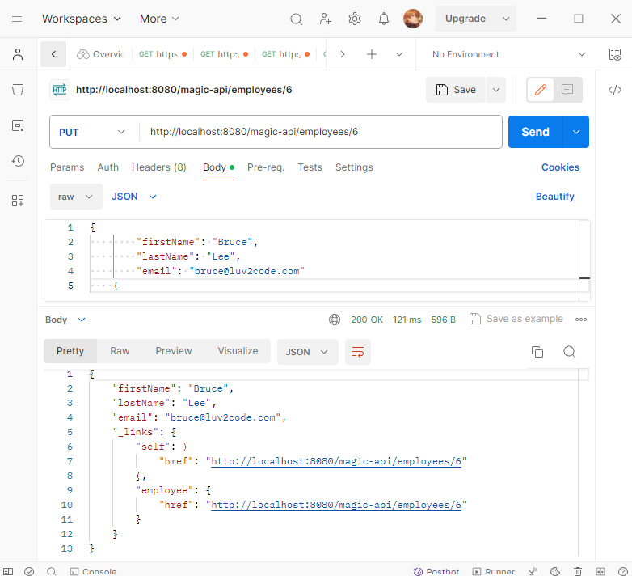

**Customize our endpoint base path**

• We can customize our endpoint base path to have more control on given URL.

• We will add some Spring Data REST properties to our **application.properties** file.

**spring.data.rest.base-path=/magic-api**

• Now we can only access the endpoints with this prefix **/magic-api/…**

<http://localhost:8080/magic-api/employees>

**Advanced Features of Spring Data REST**

• Spring Data REST also has advanced features

• It has support for **Pagination**, **sorting** and **searching**

• We can also **Extend and add custom queries with JPQL**

• We can also customize the REST API by making **use of Query Domain Specific Language (Query DSL)**

• For more information we can see <https://spring.io/projects/spring-data-rest>

**Spring Data REST Configuration, Pagination and Sorting**

**Spring Data REST Endpoints**

• By default, Spring Data REST will create endpoints based on entity type

• Simple pluralized form

• First character of Entity type is lowercase

• Then just adds an "s" to the entity

**public interface EmployeeRepository extends JpaRepository<Employee, Integer> {**

**}**

* /employees

**Pluralized Form**

• Spring Data REST pluralized form is VERY simple

• Just adds an "s" to the entity

• The English language is VERY complex! And Spring Data REST does NOT handle any special cases like correct plural form. In that case here Spring Data REST falls apart.

**Singular** **Plural**

Goose Geese

Person People

Syllabus Syllabi

… …

**Problem**

• Spring Data REST does not handle complex pluralized forms

• In this case, you need to manually specify plural name

• What if we want to expose a different resource name?

• Instead of **/employees** … use **/members**

**Solution**

• We can Specify plural name / path with an annotation **@RepositoryRestResource(path="xxxxxcustomResourceName")**

• Like for example: - For our employee repository, instead of endpoint “/employees”, we want to use “/members”.

- We use this new annotation **@RepositoryRestResource(path="members").** Here we give path value for our custom Resource name “members” for employees.

- Then we will have our endpoint URL of [**http://localhost:8080/members**](http://localhost:8080/members)

**@RepositoryRestResource(path="members")**

**public interface EmployeeRepository extends JpaRepository<Employee, Integer> {**

**}**

**Pagination:**

• By default, Spring Data REST will return the first 20 elements

• Page size = 20

• You can navigate to the different pages of data using query param

**http://localhost:8080/employees?page=0**

**http://localhost:8080/employees?page=1**

**…**

• Pages are zero-based. So the first page starting at page = 0.

**Spring Data REST Configuration:**

• Spring Data REST has following properties, that we can set in *application.properties* file.

|  |  |
| --- | --- |
| **Name** | **Description** |
| spring.data.rest.base-path | Base path used to expose repository resources |
| spring.data.rest.default-page-size | Default size of pages |
| spring.data.rest.max-page-size | Maximum size of pages |
| … | … |

• More properties available at [www.luv2code.com/spring-boot-props](http://www.luv2code.com/spring-boot-props)

• Scan the list for **spring.data.rest.\*** properties

**Sample Configuration:**

File: application.properties

**spring.data.rest.base-path=/magic-api**

- Now, we can access it through URL <http://localhost:8080/magic-api/employees>

**spring.data.rest.default-page-size=3**

- By setting default page size = 3, so it will return 3 elements per page.

**JSON Response:**

{

    "_embedded": {

        "employees": [

            {

                "firstName": "Leslie",

                "lastName": "Andrews",

                "email": "leslie@luv2code.com",

                "_links": {

                    "self": {

                        "href": "http://localhost:8080/magic-api/employees/1"

                    },

                    "employee": {

                        "href": "http://localhost:8080/magic-api/employees/1"

                    }

                }

            },

            {

                "firstName": "Emma",

                "lastName": "Baumgarten",

                "email": "emma@luv2code.com",

                "_links": {

                    "self": {

                        "href": "http://localhost:8080/magic-api/employees/2"

                    },

                    "employee": {

                        "href": "http://localhost:8080/magic-api/employees/2"

                    }

                }

            },

            {

                "firstName": "Avani",

                "lastName": "Gupta",

                "email": "avani@luv2code.com",

                "_links": {

                    "self": {

                        "href": "http://localhost:8080/magic-api/employees/3"

                    },

                    "employee": {

                        "href": "http://localhost:8080/magic-api/employees/3"

                    }

                }

            }

        ]

    },

    "_links": {

        "first": {

            "href": "http://localhost:8080/magic-api/employees?**page=0**&size=3"

        },

        "self": {

            "href": "http://localhost:8080/magic-api/employees?page=0&size=3"

        },

        "next": {

            "href": "http://localhost:8080/magic-api/employees?**page=1**&size=3"

        },

        "last": {

            "href": "http://localhost:8080/magic-api/employees?page=1&size=3"

        },

        "profile": {

            "href": "http://localhost:8080/magic-api/profile/employees"

        }

    },

    "page": {

        "size": 3,

        "totalElements": 5,

        "totalPages": 2,

        "number": 0 // First page number is zero

    }

}

**Sorting:**

• We can sort by the property names of our entity

• In our Employee example, we have: **firstName**, **lastName** and **email**

• Sort by last name (**ascending is default**) -> <http://localhost:8080/employees?sort=lastName>

• Sort by first name, descending -> <http://localhost:8080/employees?sort=firstName,desc>

• Sort by last name, then first name, ascending -> <http://localhost:8080/employees?sort=lastName,firstName,asc>

**DTO (Data Transfer Object) pattern**

• The Data Transfer Object (DTO) pattern is a design pattern that allows you to transfer data between different parts of your application.

• DTOS are simple objects that contain only data, and they do not contain any business logic. This makes them ideal for transferring data between different layers of your application, such as the presentation layer and the data access layer.

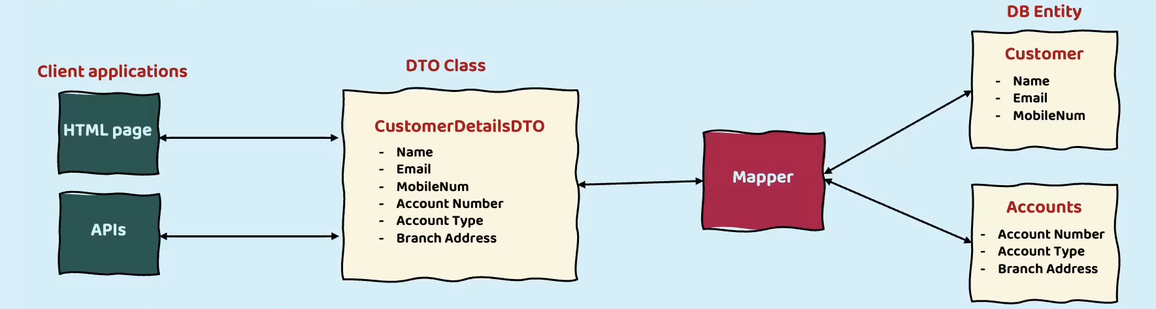

Here are some of the benefits of using the DTO pattern:

• **Reduces network traffic**: DTOs can be used to batch up multiple pieces of data into a single object, which can reduce the number of network requests that need to be made. This can improve performance and reduce the load on your servers.

• **Encapsulates serialization**: DTOs can be used to encapsulate the serialization logic for transferring data over the wire. This makes it easier to change the serialization format in the future, without having to make changes to the rest of your application.

• **Decouples layers**: DIOS can be used to decouple the presentation layer from the data access layer. This makes it easier to change the presentation layer without having to change the data access layer.

**Spring Boot REST API Security Overview**

• How to Secure Spring Boot REST APIs

• Define users and roles

• Protect URLs based on given role

• Store users, passwords and roles in DB (using plain-text -> encrypted format)

**Practical Results**

• Cover the most common Spring Security tasks that you will need on daily projects

• Not an A to Z reference … for that you can see Spring Security Reference Manual

<http://www.luv2code.com/spring-security-reference-manual>

**Spring Security Model**

• Spring Security defines a framework for security

• Implemented using Servlet filters in the background

• We can use Two methods of securing an app: **declarative** and **programmatic**

**Spring Security with Servlet Filters**

• Servlet Filters are used to pre-process / post-process web requests

• Servlet Filters can route web requests based on security logic

• Spring provides a bulk of security functionality with servlet filters

**Spring Security Overview**

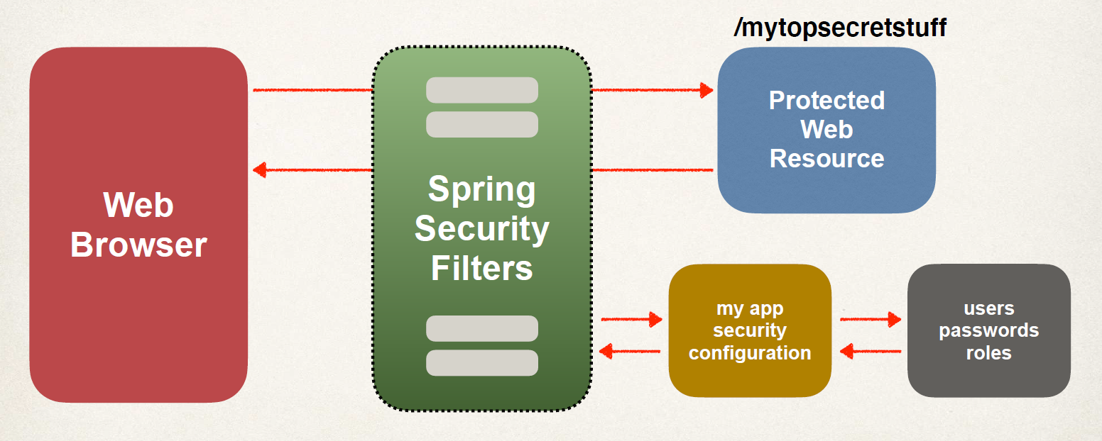

• We have our *Web browser* and the *Protected Web Resource.* Browser attempts to access the top-secret information and get the result. Spring Security comes into play in between this.

• Spring Security Filter will intercept those requests, pre-process them and then see if the user can actually access that protected resource.

• Spring Security will look into your application security configuration and then, it’ll also look at the user’s password and roles that are in your data base to see if this user is authenticated and also if they are authorized to access this web resource. This all happens in the background by Spring security.

**Spring Security in Action – Flow chart**

• Spring security Filter in action basically first check – “Is Web Resource Protected ?”

• If “YES” then, “is this user authenticated?”

• If “the user Not authenticated” then, send that user to login form. Show that Login form and take the user ID and password and *authenticate* it.

- Check this user ID and password is valid or not based on the information we have stored in our system. Then, if they pass test, so they’re authenticated.

• After authentication success it check, “If the user authorized ?” – Do they have authorization to access this resource? (Accessing all components is based on the user access level or Authorization role).

* There is additional security level at place and Spring has support for this using security roles.
* If you don’t have the given role, then it will say access denied. OR
* If you do have the given role, then it will actually show you the resource and give you access to this secure site.

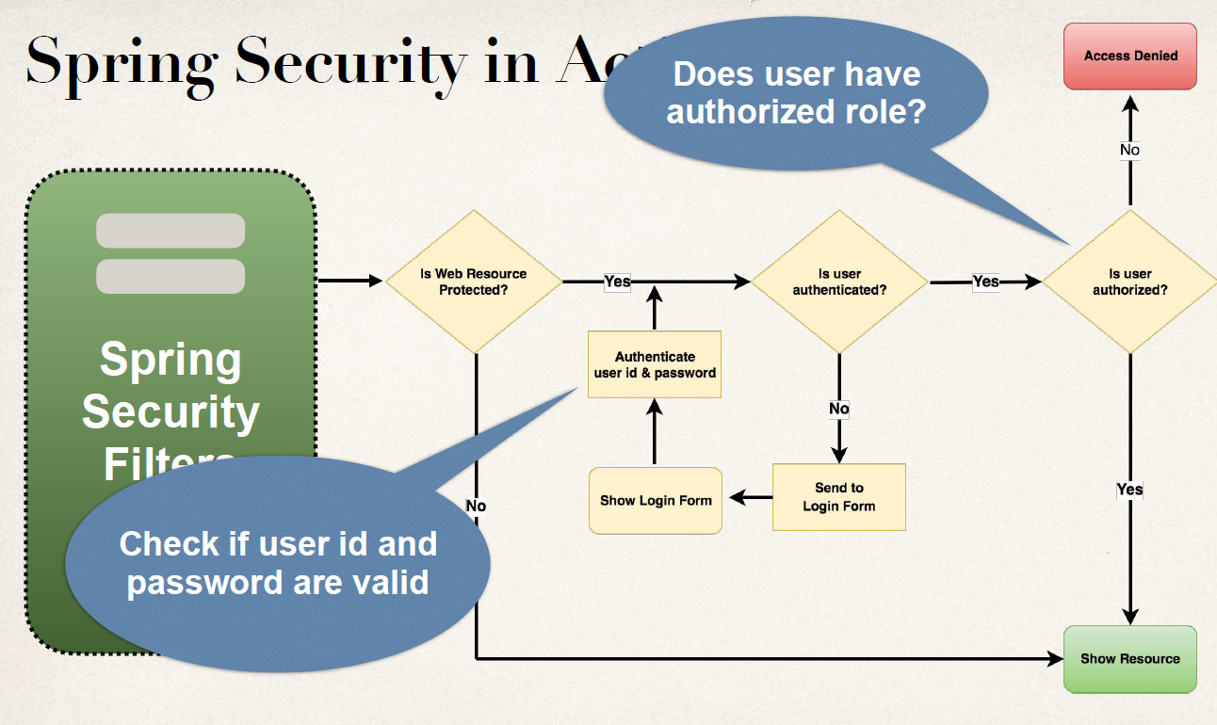

**Security Concepts**

Two level of security in place for the Spring Security framework.

• Authentication

• Check user id and password with credentials stored in app / db

• Authorization

• Check to see if user has an authorized role

**Declarative Security**

• Spring security has declarative Security. Here we Define application’s security constraints in configuration

• This is handled by all Java config using a Configuration class @Configuration

• The nice thing is by this; it provides separation of concerns between application code and security code.

**Programmatic Security**

• Spring Security provides an API for custom application coding. And this is where we can have greater customization for our specific application requirements.

• Spring security provides basic to implement additional business rules or business logic in real-world, real-time enterprise projects. We can easily plugin our own security implementation.

**Enabling Spring Security**

1. Edit **pom.xml** and add **spring-boot-starter-security**

<dependency>

<groupId>org.springframework.boot</groupId>

<artifactId>spring-boot-starter-security</artifactId>

</dependency>

1. By adding this dependency Spring-boot will *automagically* secure all endpoints for the application. No additional coding is required at this point. However we can also customize the configuration.

**Secured Endpoints**

• Now when we run and access our application, then our application is secured.

• As a result, Spring Security will prompt us to login

• By Default, the username is user and the generated password is in the application logs.

• We can do customize the user ID and the password, including storing information in the data base.

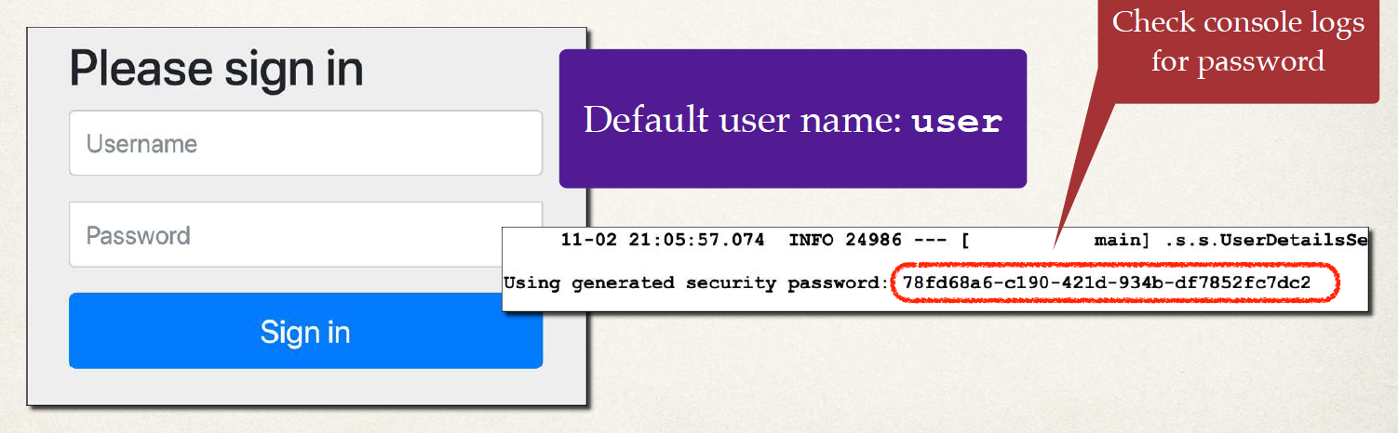

**Spring Security configuration**

• We can manage basic configuration of Spring Security

• we can override default user name and generated password in application.prperties file

*File: src/main/resources/application.properties*

**spring.security.user.name=scott**

**spring.security.user.password=test123**

**Authentication and Authorization**

• There is different technique to define **Users, Passwords, Roles.**

* We can use in-memory authentication
* We can also use JDBC, to define users, passwords and roles in a database.
* There is support LDAP
* We can also use our own Custom plugin / Pluggable(own authentication and authorization coding)
* others …

• We will cover in-memory authentication and password storage in JDBC and in DB as plain-text AND encrypted.

**Configuring Basic Security**

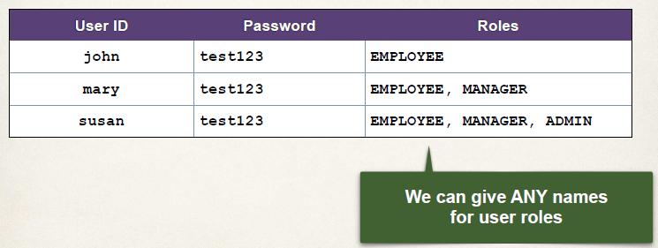

**Development Process (Step-By-Step)**

1. Create Spring Security Configuration class (@Configuration)

2. Add users, passwords and roles

**Step 1: Create Spring Security Configuration**

*File: DemoSecurityConfig.java*

**import org.springframework.context.annotation.Configuration;**

**@Configuration**

**public class DemoSecurityConfig {**

***// add our security configurations here …***

**}**

**Spring Security Password Storage**

In Spring Security, passwords are stored using a specific format.

**{id}encodedPassword**

**ID Description**

noop Plain text passwords

**bcrypt** BCrypt password hashing

… …

• **noop** :- no operation no encryption, no hashing just plain text

• **bcrypt :**- one way hashing or one way encryption. Take the password and hash it using **bcrypt** algorithm and stored in that fashion. BCrypt is very popular hashing.

**Password Example:**

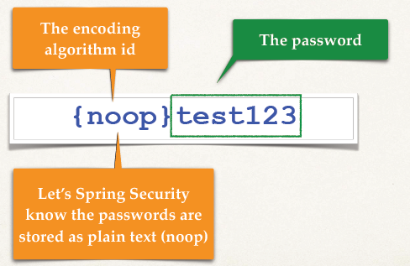

**Step 2: Add users, passwords and roles**

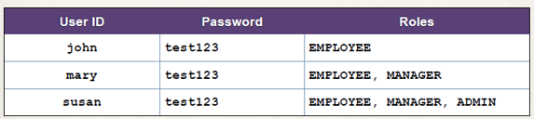

*File: DemoSecurityConfig.java*

**@Configuration**

**public class DemoSecurityConfig {**

**@Bean**

**public InMemoryUserDetailsManager userDetailsManager() {**

**UserDetails john = User.*builder*()**

**.username("john")**

**.password("{noop}test123")**

**.roles("EMPLOYEE")**

**.build();**

**UserDetails mary = User.*builder*()**

**.username("mary")**

**.password("{noop}test123")**

**.roles("EMPLOYEE", "MANAGER")**

**.build();**

**UserDetails susan = User.*builder*()**

**.username("susan")**

**.password("{noop}test123")**

**.roles("EMPLOYEE", "MANAGER", "ADMIN")**

**.build();**

**return new InMemoryUserDetailsManager(john, mary, susan);**

**}**

**}**

• We start off defining our users InMemory.

• We create a method named **userDetailsManager()**  returns an **InmemoryUserDetailsManager.**

• we create our three users for Joh, Mary, Susan. Build the user details.

• Finally, we return a new InMemoryUserDeatilsmanager with three users.

**Restrict Access Based on Roles**

• We have numbers of REST APIs Endpoints and we would like to restrict those endpoints based on given role.

**HTTP Method Endpoint CRUD Action Role**

GET /api/employees Read all EMPLOYEE

GET /api/employees/{employeeId} Read single EMPLOYEE

POST /api/employees Create MANAGER

PUT /api/employees Update MANAGER

DELETE /api/employees/{employeeId} Delete employee ADMIN

• We have different endpoints and we have different roles based on those given operations. We can implement this using Spring Security.

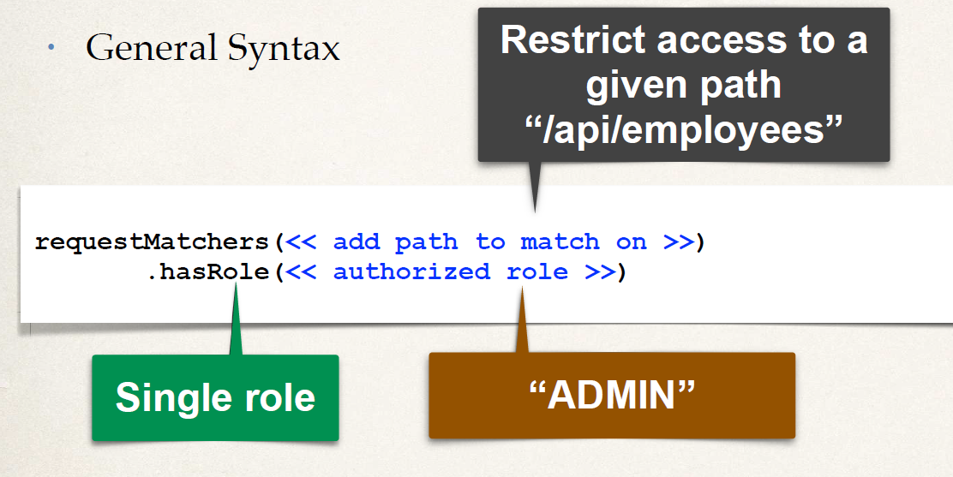

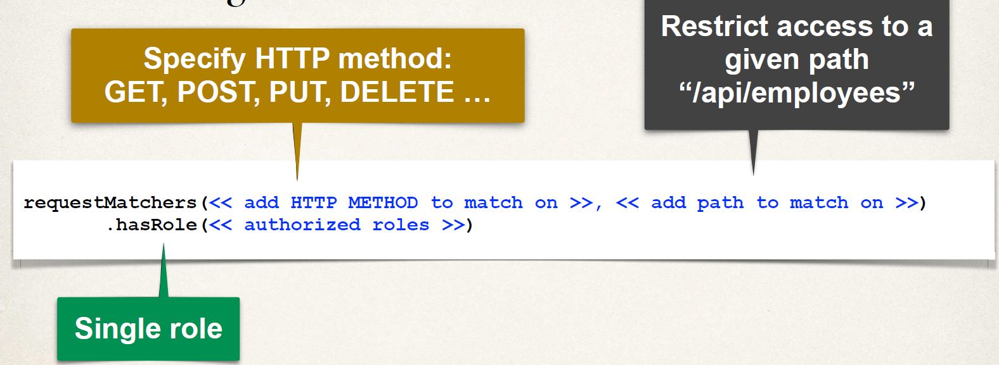

• Using **.hasAnyRole(…)** we can provide a list of authorized roles.

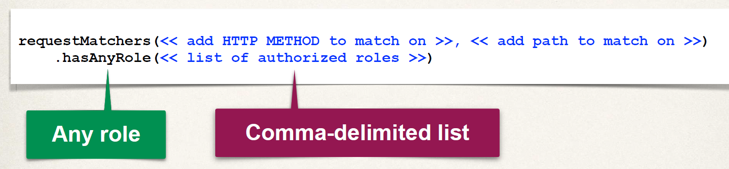

**Authorize Requests for EMPLOYEE role: -**

**HTTP Method Endpoint CRUD Action Role**

GET /api/employees Read all EMPLOYEE

GET /api/employees/{employeeId} Read single EMPLOYEE

**requestMatchers(HttpMethod.*GET*, "/api/employees").hasRole("EMPLOYEE") requestMatchers(HttpMethod.*GET*, "/api/employees/**").hasRole("EMPLOYEE")**

• The ** syntax to match on all sub-paths.

**Authorize Requests for MANAGER role: -**

**HTTP Method Endpoint CRUD Action Role**

POST /api/employees Create MANAGER

PUT /api/employees Update MANAGER

**requestMatchers(HttpMethod.POST, "/api/employees").hasRole("MANAGER") requestMatchers(HttpMethod.PUT, "/api/employees").hasRole("MANAGER")**

**Authorize Requests for ADMIN role: -**

**HTTP Method Endpoint CRUD Action Role**

DELETE /api/employees/{employeeId} Delete employee ADMIN

**requestMatchers(HttpMethod.DELETE, "/api/employees/**").hasRole("ADMIN")**

• **Pull It Together –**

**@Bean**

**public SecurityFilterChain filterChain(HttpSecurity http) throws Exception {**

**http.authorizeHttpRequests(configurer ->**

**configurer**

**.requestMatchers(HttpMethod.GET, "/api/employees").hasRole("EMPLOYEE") .requestMatchers(HttpMethod.GET, "/api/employees/**").hasRole("EMPLOYEE") .requestMatchers(HttpMethod.POST, "/api/employees").hasRole("MANAGER") .requestMatchers(HttpMethod.PUT, "/api/employees").hasRole("MANAGER") .requestMatchers(HttpMethod.DELETE, "/api/employees/**").hasRole("ADMIN"));**

**// use HTTP Basic authentication**

**http.httpBasic(Customizer.withDefaults());**

**return http.build();**

**}**

• We create the bean in the class security filter bean. It’s going to pass **HttpSecurity http** , we are going to use of it. Inside this method we have http authorize HTTP requests.

• We are authorizing based on roles. We have **configure.requestMatchers** , we give the method (GET, POST, etc,.) , endpoints and .hasRole(“…”)

• Define authorization roles here, who can access certain endpoints in our application.

• Also, we tell the app to use http basic authentication, since we are overriding providing our own security filter chain. We have to be explicit in saying the type of authentication method we are using.

• Finally we return the **http.build().** It gives us an instance of the security filter chain that’ll be used by Spring Security.

**Cross-Site Request Forgery (CSRF)**

• Spring Security can protect against CSRF attacks

• in background Spring security, Embed additional authentication data/token into all HTML forms

• On subsequent requests, web app will verify token before processing

• Primary use case is traditional web applications (HTML forms etc …)

**When to use CSRF Protection?**

• The Spring Security team recommends

• Use CSRF protection for any normal browser web requests

• Traditional web apps with HTML forms to add/modify data

• If you are building a REST API for non-browser clients

• you may want to disable CSRF protection

• In general, not required for stateless REST APIs

• That use POST, PUT, DELETE and/or PATCH

• **Pull It Together –**

**@Bean**

**public SecurityFilterChain filterChain(HttpSecurity http) throws Exception {**

**http.authorizeHttpRequests(configurer ->**

**configurer**

**.requestMatchers(HttpMethod.GET, "/api/employees").hasRole("EMPLOYEE") .requestMatchers(HttpMethod.GET, "/api/employees/**").hasRole("EMPLOYEE") .requestMatchers(HttpMethod.POST, "/api/employees").hasRole("MANAGER") .requestMatchers(HttpMethod.PUT, "/api/employees").hasRole("MANAGER") .requestMatchers(HttpMethod.DELETE, "/api/employees/**").hasRole("ADMIN"));**

**// use HTTP Basic authentication**

**http.httpBasic(Customizer.withDefaults());**

**// disable Cross Site Request Forgery (CSRF)**

**http.csrf(csrf -> csrf.disable());**

**return http.build();**

**}**

**Spring Security User Accounts Stored in Database**

**Database Access**

• So far, our user accounts were hard coded in Java source code to keep things simple

• We want to add database access. Advance feature in Spring security

**Recall Our User Roles:**

**User ID** **Password** **Roles**

john test123 EMPLOYEE

mary test123 EMPLOYEE, MANAGER

susan test123 EMPLOYEE, MANAGER, ADMIN

**Database Support in Spring Security**

• Spring Security can read user account info from database

• By default, you have to follow Spring Security’s predefined table schemas

• Spring security include all of the JDBC codes, read information from the database. So, very less java code to write for JDBC code to read information from database.

• We just need to Setup configuration and create appropriate tables and then spring security will do all heavy lifting task in the back ground.

**Customize Database Access with Spring Security**

• We can also customize the table schemas

• Useful if you have custom tables specific to your project / custom

• You will be responsible for developing the code to access the data

• In this scenario we need to write JDBC code or Hibernate code to read the data from appropriate tables. We will have to read the account info. and user roles.

• JDBC, JPA/Hibernate etc …

• Follow Spring Security’s predefined table schemas. It will give us all the functionalities and code for hooking into the actual database. This is all given to us out of the box.

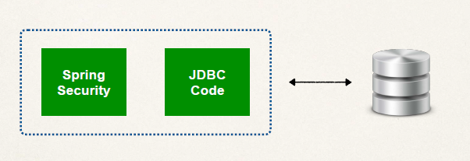

**Development Process (Step-By-Step)**

1. Develop SQL Script to set up database tables

2. Add database support to Maven POM file

3.Create JDBC properties file

4. Update Spring Security Configuration to use JDBC

**Default Spring Security Database Schema**

• Spring security has a default database schema; we need to follow it.

• There are two tables. Also, this table has these specific columns. We have to use the exact table names and columns names as shown here.

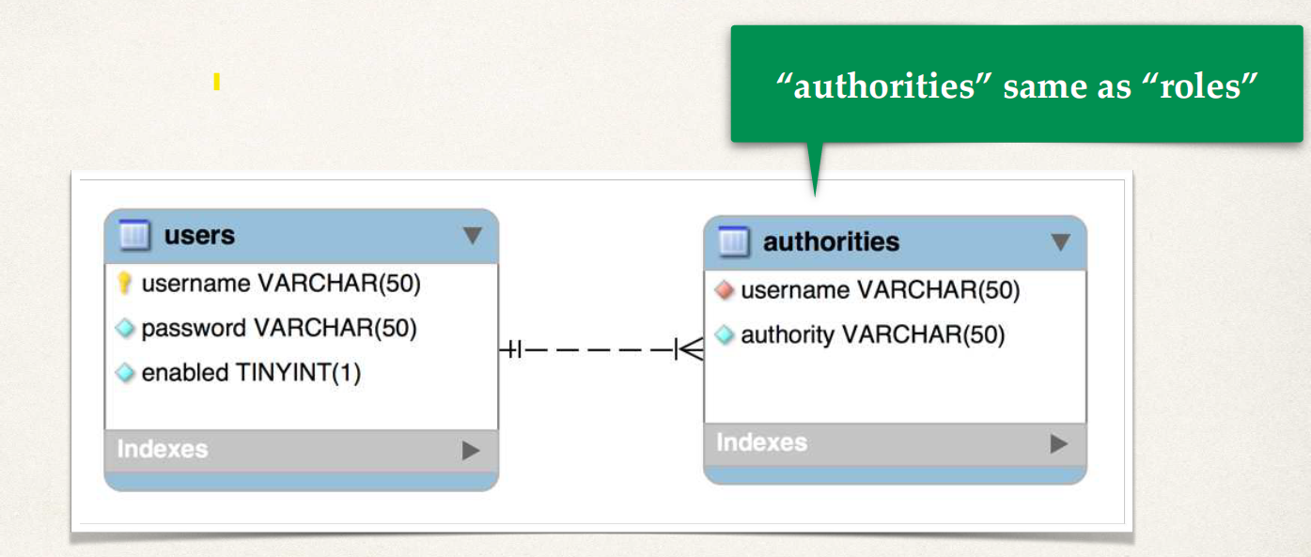

**Step 1: Develop SQL Script to setup database tables**

**CREATE TABLE** `users` (

`username` **varchar**(50) **NOT NULL**,

`password` **varchar**(50) **NOT NULL**,

`enabled` tinyint **NOT NULL**,

**PRIMARY KEY** (`username`)

) ENGINE=InnoDB **DEFAULT** CHARSET=latin1;

• Primary Key is based on the username.

• Then, we go ahead and handle the password storage here.

• in Values – (Username, password, enableStatus)

**INSERT INTO `users`**

**VALUES**

**('john','{noop}test123',1),**

**('mary','{noop}test123',1),**

**('susan','{noop}test123',1);**

• Next, we write SQL script for the table for **roles** or **‘authorities’**

• we setup unique key based on username and authority

• We also setup our constraints

• Then we mention the Foreign Key and Reference to users table `username`

**CREATE TABLE** `authorities` (

`username` **varchar**(50) **NOT NULL**,

`authority` **varchar**(50) **NOT NULL**,

**UNIQUE KEY** `authorities_idx_1` (`username`,`authority`),

**CONSTRAINT** `authorities_ibfk_1`

**FOREIGN KEY** (`username`)

**REFERENCES** `users` (`username`)

) ENGINE=InnoDB **DEFAULT** CHARSET=latin1;

• Then, we go ahead and insert our roles into our database in ‘authorities’ table.

• Internally Spring Security uses “ROLE_” prefix

**INSERT INTO** `authorities`

**VALUES**

('john','ROLE_EMPLOYEE'),

('mary','ROLE_EMPLOYEE'),

('mary','ROLE_MANAGER'),

('susan','ROLE_EMPLOYEE'),

('susan','ROLE_MANAGER'),

('susan','ROLE_ADMIN');

**Step 2:** **Add Database Support to Maven POM file**

• We add Database Support to Maven POM file.

• Make sure to give a reference to our JDBC driver

**<!-- MySQL -->**

**<dependency>**

**<groupId>com.mysql</groupId>**

**<artifactId>mysql-connector-j</artifactId>**

**<scope>runtime</scope>**

**</dependency>**

**Step 3: Create JDBC Properties File**

• Creating JDBC properties file, mention in application.properties file.

• Here, we reused our existing JDBC properties file. As we keep our security table in same database schema of Employee.

*File: application.properties*

**#**

**# JDBC connection properties**

**#**

**spring.datasource.url=jdbc:mysql://localhost:3306/employee_directory spring.datasource.username=springstudent**

**spring.datasource.password=springstudent**

**Step 4: Update Spring Security to use JDBC**

• Basically, here we tell spring security to use JDBC authentication.

• We create bean to provide the **UserDetailsManager.** Then weinject the data source. That is auto-configured by Spring Boot.

• Then we create new **JdbcUserDetailsManager** and tell Spring security to use JDBC authentication with our data source.

• And Spring security knows that it’s using a predefined table schema. It knows the exact two table name and columns to look in your database for users and roles.

• We are no longer hard coding the users. We are reading Users and Roles from data base.

• And in background, Spring security handles all low-level works of reading the user, password, roles and so on from database as we are following its schema same table and column names.

**@Configuration**

**public class DemoSecurityConfig {**

**@Bean**

**public UserDetailsManager userDetailsManager(DataSource dataSource) {**

**return new JdbcUserDetailsManager(dataSource);**

**}**

**…**

**}**

**Spring Security Password Encryption**

**Password Storage**

• So far, our user passwords are stored in plaintext … yikes!



• Ok for getting started … but not for production / real-time project

**Password Storage - Best Practice**

• The best practice is storing passwords in an encrypted format. So even the Database hacked, the hacker can’t know the password.



**Spring Security Team Recommendation**

• Spring Security recommends using the popular **bcrypt** algorithm

• **bcrypt**

• Performs one-way encrypted hashing

• Adds a random salt to the password for additional protection

• Includes support to defeat brute force attacks

**Bcrypt Additional Information**

• Why you should use bcrypt to hash passwords

[www.luv2code.com/why-bcrypt](http://www.luv2code.com/why-bcrypt)

• Detailed bcrypt algorithm analysis

[www.luv2code.com/bcrypt-wiki-page](http://www.luv2code.com/bcrypt-wiki-page)

• Password hashing - Best Practices

[www.luv2code.com/password-hashing-best-practices](http://www.luv2code.com/password-hashing-best-practices)

**How to Get a Bcrypt password**

You have a plaintext password and you want to encrypt using bcrypt

• Option 1: Use a **website utility** to perform the encryption

• Option 2: Write **Java code** to perform the encryption

**How to Get a Bcrypt password - Website**

• Visit: [www.luv2code.com/generate-bcrypt-password](http://www.luv2code.com/generate-bcrypt-password)

• Enter your plaintext password

• The website will generate a bcrypt password for you

Password hash result:

$2a$10$ZUTFrkvSzWhTOvy82ejZzu0CObEwNX8Qc998DtmXi/tx3HEsp.YO.

**Development Process (Step-By-Step)**

1. Run SQL Script that contains encrypted passwords

* Modify DDL for password field, length should be 68

(THAT’S IT… It’s just a configurational exercise. … no need to change Java source code)

**Spring Security Password Storage**

• In Spring Security, passwords are stored using a specific format

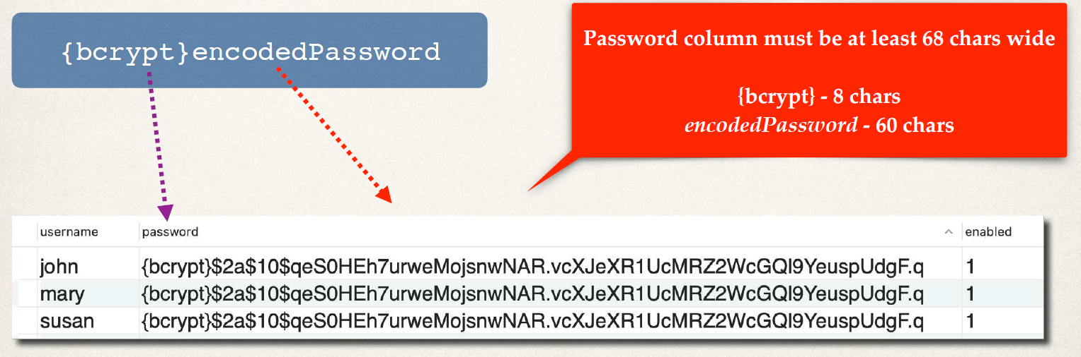

**Modify DDL for Password Field**

**CREATE TABLE** `users` (

`username` **varchar**(50) **NOT NULL**,

`password` **char**(**68**) **NOT NULL**,

`enabled` tinyint **NOT NULL**,

**PRIMARY KEY** (`username`)

) ENGINE=InnoDB **DEFAULT** CHARSET=latin1;

• Password column must be at least 68 chars wide

{bcrypt} - 8 chars

encodedPassword - 60 chars

**Step 1: Develop SQL Script to Setup database tables for Security**

INSERT INTO `users`

VALUES

(‘john','{bcrypt}$2a$10$qeS0HEh7urweMojsnwNAR.vcXJeXR1UcMRZ2WcGQl9YeuspUdgF.q',1), ('mary','{bcrypt}$2a$04$eFytJDGtjbThXa80FyOOBuFdK2IwjyWefYkMpiBEFlpBwDH.5PM0K',1), ('susan','{bcrypt}$2a$04$eFytJDGtjbThXa80FyOOBuFdK2IwjyWefYkMpiBEFlpBwDH.5PM0K',1);

**{bcrypt}** - The encoding algorithm id.

Let’s Spring Security know the passwords are stored as encrypted passwords: bcrypt

**$2a$10$qeS0HEh7urweMojsnwNAR.vcXJeXR1UcMRZ2WcGQl9YeuspUdgF.q'**

- The encrypted password: fun123

Here the encrypted password for below plain text password

**User**: john

**Password**: fun123

**Spring Security Login Process**

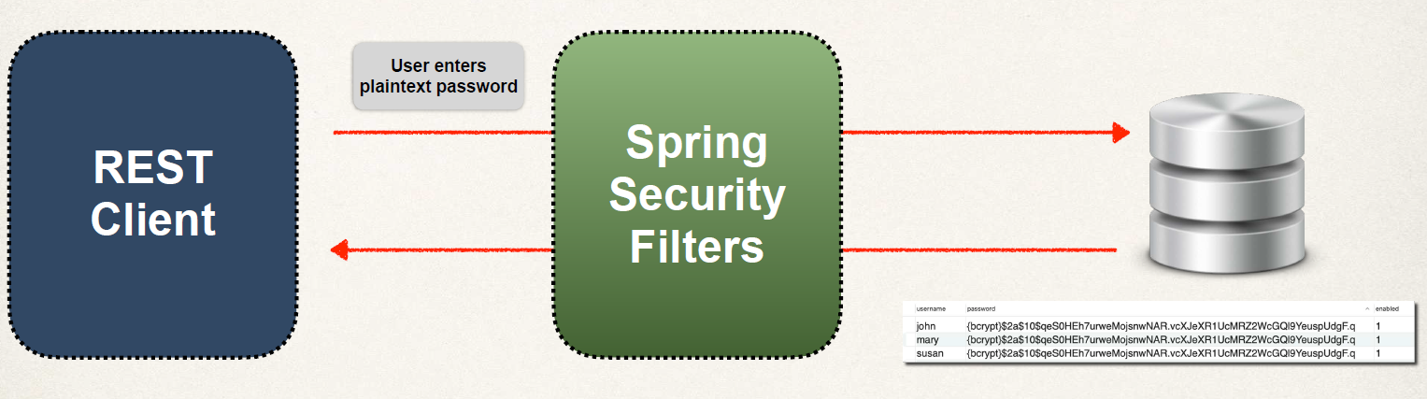

• We have our Login form (REST Client) and Database that has our encrypted passwords. The Spring Security Filter in place between them.

• User enters his plain text password on the form and hit login.

• Behind the scenes, the spring security will read this information and perform some operations on it using the JDBC authentication.

Behind the scenes in this JDBC authentication process

1. First it Retrieve password from db for the user

2. Read the encoding algorithm id (bcrypt etc)

3. For case of bcrypt, encrypt plaintext password from login form (using salt from db password)

4. Compare encrypted password from login form WITH encrypted password from db

5. If there is a match, login successful

6. If no match, login NOT successful

**Note:** The password from db is NEVER decrypted**.** Because **bcrypt** is aone-wayencryption algorithm.

So, we never grab the password from DB and decrypt it and have it as plain text. Because it doesn’t support that algorithm as it’s only a one-way algorithm.

**Spring Security Custom Tables**

• Configure of Spring Security to use custom tables

**Default Spring Security Database Schema**

• In default spring security schema, we use the exact schema the same table name and column names. It’s bit restrictive…

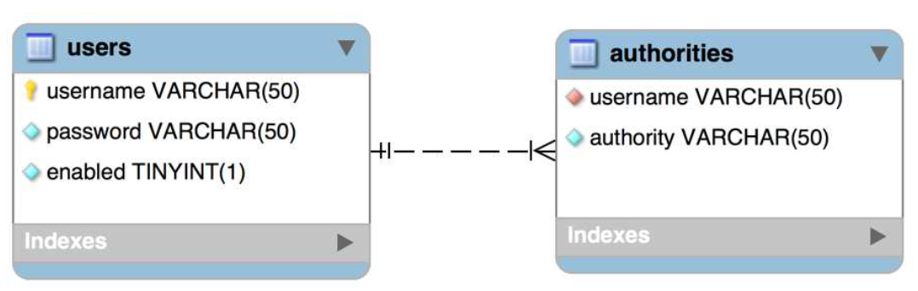

**Custom Tables**

• What if we have our own custom tables?

• Our own custom column names?

• For Example: In a company there are existing security tables and we configure the spring security use those custom tables.

We should be able to use any tables and any columns. Like below database diagram of tables. We have custom tables **members** and **roles**. Here these tables not match with default spring security table schema.

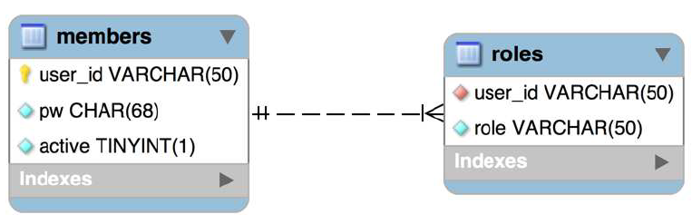

**For Security Schema Customization**

We can use own custom table for spring security. But we need to tell security “Hey, this is how you find the given user and here is how you find the roles for that given user”. So,

• Tell Spring how to query your custom tables

• Provide query to find user by user name

• Provide query to find authorities / roles by user name

**Development Process (Step-By-Step)**

1. Create our custom tables with SQL

2. Update Spring Security Configuration

• Provide query to find user by user name

• Provide query to find authorities / roles by user name

**Step 1: Create our custom tables with SQL**

• This is all custom - Nothing matches with default Spring Security table schema. We have freedom to use any table name and column name.



USE `employee_directory`;

DROP TABLE IF EXISTS `roles`;

DROP TABLE IF EXISTS `members`;

CREATE TABLE `members` (

`user_id` varchar(50) NOT NULL,

`pw` char(68) NOT NULL,

`active` tinyint NOT NULL,

PRIMARY KEY (`user_id`)

) ENGINE=InnoDB DEFAULT CHARSET=latin1;

INSERT INTO `members`

VALUES

('john','{bcrypt}$2a$10$qeS0HEh7urweMojsnwNAR.vcXJeXR1UcMRZ2WcGQl9YeuspUdgF.q',1),

('mary','{bcrypt}$2a$10$qeS0HEh7urweMojsnwNAR.vcXJeXR1UcMRZ2WcGQl9YeuspUdgF.q',1),

('susan','{bcrypt}$2a$10$qeS0HEh7urweMojsnwNAR.vcXJeXR1UcMRZ2WcGQl9YeuspUdgF.q',1);

CREATE TABLE `roles` (

`user_id` varchar(50) NOT NULL,

`role` varchar(50) NOT NULL,

UNIQUE KEY `authorities5_idx_1` (`user_id`,`role`),

CONSTRAINT `authorities5_ibfk_1` FOREIGN KEY (`user_id`) REFERENCES `members` (`user_id`)

) ENGINE=InnoDB DEFAULT CHARSET=latin1;

INSERT INTO `roles`

VALUES

('john','ROLE_EMPLOYEE'),

('mary','ROLE_EMPLOYEE'),

('mary','ROLE_MANAGER'),

('susan','ROLE_EMPLOYEE'),

('susan','ROLE_MANAGER'),

('susan','ROLE_ADMIN');

**Step 2: Update Spring Security Configuration**

• We need to Update Spring Security Configuration.

• We need to modify the code where we created that JDBC User details manager and we have to provide the query how to find users by giving username.

• We give appropriate SQL query to access our custom *members* and *roles* table. Also, we have to provide query for how to find roles by given username.

**@Configuration**

**public class DemoSecurityConfig {**

**@Bean**

**public UserDetailsManager userDetailsManager(DataSource dataSource) {**

**JdbcUserDetailsManager theUserDetailsManager =**

**new JdbcUserDetailsManager(dataSource);**

**theUserDetailsManager .setUsersByUsernameQuery(**

**"select user_id, pw, active from members where user_id=?");**

**theUserDetailsManager .setAuthoritiesByUsernameQuery(**

**"select user_id, role from roles where user_id=?"); return theUserDetailsManager;**

**}**

**…**

**}**

**Update Audit Columns using Spring Data**

• The columns like **CreatedDate, CreatedBy, LastModifiedDate,** and **LastModifiedBy,** whenever the update operation is happening. With help of Spring Data JPA, we can update these meta data columns automatically.

• Spring Data JPA framework is taking care of all database interactions. It will take responsibility of creating the script for insertion, update and select. We don’t pass any single query for these inside our application.

• We use the bellow annotations above respective columns field in Entity class.

**@CreatedDate**

**@CreatedBy**

**@LastModifiedDate**

**@LastModifiedBy**

• Date and Time can be fetched from server. For knowing the person who has done the update and entry, we need to write a logic.

•